Interdisciplinary course of

**Design and Robotics**

XII° edition, 2024

Project:

**Yudu: Engage, Stretch, Energize!**

Professors:

Andrea Bonarini, DEIB department, Politecnico di Milano

Maximiliano Romero, Design department, IUAV, Venice University

Tutors:

Federico Espositi

Group number 5

Students:

Mohammadsobhan Esfandiar, School of Design

Marco Grazi, School of Engineering

Sofia Gregorio, School of Design

Lorenzo Pedini, School of Design

Federico Verga, School of Engineering

# Index

**Index 1**

**Abstract 3**

**Phase 1: Discover 4**

Team Organization 4

Project Management 5

Research 5

Interviews 6

Desk Research and Case Studies 8

Moodboard 11

Cardboard Models 12

Robot strategies 15

Functionalities 15

Location detection 15

Movements 15

Feedback 16

**Phase 2: Define 16**

Strategy 16

Shape 18

Naturalistic design 18

Animal Design 19

Minimalist Design 20

First Development Step 20

Mechanical Design 22

Second Defining Step 24

Movements 25

Detection 25

Attraction 25

Interaction 25

Expressions 28

Concept 29

Third Defining Step 30

Electronics 32

**Phase 3: Develop 36**

Strategy 36

Modelling 36

Prototyping-Testing-Refining 38

Interaction Flowchart 41

Final Product Architecture 47

Human-Robot Interaction 49

Materials & Process of Production 51

Electronics 51

Coding 54

Logo 60

**Phase 4: Deliver 62**

**Final Robot Description 62**

Strategy 62

Shape 62

Mechanics 62

Electronics 65

Informatics 65

**User Interaction Discussion 66**

**Conclusion 67**

**APPENDIX 69**

**User & Maintenence Manual 70**

**Minutes of the Meetings 88**

Meeting 08/03/2024 88

Meeting 15/03/2024 89

Meeting 16/03/2024 89

Meeting 20/03/2024 89

Meeting 22/03/2024 89

Meeting 06/04/2024 89

Meeting 11/04/2024 90

Meeting 23/04/2024 90

Meeting 25/04/2024 90

Meeting 26/04/2024 90

Meeting 03/05/2024 90

Meeting 07/05/2024 91

Meeting 10/05/2024 91

Meeting 13/05/2024 91

Meeting 20/05/2024 91

**Bibliography 92**

**Attachments 94**

# 

# Abstract

Sitting is probably the most significant part of student life; sitting for prolonged periods in the same position comes with bad effects, and when coupled with bad posture it can cause chronic pain to the neck and shoulders. Students in Politecnico di Milano are heavily affected by upper body pain due to bad posture while studying, the Yudu robot assesses this problem by creating a robot able to actively interact with students, attract their attention in a friendly way and then induce them to perform a muscle reactivating routine. The robot is ideated as a fun way to reactivate students’ muscles when they are taking study breaks: the project aims to seamlessly introduce stretching movements into students’ routines, making them in the long run a part of their everyday lives. The following report covers the development process of the robot, from the first brief to the final human-robot interaction analysis. To assess the functionality of the robot, Yudu has been positioned a whole morning next to the vending machines to interact with students during their break: users are generally happy with the aesthetic and functionality of the product.

# Phase 1: Discover

Nowadays robots should not be seen as mere machines, as they are capable of actively interacting with humans and, with a well-tought interaction, can make humans’ behaviour different. In this project's preliminary phase, we will ask ourselves multiple questions relating to technology's capacity to induce significant social change by analysing the underlying dynamics, emerging behaviours, and strategies to cause change through its use.

What makes this question so intriguing is the complexity of human and technological interactions. How does technology affect our relationships, perceptions and actions? What are the dynamics that develop when technology becomes intertwined with social processes? And, perhaps more importantly, what behaviours can be stimulated or changed through the targeted use of technology?

During the first phase, we will also focus on the essentials of good team organisation, establishing the prominent roles that each member assumes during the prototype's design. The next step involves planning the deadlines assigned to the entire team by the professors and those assigned internally to each member.

## Team Organization

The team is a blend of diverse talents, with each member contributing a unique expertise crucial to the success of our project.

Mohammadsobhan Esfandiar, who is pursuing a master's degree in Design and Engineering with a specialisation in mechanical engineering, is leading our efforts as the production manager. His role focuses on managing the mechanical aspects of the robot's development and production process.

Marco Grazi, an accomplished computer science engineer who serves as our Technical Manager, oversees the technical aspects of our project. Marco's responsibilities revolve around designing and implementing the computer systems integral to our robot's functionality.

Sofia Gregorio, an industrial engineer transitioning into a master's program in Design and Engineering, is driving the project forward as our project manager. Sofia's expertise lies in budgeting and scheduling, ensuring the project stays on track and within budget.

Guiding our design efforts is Lorenzo Pedini, who draws from his background in product design and engineering studies as our chief design manager. Lorenzo spearheads our team's innovation and design management processes.

Lastly, Federico Verga, an automation engineer, takes on the role of Automation engineer and coding assistant. Federico is responsible for motor control and management of individual components.

Our diverse skill sets and collaborative spirit form the backbone of our team, driving us to achieve the successful realization of our robot project.

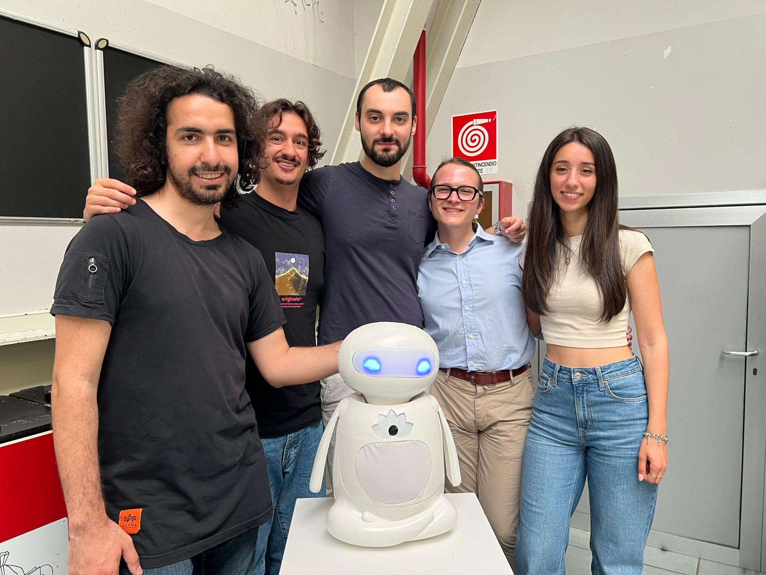

## Project Management

The time and the milestones in the project were already mapped out by the professors, the diversity in student backgrounds gave us the ability to easily and clearly separate the tasks among the teammates. Thanks to the clear organization, the teams can be subdivided into smaller sub-teams, this way we can move on faster by making generic development considerations altogether and then take action separately, discussing eventual problems with the other teammates with similar backgrounds in the subteam. Thanks to this kind of organization the Hardware subteam (Sobhan and Lorenzo), can make models and prototypes keeping in mind two main factors: prioritizing the production of functional prototypes to hand out to the Software subteam (Marco and Federico) to start real-life testing of the functions. Following this organization the two teams can work in parallel and develop solutions faster, talking to each other to define requirements and constraints for each step. After the Hardware team handed out the functional prototype to the Software team, it is possible to move on with the development of aesthetic and usability-related parts, all of that while leaving time for the Software team to test and consequently modify the code.

## Research

The first phase of the project unfolds primarily in two distinct moments: defining the robot's purpose and determining its physical and functional characteristics.

Brief: make a robot communicate intentions non-verbally to persuade individuals to engage in an activity, thereby inducing a behavioural change for social benefit.

Based on the brief, the team focused on identifying the primary purpose that the robot assumes in the daily lives of every student at Politecnico di Milano.

As the robot was going to be located in Campus Candiani, the user study involved students in that specific campus, two main user study techniques were involved in our analysis of students’ needs: user shadowing and interviews.

Starting from our own experience we briefly discussed places on campus where we experienced some of our needs not being fulfilled, and then we went around to observe the users in their activities and tried to obtain insights from their behaviour. After roaming through different areas of the campus such as the smoking area, the cafeteria, the library and the study room, and shadowing some users to analyze their behaviour, we all agreed that the two main issues we were recurrently finding were cigarette butt littering in the environment., and back and shoulder pain related to bad posture during study sessions.

Given that we were the only group trying to assess the pain problem, we decided to move in that direction and further research that topic, hence we came up with a set of questions to better dive into the topic and have direct feedback on our initial idea: a robot capable of inducing the user to perform particular arm and neck movements beneficial for physical mobility, lacking due to the unhealthy habits practised by students during long study sessions.

### Interviews

We interviewed a sample of 10 users from different backgrounds in Politecnico and in different locations, the following six questions were created to obtain information about users’ habits and about how to seamlessly integrate our robot into their study routine.

Listed below are the three most valuable interviews selected from the user sample, showing common answers.

**First interviewee**:

1. When you study here at Campus Candiani, do you feel you have moved your body enough?

<< No, usually. >>

1. What parts of the body do you move less and feel more fatigued after a study day?

<< I move my back and legs less. >>

1. Why do you feel like you don’t move much?

<< Because of study.>>

1. When do you have time to move?

<< Generally during lunch break.>>

1. What are the barriers to your movements? Is the environment you are in affecting your willingness to move?

<< Principally, the barrier is the absence of places to move. >>

1. Do you feel more comfortable doing movements alone or in a group?

<< I would prefer doing movements alone because it could be embarrassing and weird in front of other people. >>

**Second interviewee**:

1. When you study here at Campus Candiani, do you feel you have moved your body enough?

<< Zero at university. >>

1. What parts of the body do you move less and feel more fatigued after a study day?

<< I move my legs and shoulders less. >>

1. Why do you feel like you don’t move much?

<< Because I don’t have time. >>

1. When do you have time to move?

<< Only during breaks and lunchtime. >>

1. What are the barriers to your movements? Is the environment you are in affecting your willingness to move?

<< I don’t have barriers; i would probably prefer a closed place. >>

1. Do you feel more comfortable doing movements alone or in a group?

<< I would prefer to move alone. >>

**Third interviewee**:

1. When you study here at Campus Candiani, do you feel like you have moved your body enough?

<< I don’t do sufficient movements on campus. >>

1. What parts of the body do you move less and feel more fatigued after a study day?

<< I move my neck and arms less. >>

1. Why do you feel like you don’t move much?

<< Because of study sessions. >>

1. When do you have time to move?

<< Only during breaks. >>

1. What are the barriers to your movements? Is the environment you are in affecting your willingness to move?

<< I would prefer an open place. >>

1. Do you feel more comfortable doing movements alone or in a group?

<< I prefer to move alone. >>

### Desk Research and Case Studies

Once the main idea for the robot was set in stone, we started desk research looking for previous projects with similar constraints and objectives and scientific research on human-robot interaction applied to the field of physical exercise, guiding us in the project definition and in finding good practices to start from. When looking for robot projects for behavioural change connected to physical activity, a recurring topic was “Socially Assistive Robots (SAR)”, defined as a group of robots that “interact with humans and even offer social assistance” Lotfi et al. (2018), helping people in need, mainly elderly humans, to fulfil their daily needs. Lotfi et al. (2018) describe the early development of robots for human exercise, such as the Taizo Humanoid robot developed in 2009 to help elders engage in seated arm exercises or the Robo Coach Xuan robot developed in 2015, to also administer arm exercise to be executed seated. Both projects have similar aims and similar working functions moving the arms and requiring the user to mirror the movement shown, with the only difference being the Xuan robot being able to motivate the humans by giving praise and feedback from actively evaluating their performance.

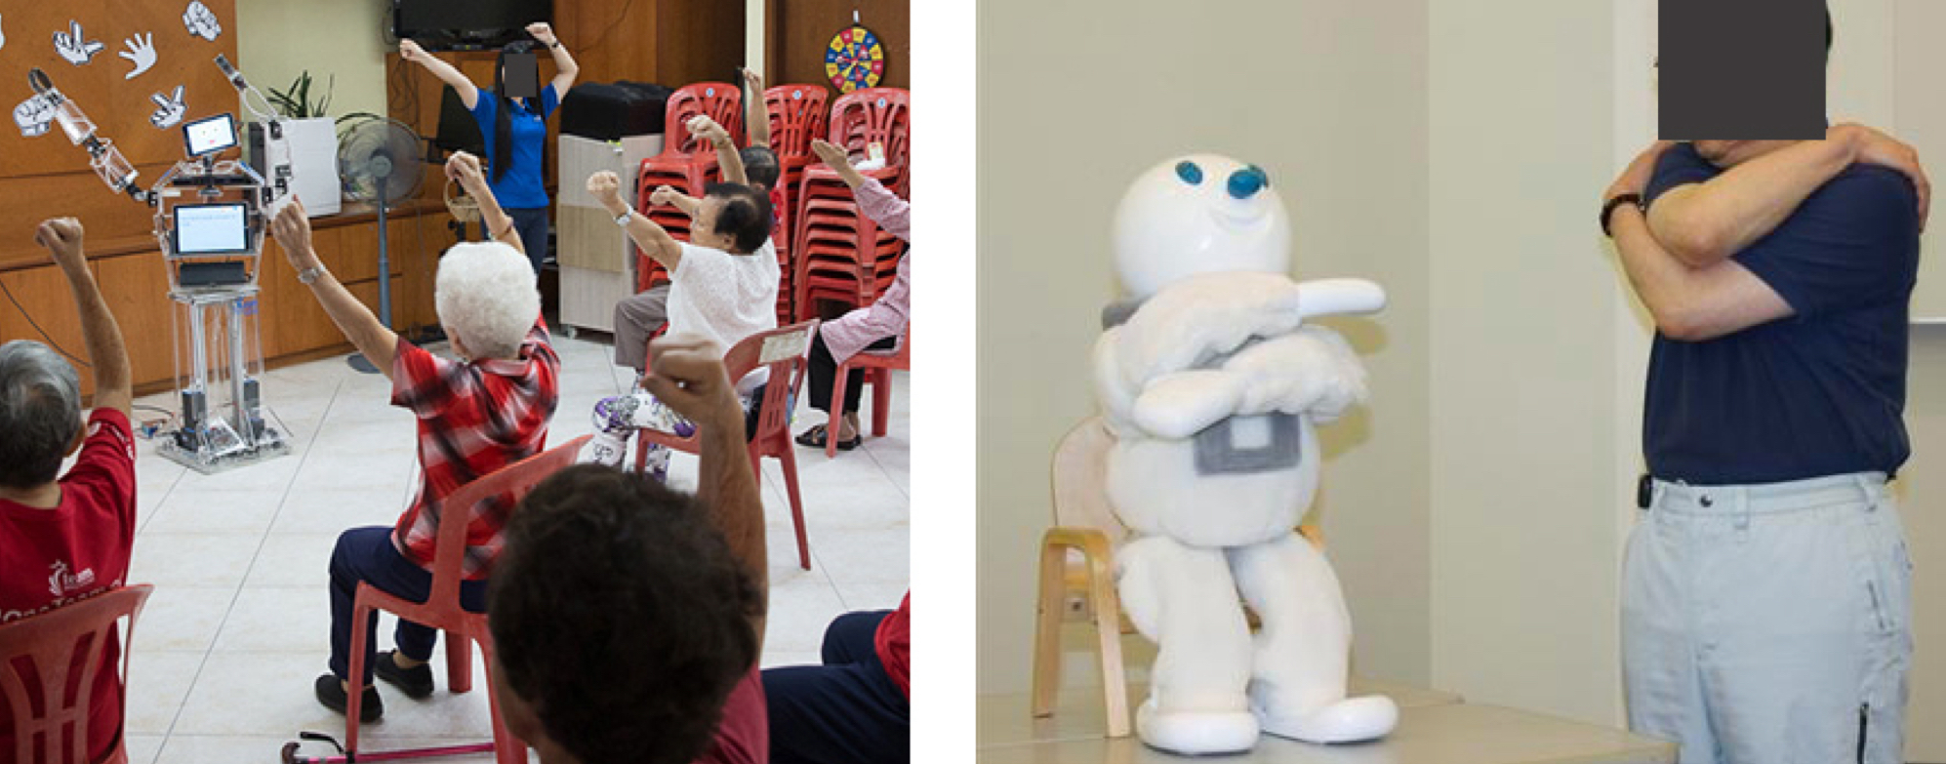

Research by Fasola and Matarić (2013) showed that people prefer to be trained by a physical object than virtual training software (Lotfi et al., 2018), in the project they designed a robot with the ability to influence the user’s intrinsic motivation to perform a task and the ability to personalize social interaction to maintain engagement. To give active feedback and ensure the correctness of the movements: a visual user activity recognition algorithm was developed to recognise user arm poses in real-time without markers on the user via a monocular camera. The robot had four exercise games available, Workout game, Sequence game, Imitation game and Memory game, the robot showed one exercise gesture at a time and asked the user to imitate, upon successful completion by the user, the robot generated a different gesture and the process repeated. While doing the activity, the robot gave active feedback on how to correctly move body parts to achieve the right position. The robot was tested in two conditions, the “relational condition”, where the robot would praise the user upon exercise completion and reassure the user in case of error, the second condition was the “non-relational condition”, where the robot guided the user through the movement and provide instructional feedback, avoiding any kind of relationship building attempt, avoiding praising, hence not showing empathy. The research shows how SAR in the relational condition was preferred by users, 85% of them rated it higher in terms of enjoyment, 77% considered it more useful, a better companion and a better exercise coach, showing also high user compliance and performance within the exercise task, validating the effectiveness of SAR exercise system approach. To further validate the research, the study was expanded with a sample of 33 young adults, showing consistent results with those observed with older users.

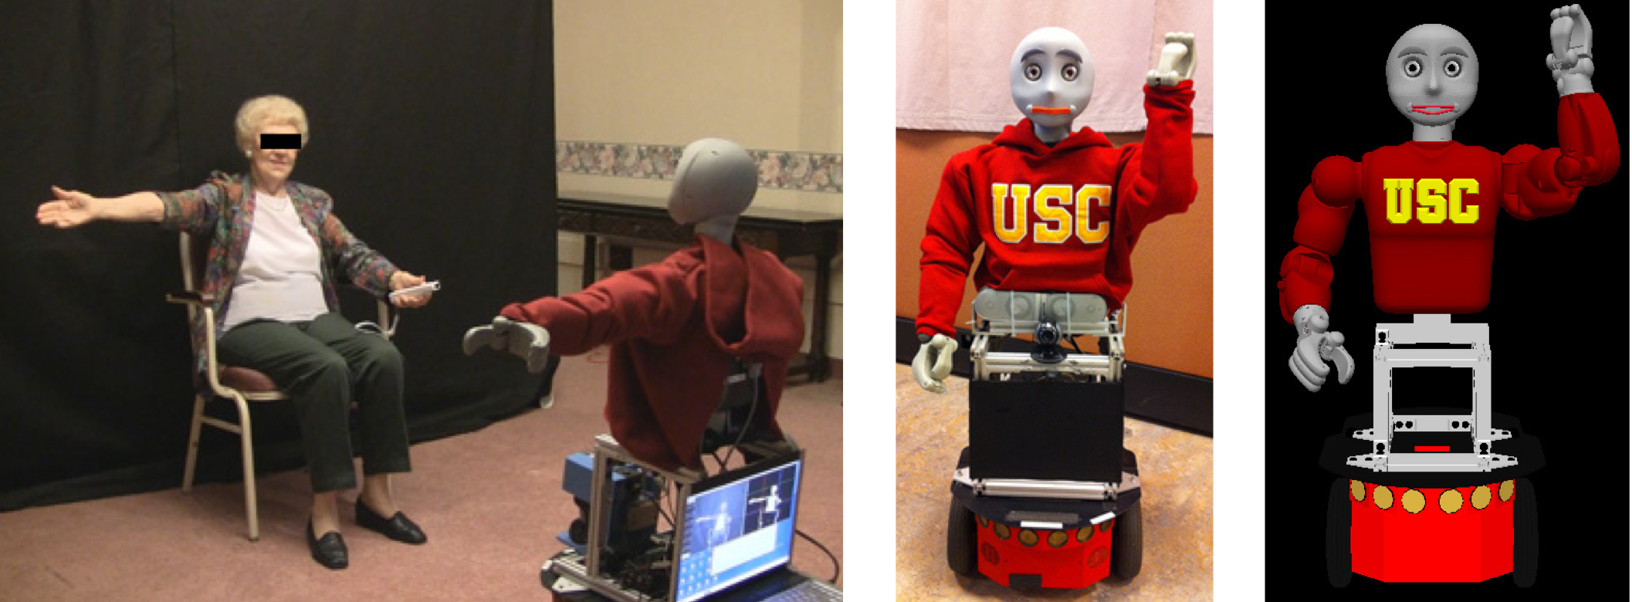

Research proved how robots can have an effective role in making people move more, giving similar results in older and younger adults. Moving from the technical aspect to the experience design one, the co-design project by Antony et al. (2023) gave us some insights into the users’ perspective on robot features and desiderata. Robots were again seen as good trainers “lowering barriers to initiating exercise due to a lack of prior experience and fear of embarrassment by facilitating individual workout sessions”: users suggested avoiding repetitiveness by having a wide range of exercises and different interaction modalities, training should not only be a one to one session, indeed robots were seen as possible group activity leader, making PE more enjoyable and motivating the peers in the group. General robot features highlighted by users in Antony et al were:

* interactivity: engage with the user via motivational feedback
* verbal and non-verbal communication: the robot should somehow be able to effectively communicate with the user, one suggestion for non-verbal communication was to use an expressive face
* easy to use
* mindful towards privacy
* appearance: participants looking for a PE companion preferred humanoid or zoo-morphic-looking robots, with a clear desire for compactness and for an aesthetic often described as “cute”
* respectful interactions

While all of the projects analysed up until now were focused on the development of social robots for interaction with older people and were mainly engaging via mirroring exercises, the last project from Fitter et al. (2020), broadened up the robot-user interaction by introducing the “Dynamic Physical Human-Robot Interaction (pHRI) into the equation. The Baxter robot, originally used as a production line robot, was “hacked” to make it interact with users via eight games, six of which are pHRI-based, the games varied across active, passive and zero physical touch and sound. In the user research, younger participants gave higher ratings of confidence about interacting with Baxter whereas older adults showed better results in terms of exercise engagement. In general, users did not need any sort of training to use Baxter, as the set of music and visual feedback was considered effective in understanding the task and completing it, the users also showed better interactions when starting from low-effort games and building up to the complex ones, having the time to build trust and confidence in the interaction with the robot.

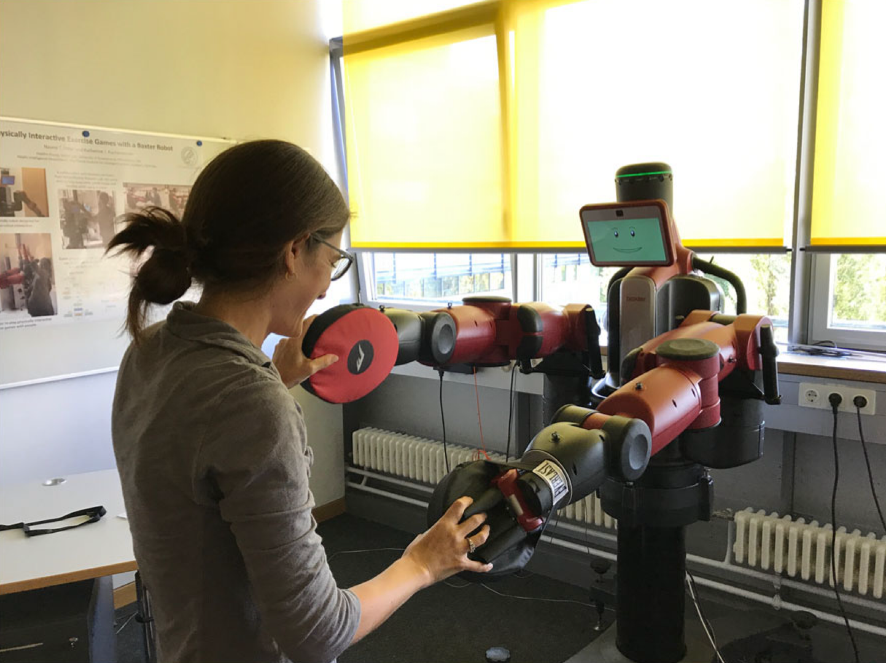

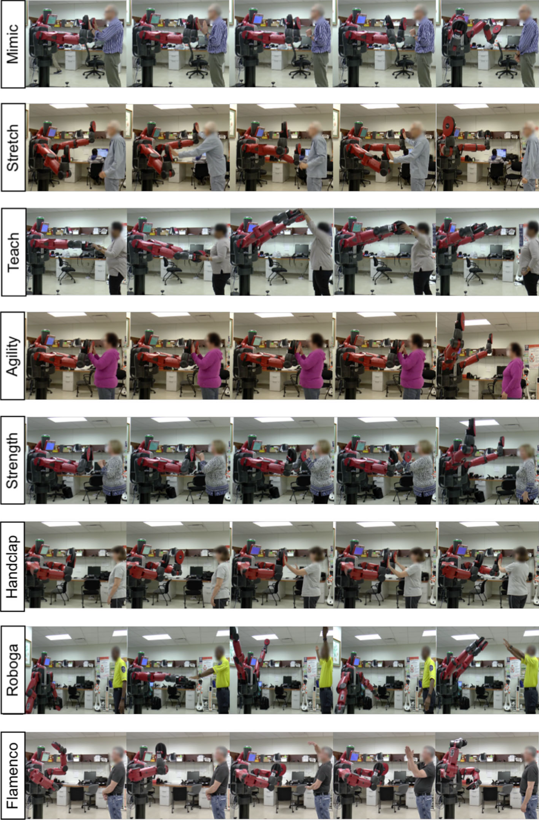

### Moodboard

Drawing from the results of the research and the best practices in the case studies, we made a moodboard to express the main ideas behind our social robot, first of all, the location, to make the robot a driver for social interactions, we decided to put the product in the breakroom, close to the vending machines, a crowded environment with many people passing by and also the place of choice for a quick study break. The location choice aimed to make the robot attract one person or a set of people altogether, hence facilitating the group logic and making the interaction less embarrassing for the single user. Then we wanted to express the mirroring idea, via the work of Daniel Rozin, an artist creating “robotic mirrors”; alongside the mirroring exercises, we also opened up to the possibility of touch exercises, allowing for direct human-robot interactions. Last, a palette of possible colours based on the chosen location was added to the moodboard, to convey energy, vitality, balance and stability; then an indication of the material finishing was also derived, indicating the use of soft-touch finishing, especially in the case of direct interaction with the user.

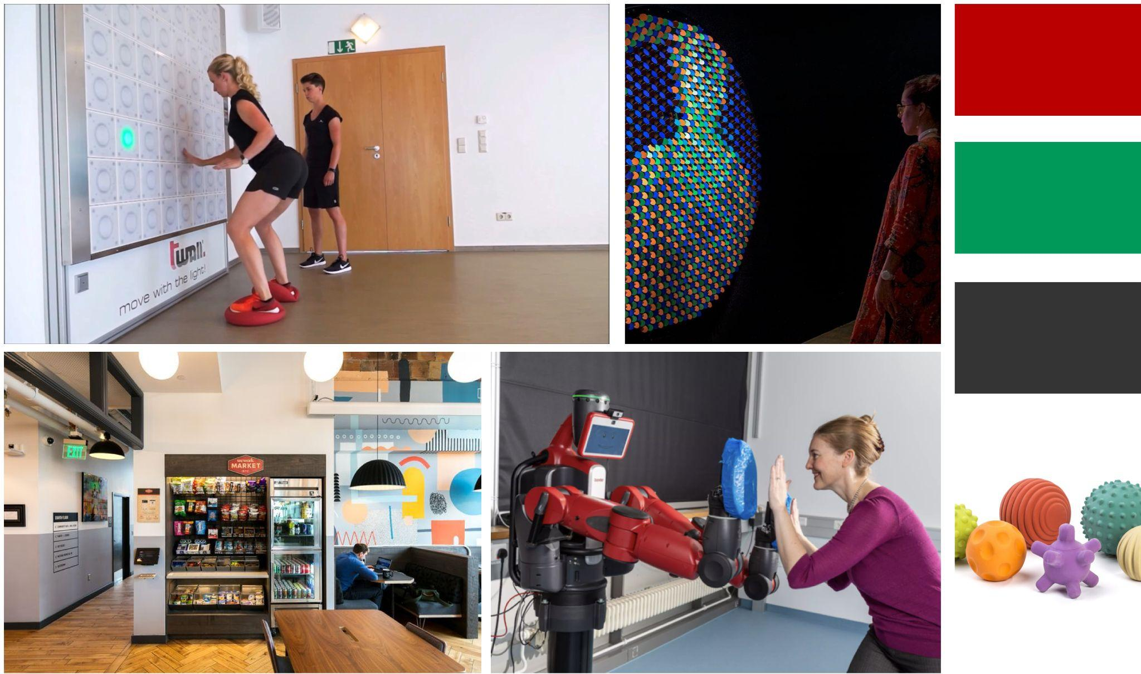

### Cardboard Models

In connection with the previous paragraph, each team member individually developed a model, both to scale and full size, inspired by their own vision of the project.

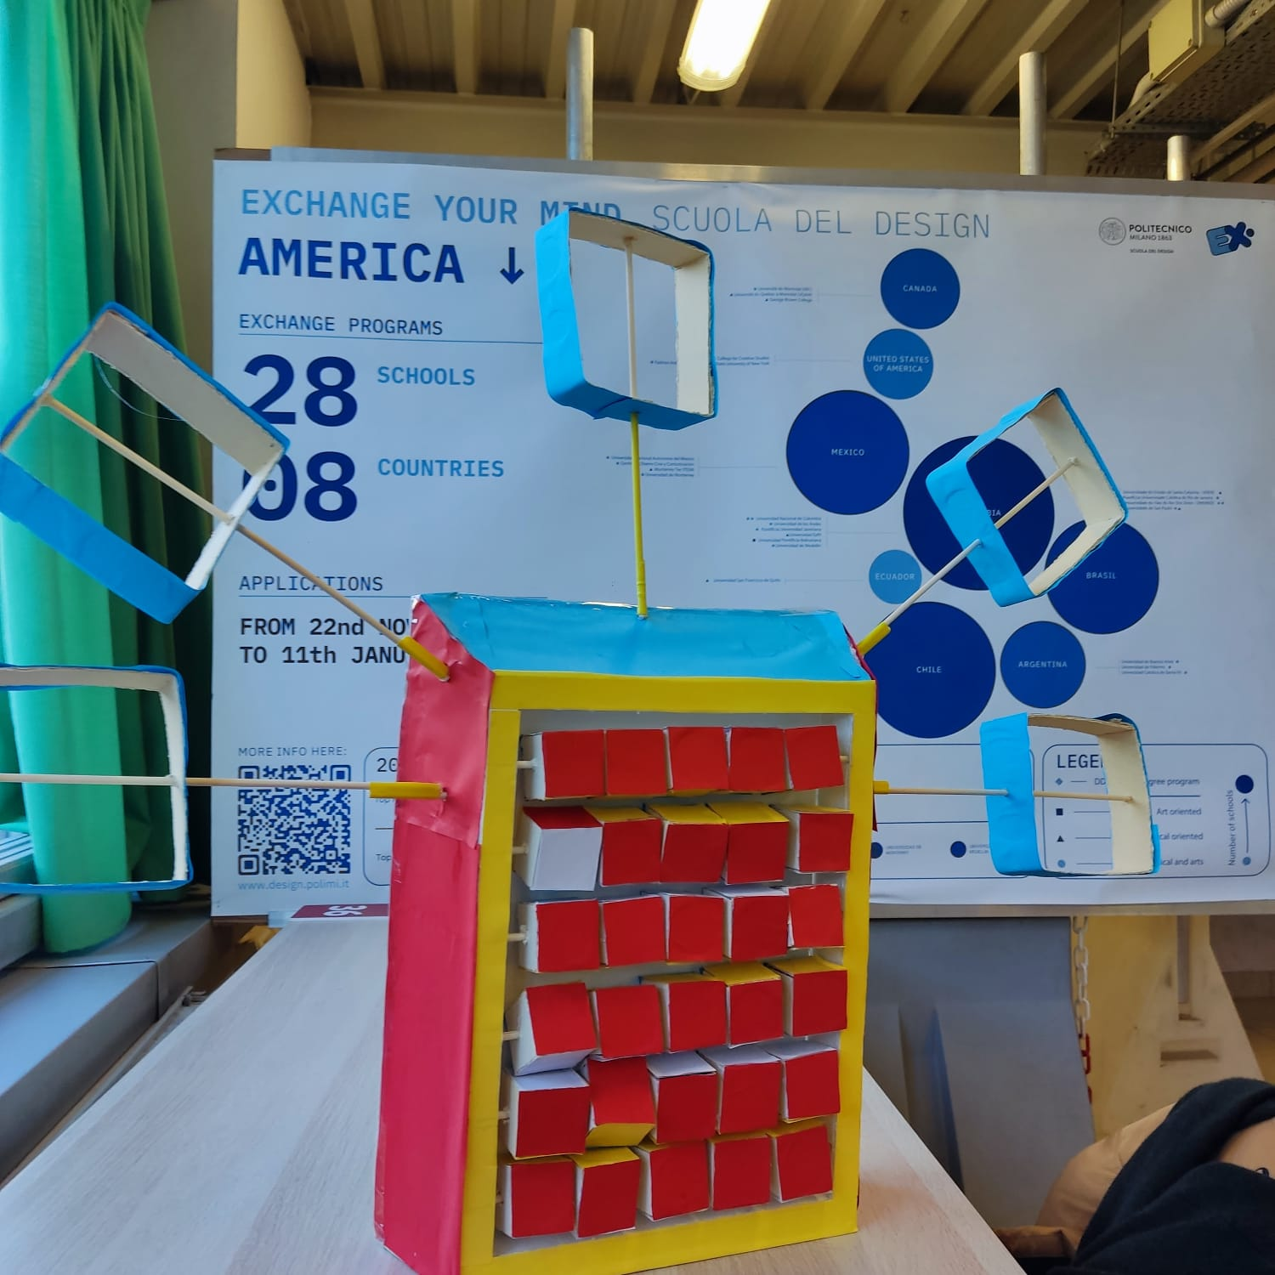

This concept was inspired by the interactive art project RGB Peg Mirror (Daniel Rozin, 2023). By mechanically controlling 1555 motorized aluminum pegs, RGB Peg Mirror reproduces a full-color reflection of the viewer.

The prototype's colors were chosen to blend in with the interior of Politecnico di Milano's B2 building. There are 30 cubes in the prototype, each of which comes in four colors: white, blue, yellow, and red. By changing the arrangement of colors on the robot's interface, you can show different emotions and communicate different movements. The other five arms are for sensing visitors' actions, and they can slide as well. A positive feedback will appear if the user places their body in front of each arm. This structure is not capable of vast range of movements but it can ask users to perform some simple stretching tasks.

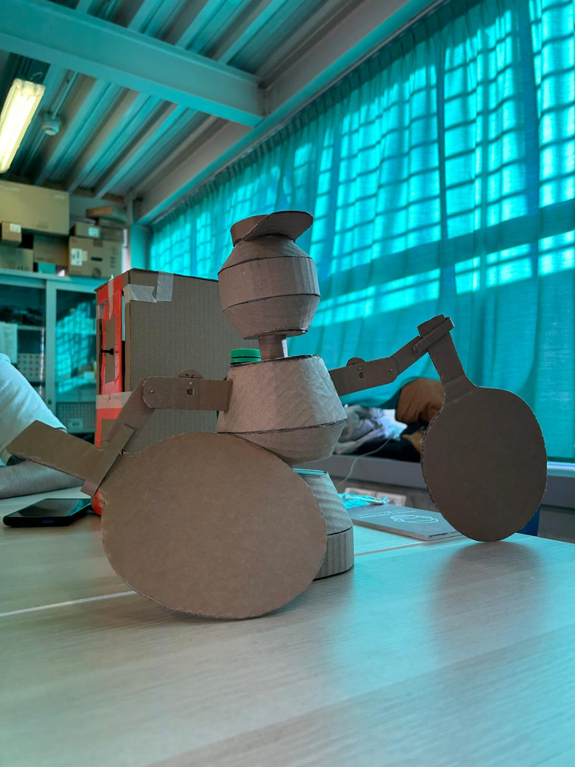

In this case, a robot has been proposed whose main purpose is to attract two users and entice them to play table tennis. through the movement of its torso, it attracts the attention of two players in the vicinity of the table tennis table, after which they independently pick up the table tennis bats and the ball placed in the hat. In order to keep track of the points scored, it is possible to touch the two arms to progressively change the score. During the game, the robot interacts by making cheering sounds with a combination of movements.

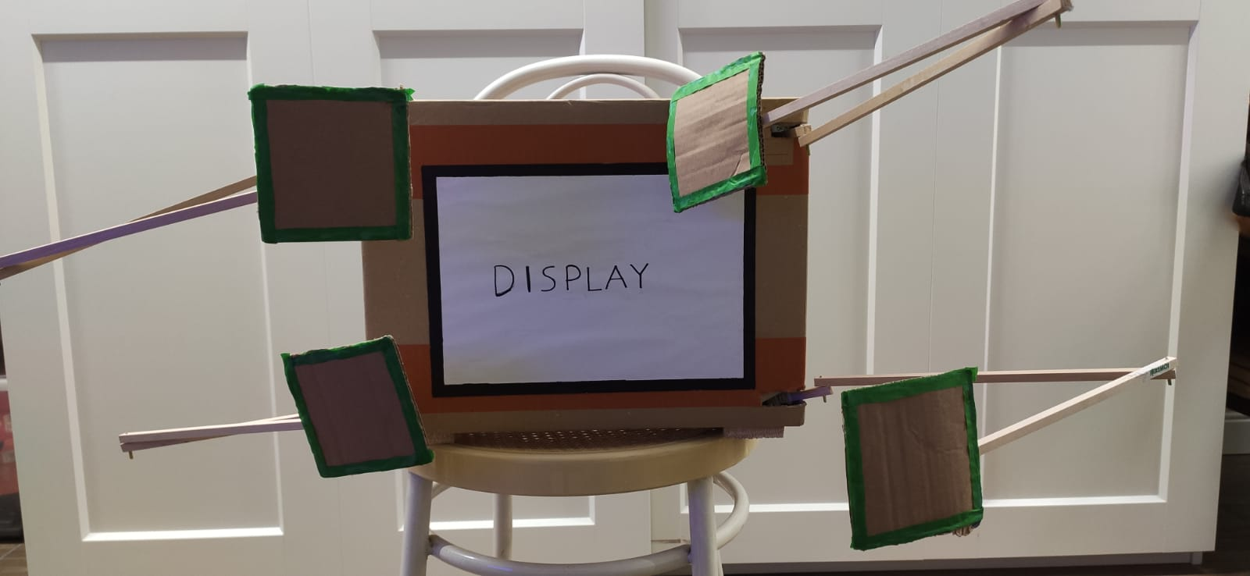

The idea behind this prototype was to encourage movement through interaction between the robot and the user. The robot could achieve a wide range of movements with its arms and, using LED strips on each pad, communicate to the user which pad to reach. To engage the user in interaction, the display could be used to create a leaderboard among various players to encourage competition. The display could also be used to suggest a sequence of pads that the user would have to remember and then repeat to 'win'. Additionally, to meet the requirement of having a trolley-sized robot while still allowing for the widest possible range of movement, the arms were designed to fold up against the sides of the robot and hide in sleeping mode.

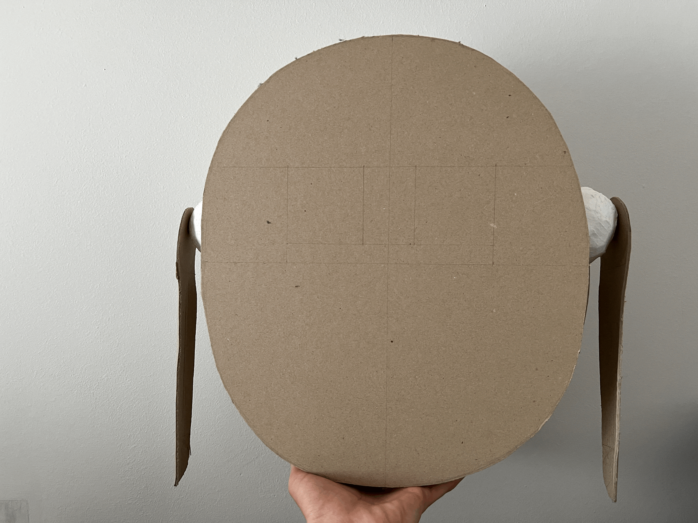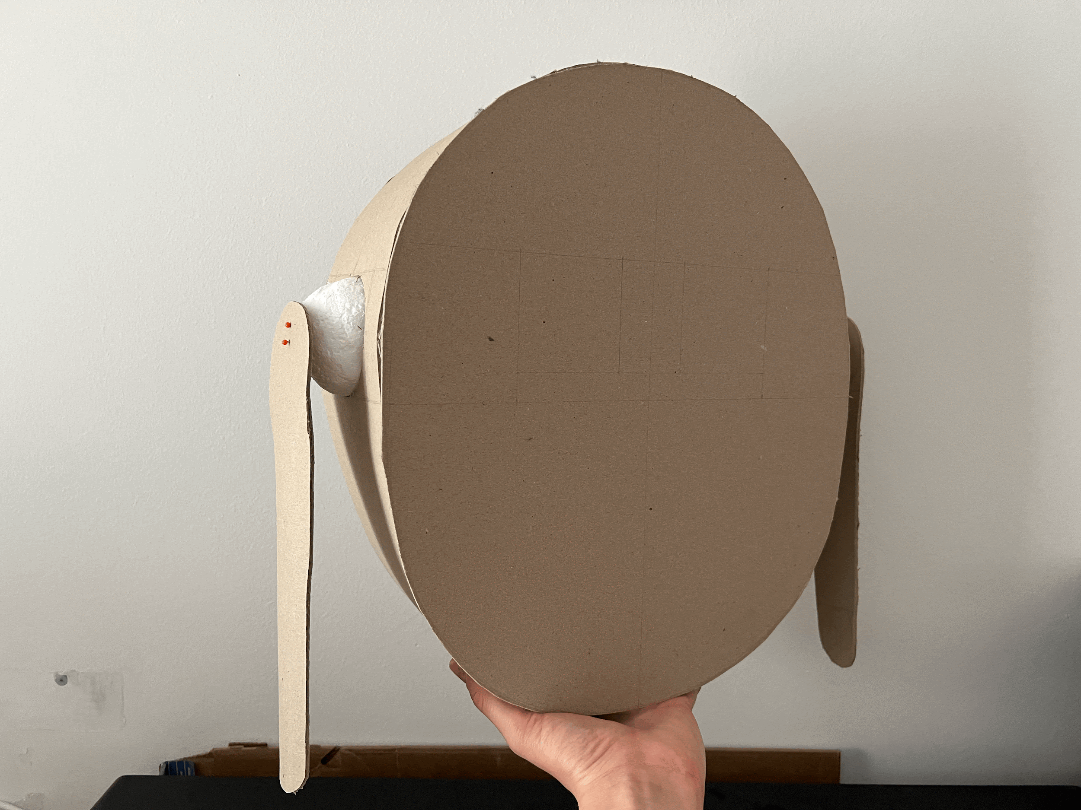

A wall-mounted robot interacts with users via a mirroring game, teaching them movements to recreate, the arms are connected to the body via a ball-joint-like structure to ensure maximum movement availability, and the eyes were drawn on the front of the body to give the user visual feedback on the movement correctness, suggesting different emotions based on the user performance.

Subsequently, each model was analysed from a functional and production point of view. It was concluded that none of them was effective enough in engaging the user in physical movement. The first had a high level of production complexity, the second was found to be an assistant during the game without directly interacting during the interaction, the third one was probably going to be too complicated to develop, making the arm impact-resistant when the user touches it, yet small enough to be foldable; the fourth one was considered as weak in user engagement in the initial interaction phase and needed extra thought interaction design-wise.

Once the previous models had been set aside, during a brainstorming session we tried to develop new options integrating all of our ideas and the proposal of a robot equipped with a spirit level emerged. Starting again from the idea of mirroring, the robot should be able to recognise the position of the user's shoulders, that way user could move the shoulders to adjust the spirit level, and the robot would mirror his movements, starting from an oblique position and then bringing the spirit level to a horizontal position. This robot had a dual purpose: to ensure that the user's shoulders were correctly positioned and to satisfy a common mental need, namely to centre the bubble in the central area of the spirit level. An additional idea to make the robot more interactive was to substitute the spirit level with a string of LEDs, instead of having to centre the bubble, the user had to fulfill the light strip by moving it to a horizontal position. Even though this idea was not completely satisfying our purpose, we all agreed on pursuing the mirroring interaction, as it was proven effective and seemed to satisfy our idea of interaction, making it easier from a mechanical point of view (as the robot would not need to withstand the user touch force), and making it also easier to promote group work.

## Robot strategies

Putting together all the collected data and taking into account the different ideas we had, we asked a physiotherapist and another set of desk research for help.

## Functionalities

### Location detection

Thanks to the survey carried out within the Candiani Campus, we were able to identify a strategic place where students gather during breaks. Instead of preferring an outdoor space, which would have presented several problems such as location and mode of attraction, as previously said, we decided to place the robot in coffee rooms. They are the ideal environment for robot placement, as it is possible to achieve a high number of interactions with the users and thus achieve a high level of engagement. As the presence of food and drink dispensers attracts a large number of students, the consequence is that long queues are generally created. Precisely for this reason, the robot will be positioned in the proximity of the vending machines to allow interaction while queuing or after the consumption of drinks.

### Movements

At this stage, we asked ourselves what the main movements that the user would have to make during interaction with the robot might be.

From a functional point of view, we discarded the movement of the lower part of the body so that we could focus more on the upper part. The students mainly reported problems with those parts, and the legs are already reactivated by walking. Therefore, we decided to focus on the movements possible with the arms, and thus indirectly of the torso and the neck.

We went back to desk research to better understand which movements were suggested by the experts to easily stretch the body while working. Studies have shown that today those who usually work or study at their desks are generally exposed to prolonged sedentary behavior associated with computer use. The repetitive strain on the musculoskeletal system is caused by the use of inadequate ergonomic equipment. This situation increases the risk of chronic neck and shoulder pain, which is why specific stretching movements have been devised to reduce muscle stiffness. The following movements are suggested:

1. Put your hands together, crossing only your fingers and turning your palms outwards. Then stretch your arms out in front of you, engaging your shoulder and neck muscles. Hold the position for 10-20 seconds. Repeat the exercise 2 times.

2. Still holding your hands together in the same way as in step 1, stretch your arms upwards for 10-15 seconds.

3. Put your arms behind your back and with one hand take your other hand and pull your arm down. In the meantime, tilt your head in the opposite direction to that of the arm stretched downwards. Hold the position for 10-12 seconds. Repeat the movement for the other side.

4. Extend one arm upwards and the other arm downwards. Wait 8-10 seconds; then reverse the arms, and wait another 8-10 seconds.

### Feedback

As the study showed, giving feedback to users helps them have a better interaction experience and makes them more engaged during the exercise. Hence, we decided our robot would have visual and sound feedback. To give appropriate feedback, the robot must be able to track and evaluate user performance, so the product will need to have some kind of movement detection section.

# Phase 2: Define

For the purpose of the report writing we will clearly separate the steps via different sections, but given the reiterative nature of the design process, and the diversity of backgrounds in the team, the “define” and “develop” stages of the process tend to fade into one another at specific points, as we decided to organize the work in parallel tasks, where the resources in the team where working on separate tasks individually to then discuss the results and provide the adjustments needed.

## Strategy

With an initial set of functions and constraints in mind we started defining the robot shape, product architecture and user interaction,, this way we were able to send out a BOM with all the components needed to fulfil the requirements and then move on to the development, trying to check the feasibility of every idea while we were going on.

**Interaction**

As the robot has to engage the users and change their behaviour, we started designing basic interaction steps related to the product and its interactivity. While doing that, we discussed possible shapes that could follow the required interaction steps.

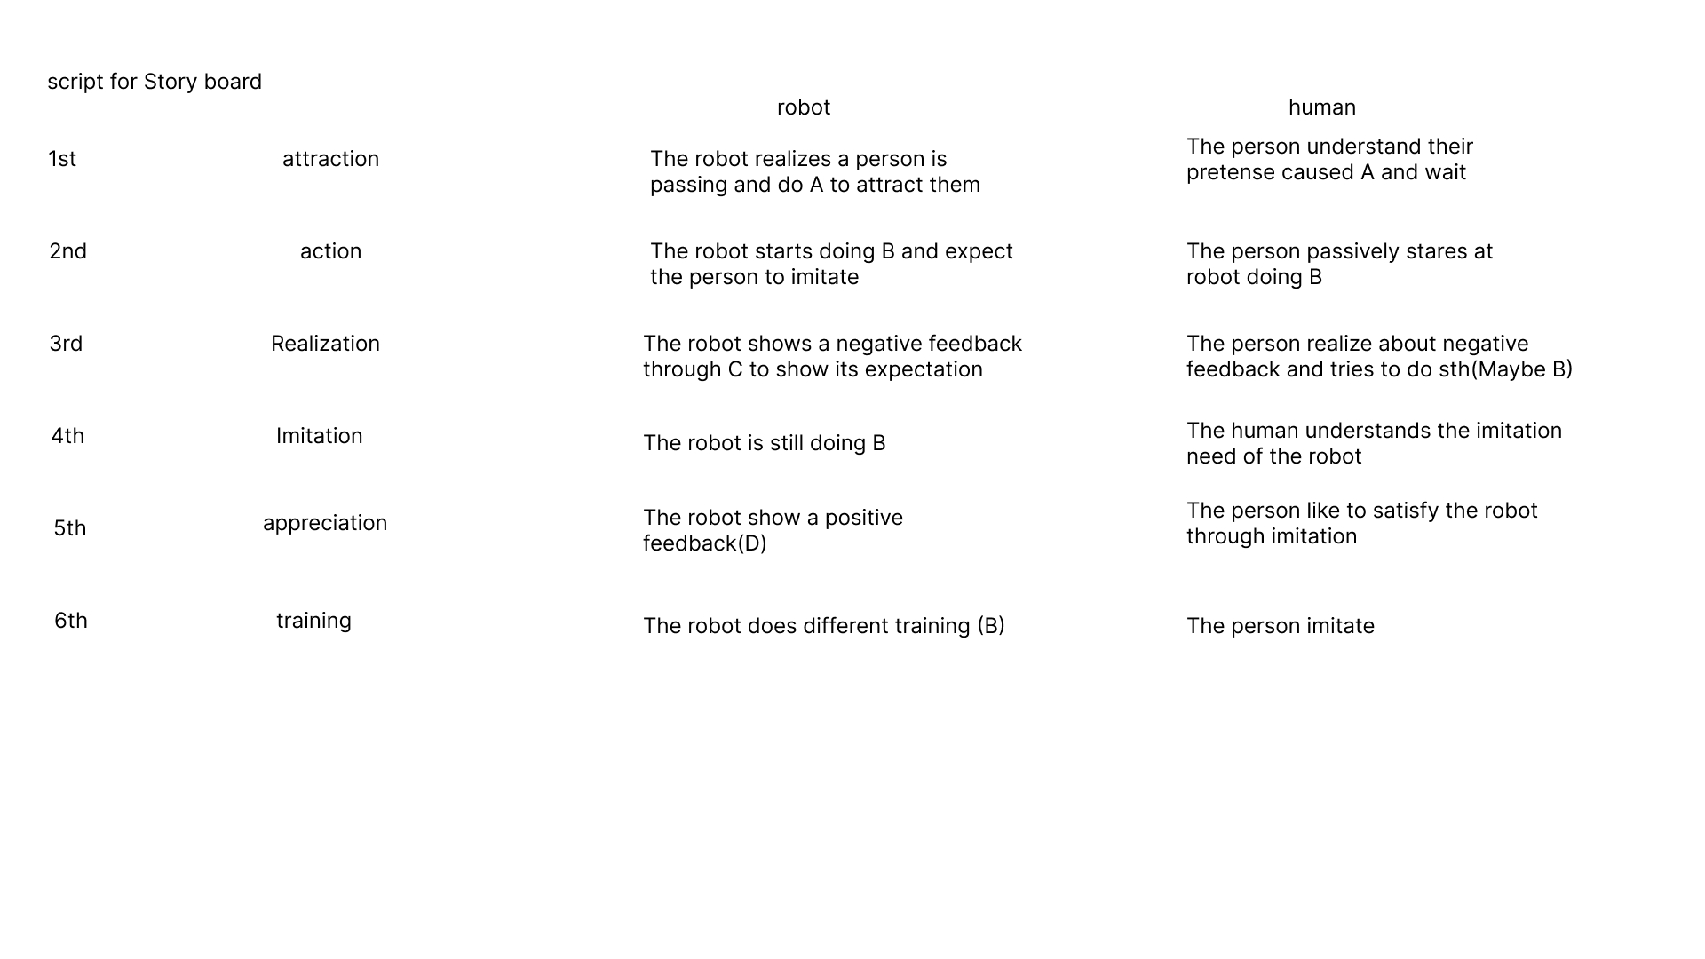

Eye LEDs: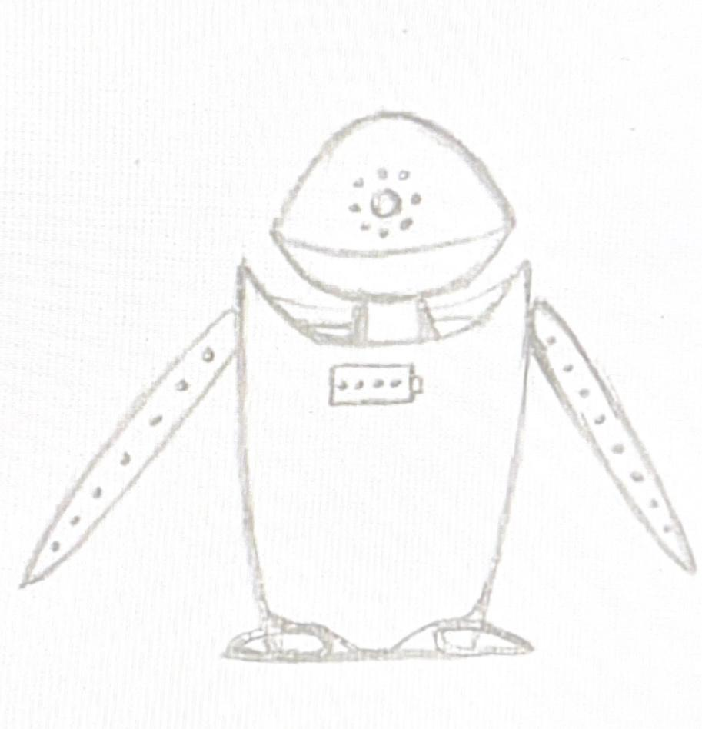

* Display a progress bar for the current exercise.

Arm LEDs:

* Display a movement correctness bar.

Battery LEDs:

* Illuminate as a reward when you complete a level, increasing the robot's battery level.

**Behaviour:**

1. The robot looks at the nearest person's face and signals with its arms (e.g., a salute or invitation).

* If the user comes closer, proceed to the next step.
* If the user does not come closer, the robot uses head and arm movements to act sad, and its eye LEDs turn a sad colour. Then, it returns to the first behaviour.

2. When the user engages, the robot acts happy, including bouncing on its feet.

3. The robot performs movements, lighting up the arm LEDs each time it achieves the desired movement. For each completed movement, the eye LEDs light up progressively like a progress bar.

* When the progress bar is complete, the eye LEDs blink, and one battery LED lights up. The robot then moves its head as if looking at the lit LED and acts happy.

4. The robot points at the user with one arm, the eye LEDs reset to one (start), and the robot assumes the initial target pose. The game for the user begins following the behavior in step three (tutorial step).

* When the user finishes, another battery LED lights up, and the robot acts happy. It then proceeds to the next, more difficult level.

## Shape

Initially, defining a form that would convince the user to interact with the robot and understand what it should do was difficult.

Taking from the research, we knew that users preferred humanoid or zoo-morphic shapes, so we evaluated three possible design paths, and we are going to show the more interesting ideas we got:

### Naturalistic design

We drew inspiration from the surrounding nature, leading us to search for an element evocative of the concept of imitation or research. Emerging with particular prominence, the sunflower presented itself as an inherently fascinating choice, mainly due to its ability to precisely follow the movement of the sun. This feature aroused immediate interest, as it could act as a non-verbal communicative vehicle, conveying to the user how to interact with the robot.

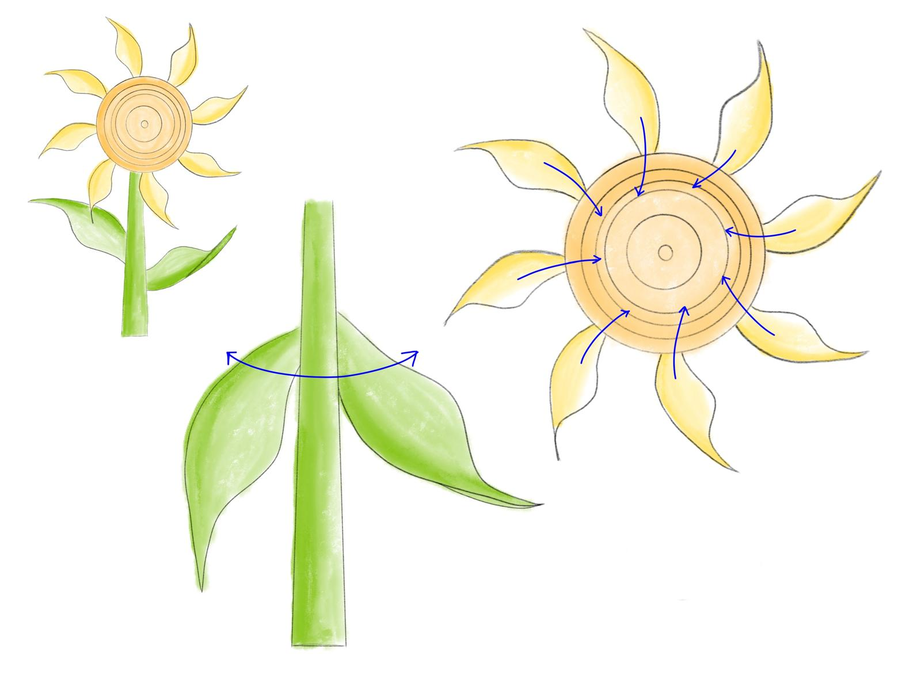 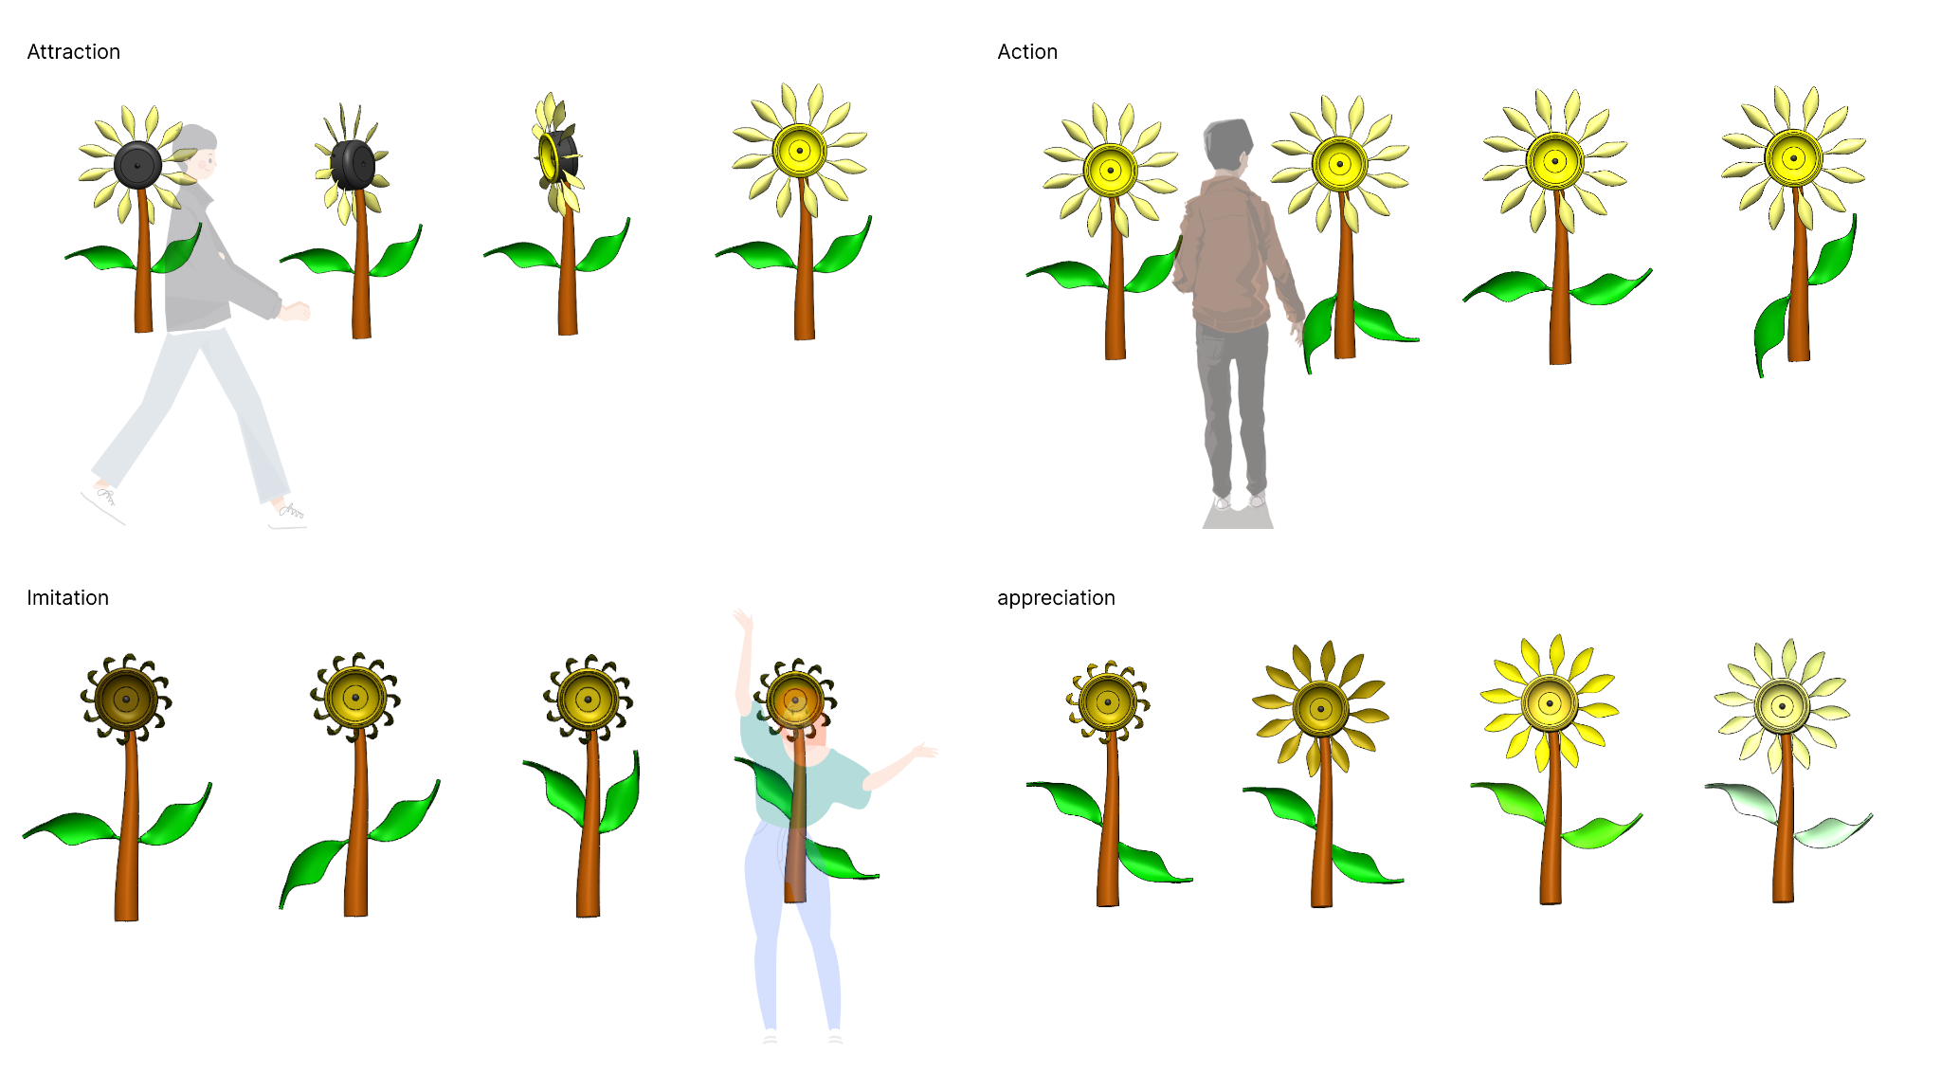

In this concept, the centre of the sunflower would store the movement observation component, the petals would be used to give feedback to the user (thinking specifically about the use of smart materials for them to shrink and expand or to direct themself in different positions), the leaves would act as “arms” to show the user the movements needed.

### Animal Design

Exploring a zoomorphic design we were inspired by animals found in nature by looking for a creature that they could imitate. The parrot is known for its imitative and repetitive abilities, in this case, the idea was to make use of the shape to put a camera in the eyes, and to use the wings to convey the different movements. This idea, even if initially good, was discarded because of a cognitive problem, indeed the parrot is commonly known for verbal repetition, not physical one, and we worried about the event of users being tricked by the shape into trying to engage in verbal communication with the robot and then not understanding the overall concept of the product.

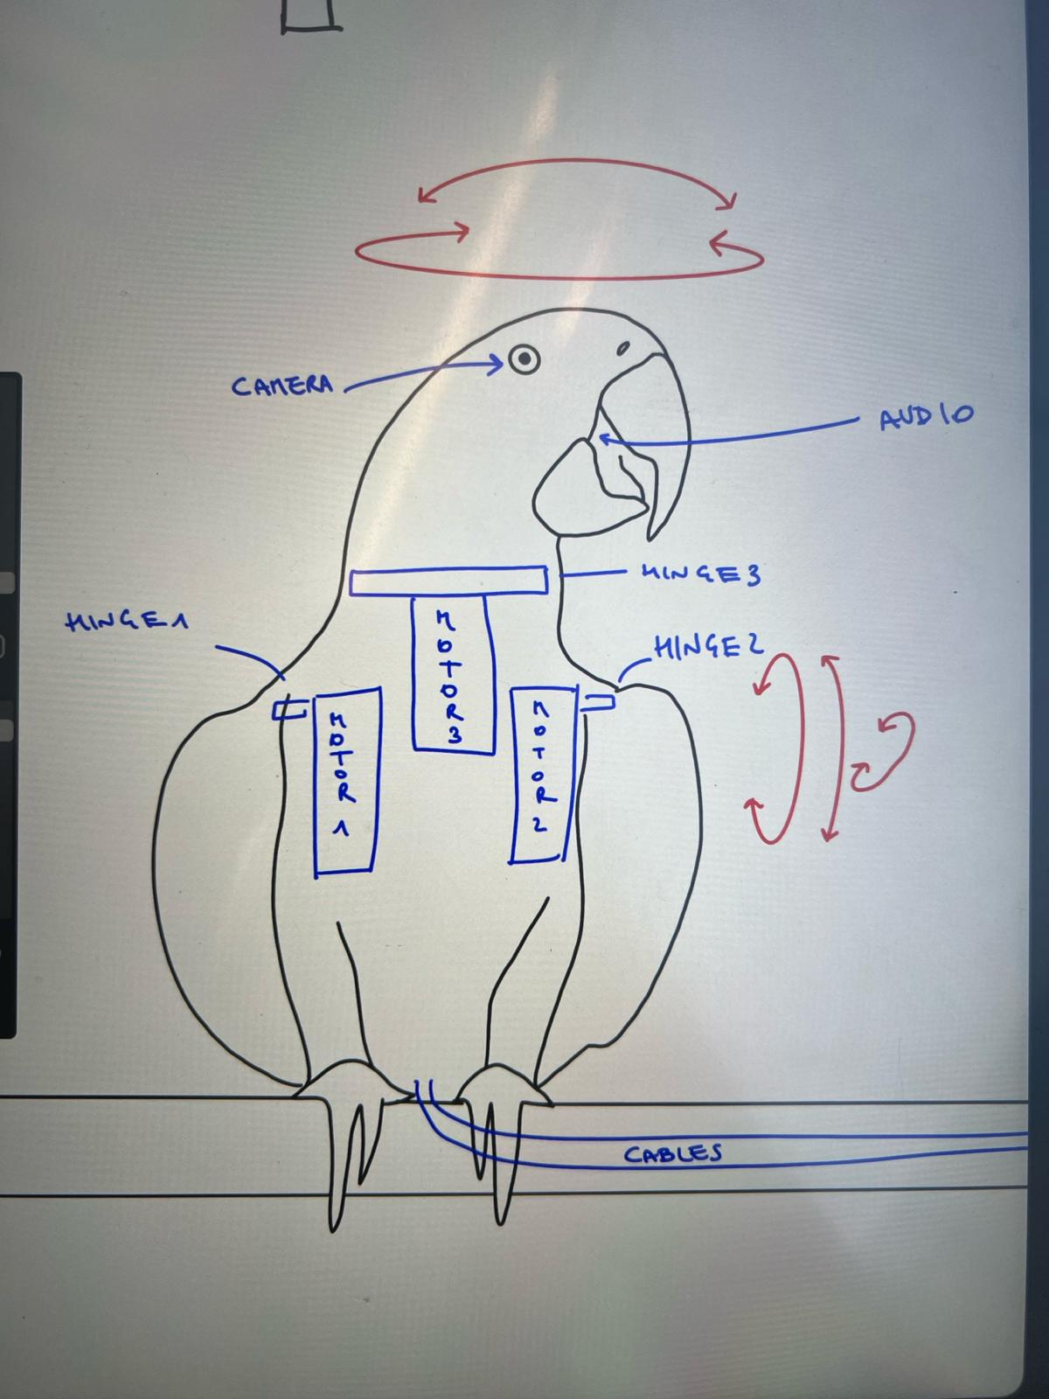

### Minimalist Design

Another path to follow was the humanoid shape. In this case, following the users’ taste, we wanted to make it cute. The first reference that came to our mind was the Eve robot from the well-known Wall-E animated film. We particularly liked how that robot presented some humanoid characteristics but at the same time preserved a robotic-looking aesthetic, being able to express its emotions and reactions via different eye shapes and movements.

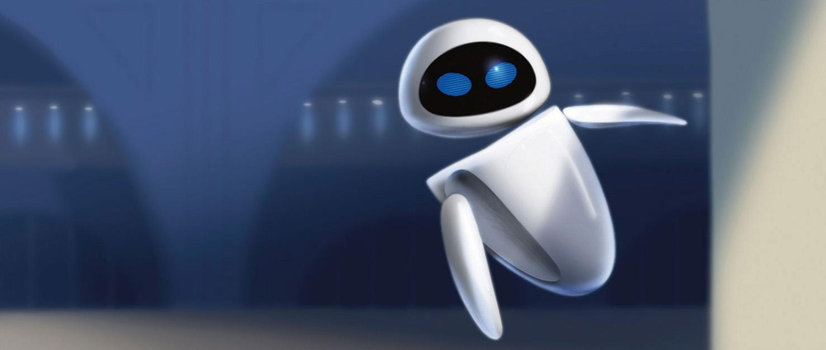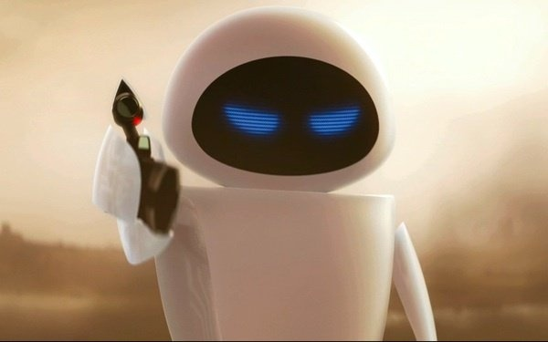

### First Development Step

One feature that makes Eve aesthetically pleasing is for sure the absence of any form of junction points, a feature that we could not replicate in any way, for that reason, we decided to move on with a determined reference shape in mind and started working in parallel developing and testing mechanical solutions to have a clear idea of the physical constraints we had and to better define the aesthetic of the robot while working on the product architecture.

As previously discussed we decided to only train the upper body parts, leaving the legs as an unsolved part of the robot; knowing that our robot was going to stand on a support of some kind, we decided to take the legs into account but making them virtually unusable. During this thinking process we noted parallelism between the aim of our robot (leading the user into following its movements and providing mental and relaxation) and a yoga session, where the yogi teaches how to move into certain positions and people follow said movements. With this new idea in mind, we created a new moodboard to dive into this parallelism and use it for the aesthetic of the product: we related to the world of yoga by using the lotus pose and the lotus flower and then referred to the shape of the eye mask typically used for sleeping, and lastly to the “chill” study environments. This way we shifted towards neutral colours and finishings and integrated the lotus position into the shape of our robot, making it a reasonable way to include the legs in the shape without having to move them during the interaction while achieving a relaxed and welcoming, non-intimidating look.

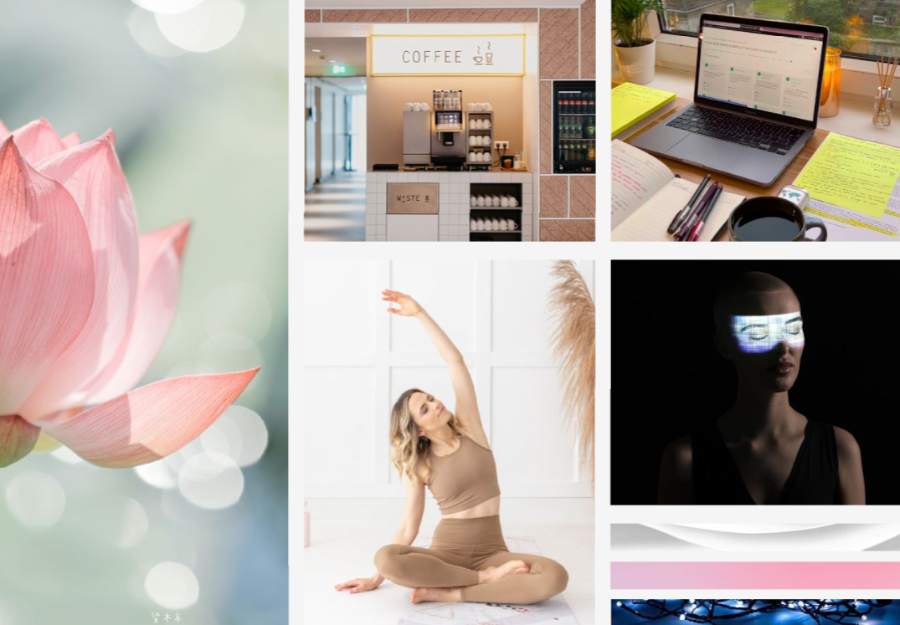

As said, we started working on different tasks in parallel, to test out the mechanisms we had in mind and to check the feasibility of our idea for the look of the robot, the modelling work was a first step to analyse the size of feasible mechanisms and to adapt the model to the technical feasibility. It is with no surprise that the first models done, mainly focused on fitting the internal components, were not aesthetically pleasing, being the first idea of the rough shapes and the mechanism.

The first idea had all the functional requirements we were considering, a head capable of rotation and tilting movements, arms capable of rotating and tilting, crossed legs and a central lotus flower for light feedback to the user. We decided to have both the head and arms moving, to reactivate the most painful parts of the body, drawing from the yoga moodboard previously shown, we decided to put a lotus flower in the centre of the body to provide visual feedback for the time passing. The initial idea was to have a “neck” to control the head movements and the arms with ball-joint-like mechanism. 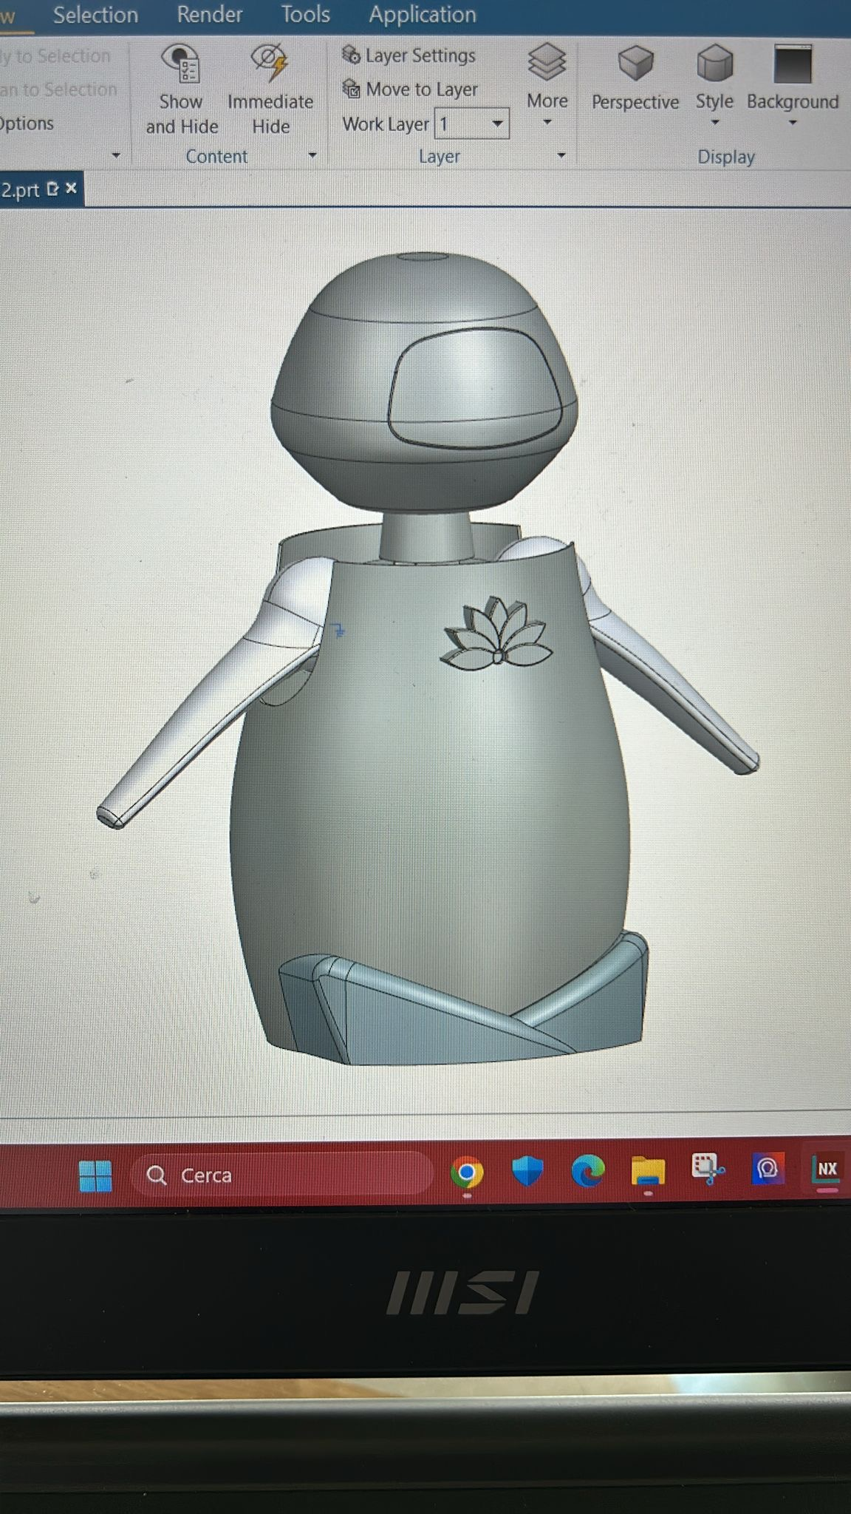

## Mechanical Design

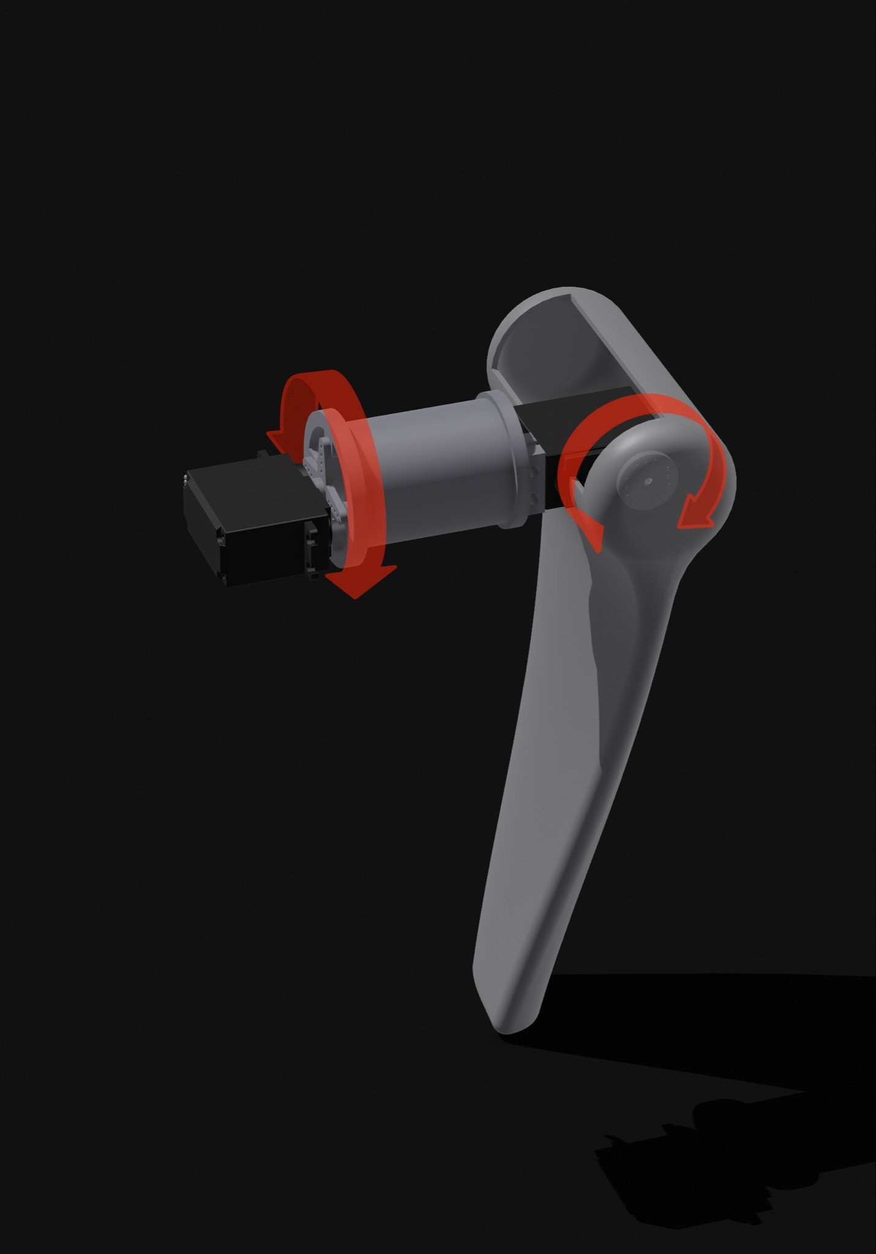

The first mechanical system we designed was one of the arms, as we wanted to recreate a ball-joint-like structure, we needed to ensure the right number of degrees of freedom, regardless of the idea of the ball joint, we needed the arms to be able to perform two sets of rotations, one around the X axis and one around the Y axis, like an arm would normally do around the shoulder joint, hence we created a mechanism with two motors to ensure the two movements.

With this joint, we can obtain all the range of movements taking into account in the movement definition. To check the feasibility of the structure and its weight we decided to make a quick prototype and test it out with the functioning motors.

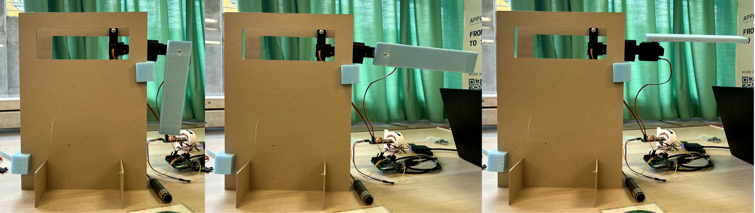

The arm prototype showed the feasibility and the size of the mechanism in real life, in the meantime we continued modelling the head mechanism to prototype it as soon as possible. The head should be able to rotate and tilt in every direction, initially, we designed a system made of rigid plastic structures connected to motors via nylon yarn: we initially started with one idea to connect the bottom half of the head with a centre body able to move the nylon yarn connecting the body to the motor horns in a way that would have constricted the head to move, shortening one end of the yarn on one side and elongating it on the other side. By looking at the model, we thought we found a better way to achieve the same result as the first idea, ensuring better stability, by creating an internal offset shell of the head, we could connect that shell to the motors via the yarn, and from there add a motor on top of the head to make it rotate around the Z axis.

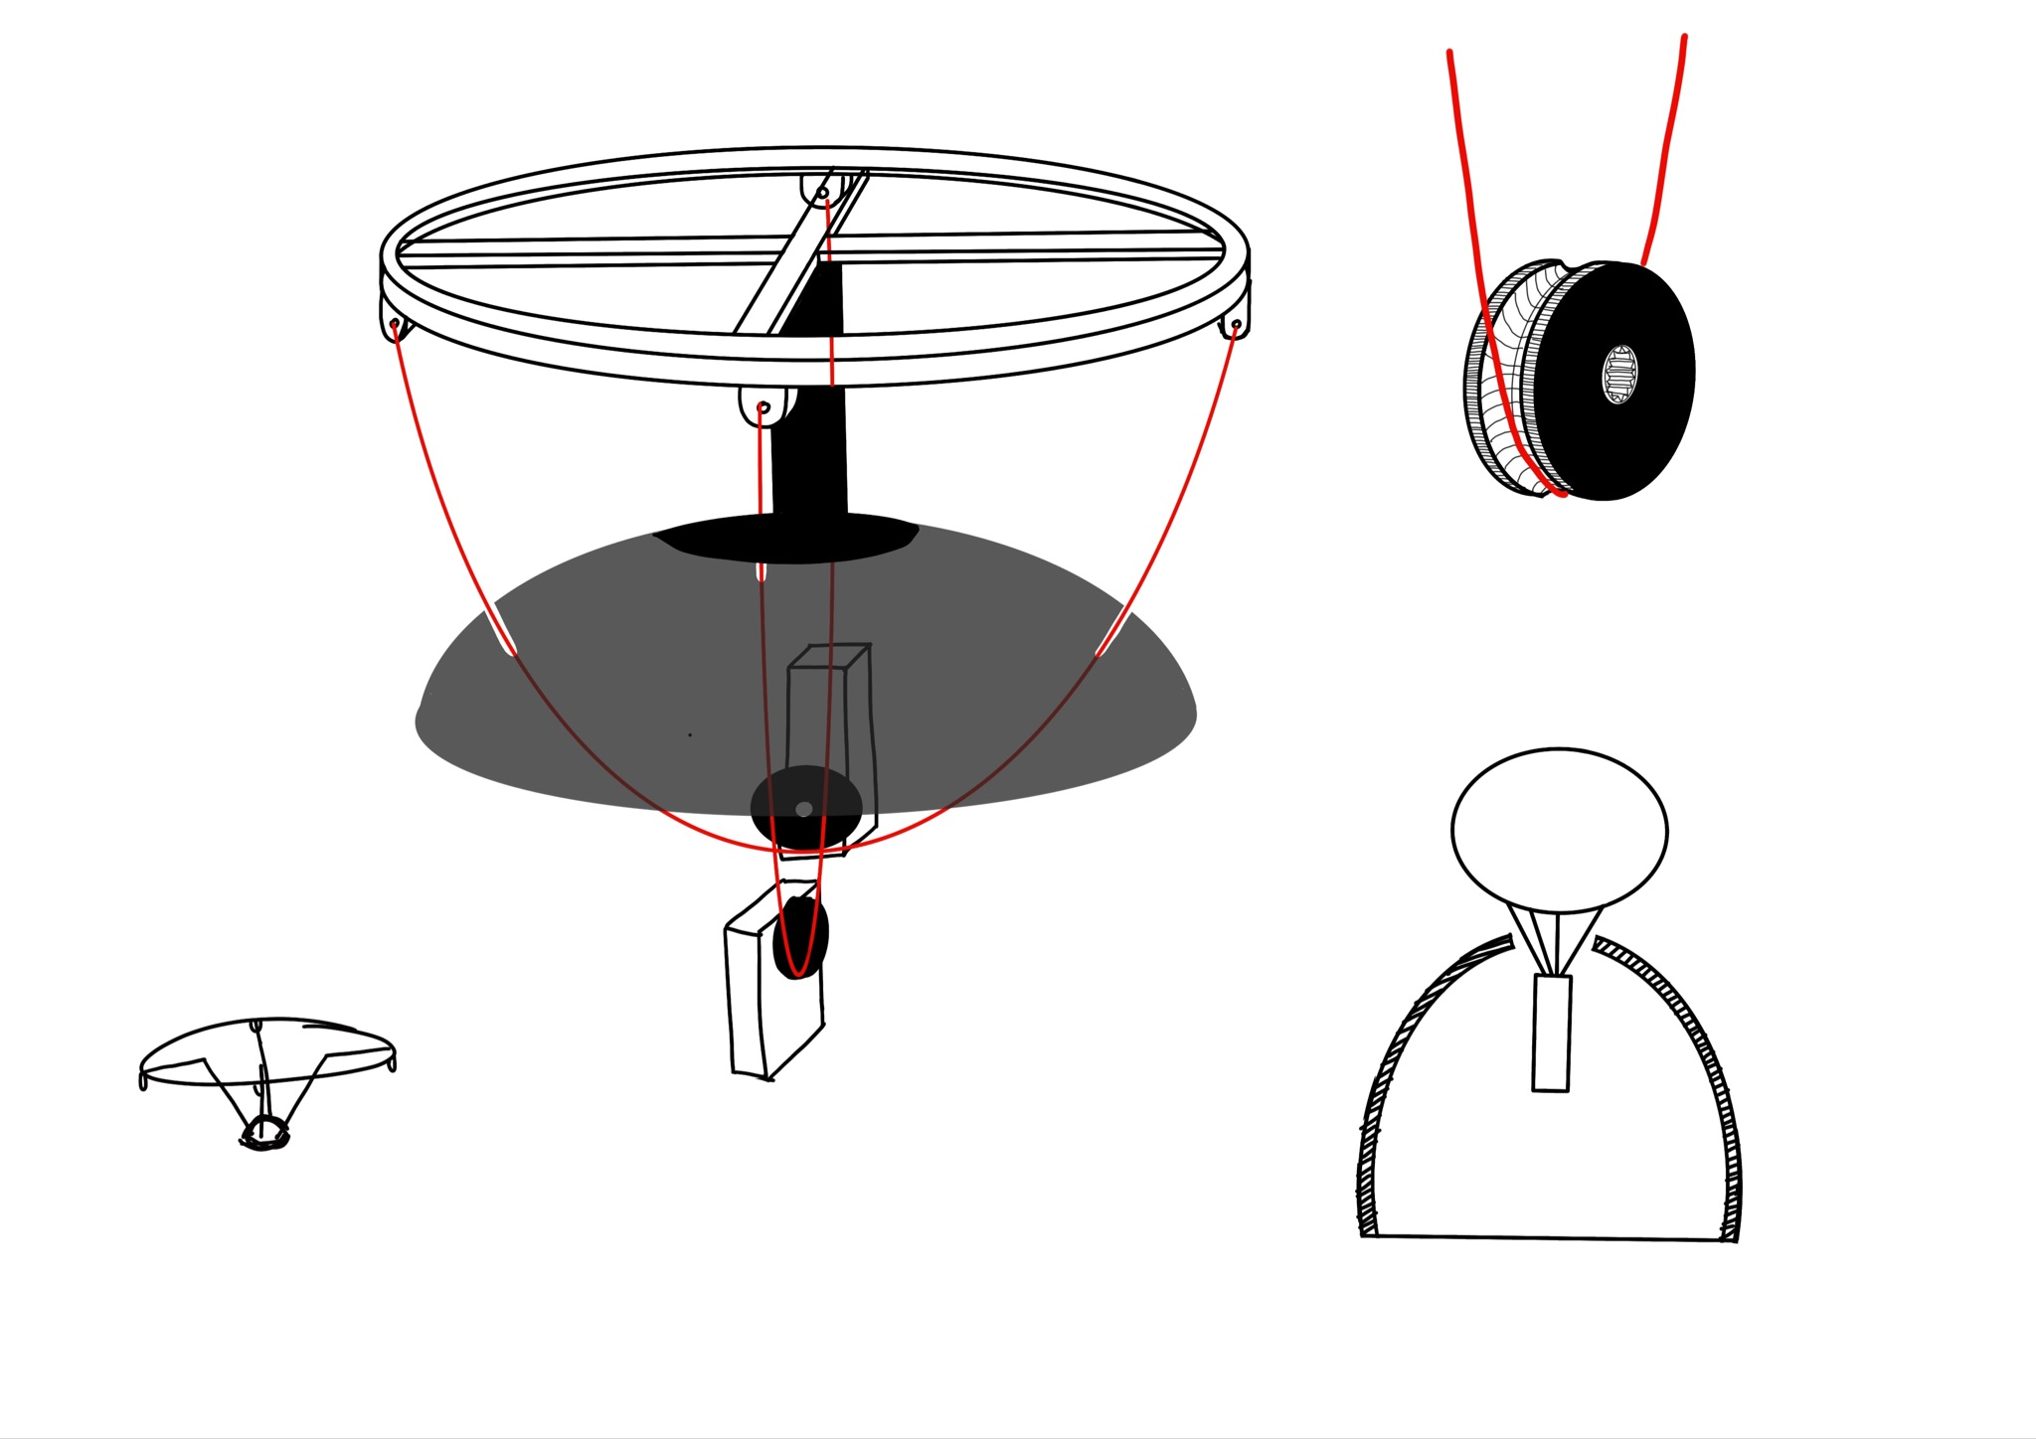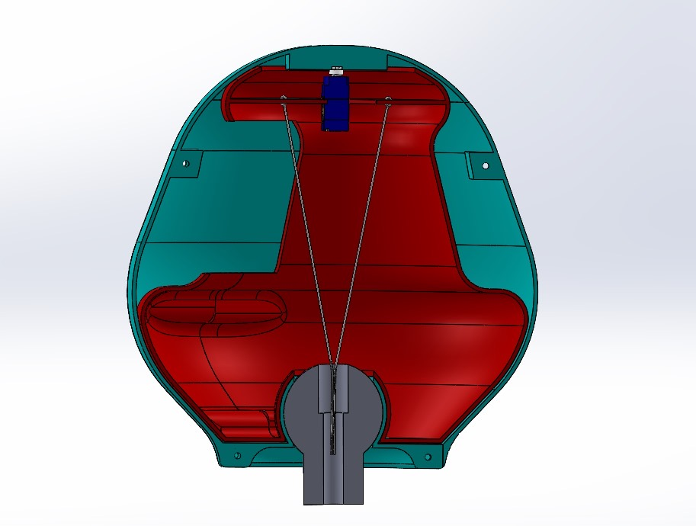

We felt the second idea was overall better and more precise in the movements, but an internal offset shell would have created many problems in terms of ease of assembly and ease of maintenance, hence we decided to reiterate the design and make a lighter and easier-to-assemble version. We decided to go on with the third design and made a prototype to test its feasibility.

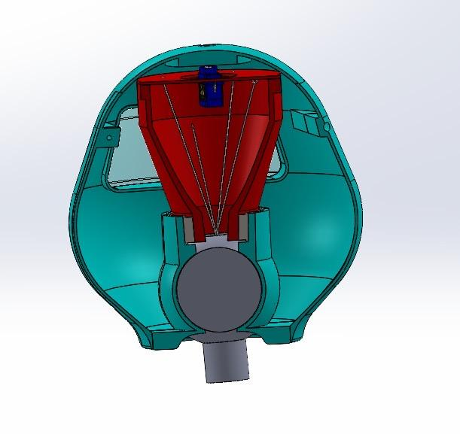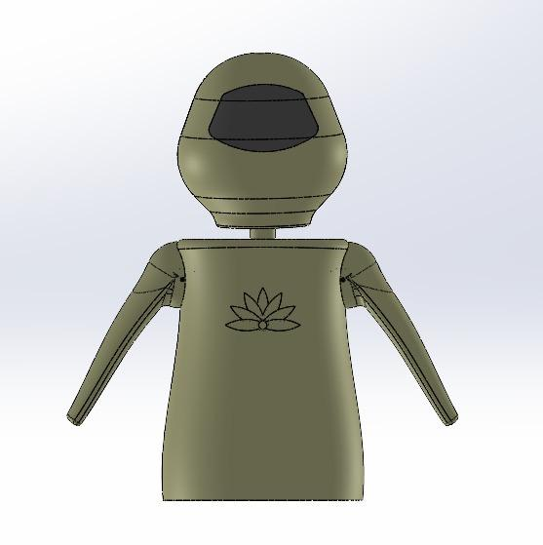

The definition of the new head mechanism slightly changed the product architecture, shortening the neck structure and making the head mechanism lay between the two arms mechanisms instead that on top of them. To make space for the head mechanism we redesigned the functioning arm mechanism by shortening up the “shoulder” component (highlighted in red in the picture), initially created to locate the first motor in the middle of the structure.

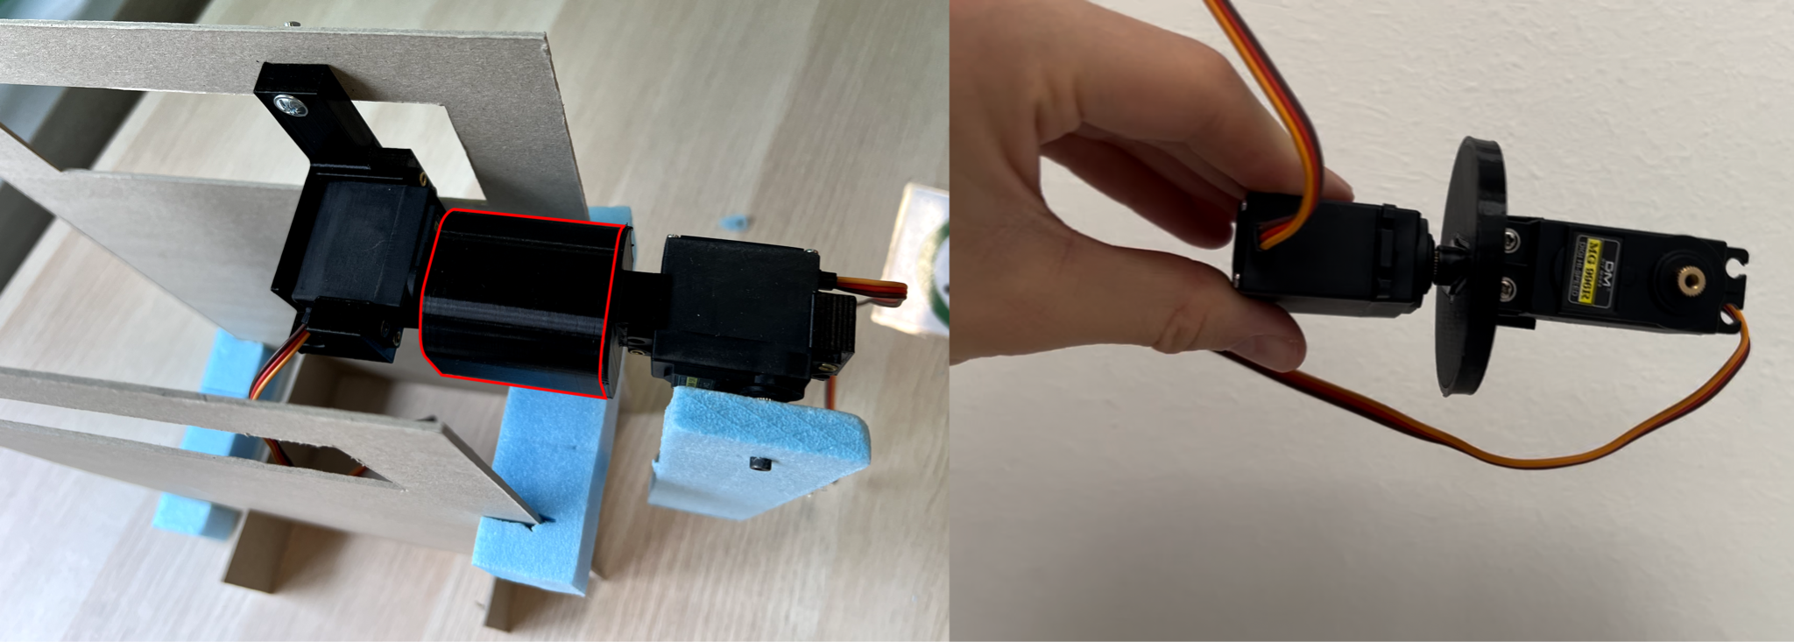

Once the arm was redesigned, the third design was prototyped and tested, highlighting major issues in assembling and maintenance and showing a low friction coefficient between the custom horn and the yarn, failing precise control of head movements.

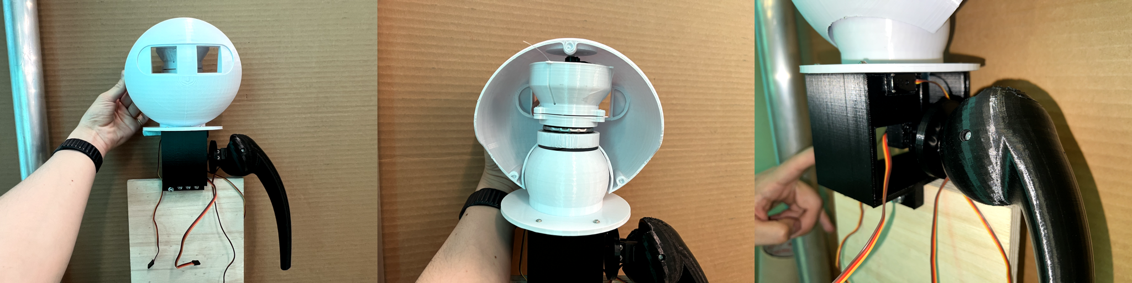

### Second Defining Step

While prototyping and testing mechanical solutions, we went back to shape refinement, once we had a general idea of the size of the mechanism and of the internal components. Based on the following drawing we softened up the shapes of the robot to make it more friendly-looking and softer.

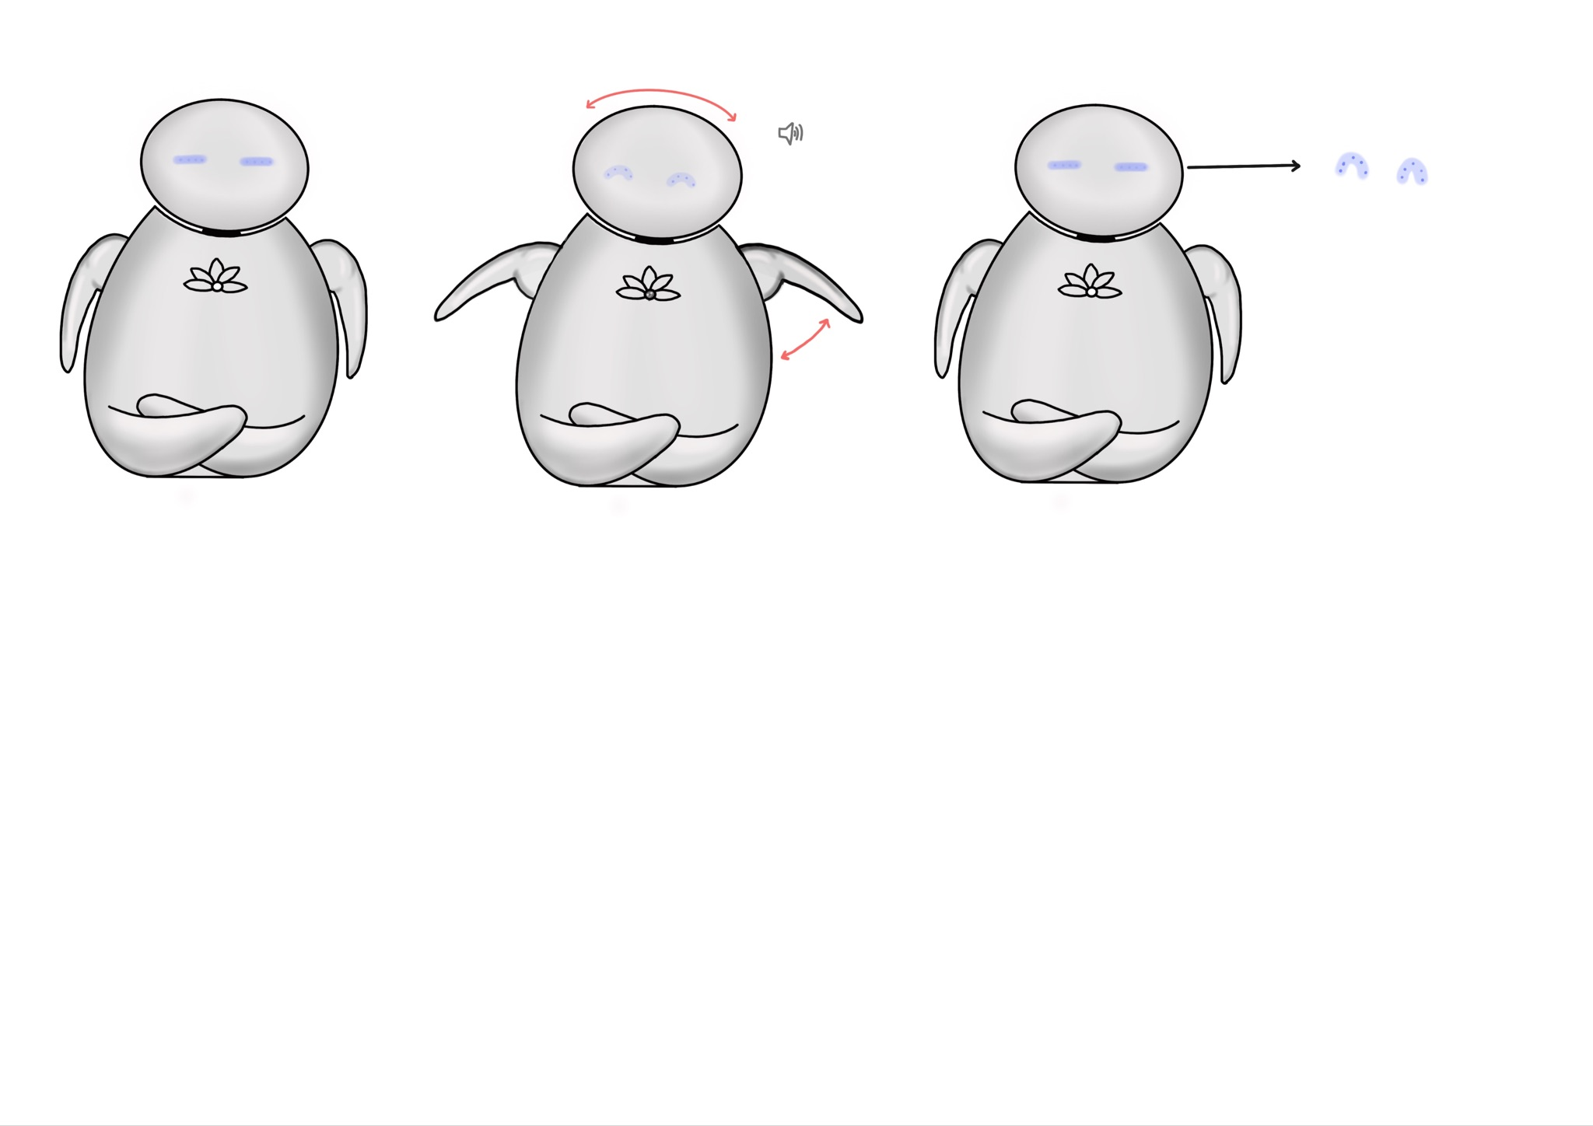

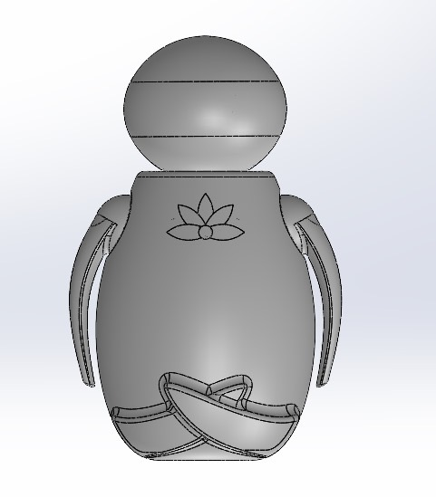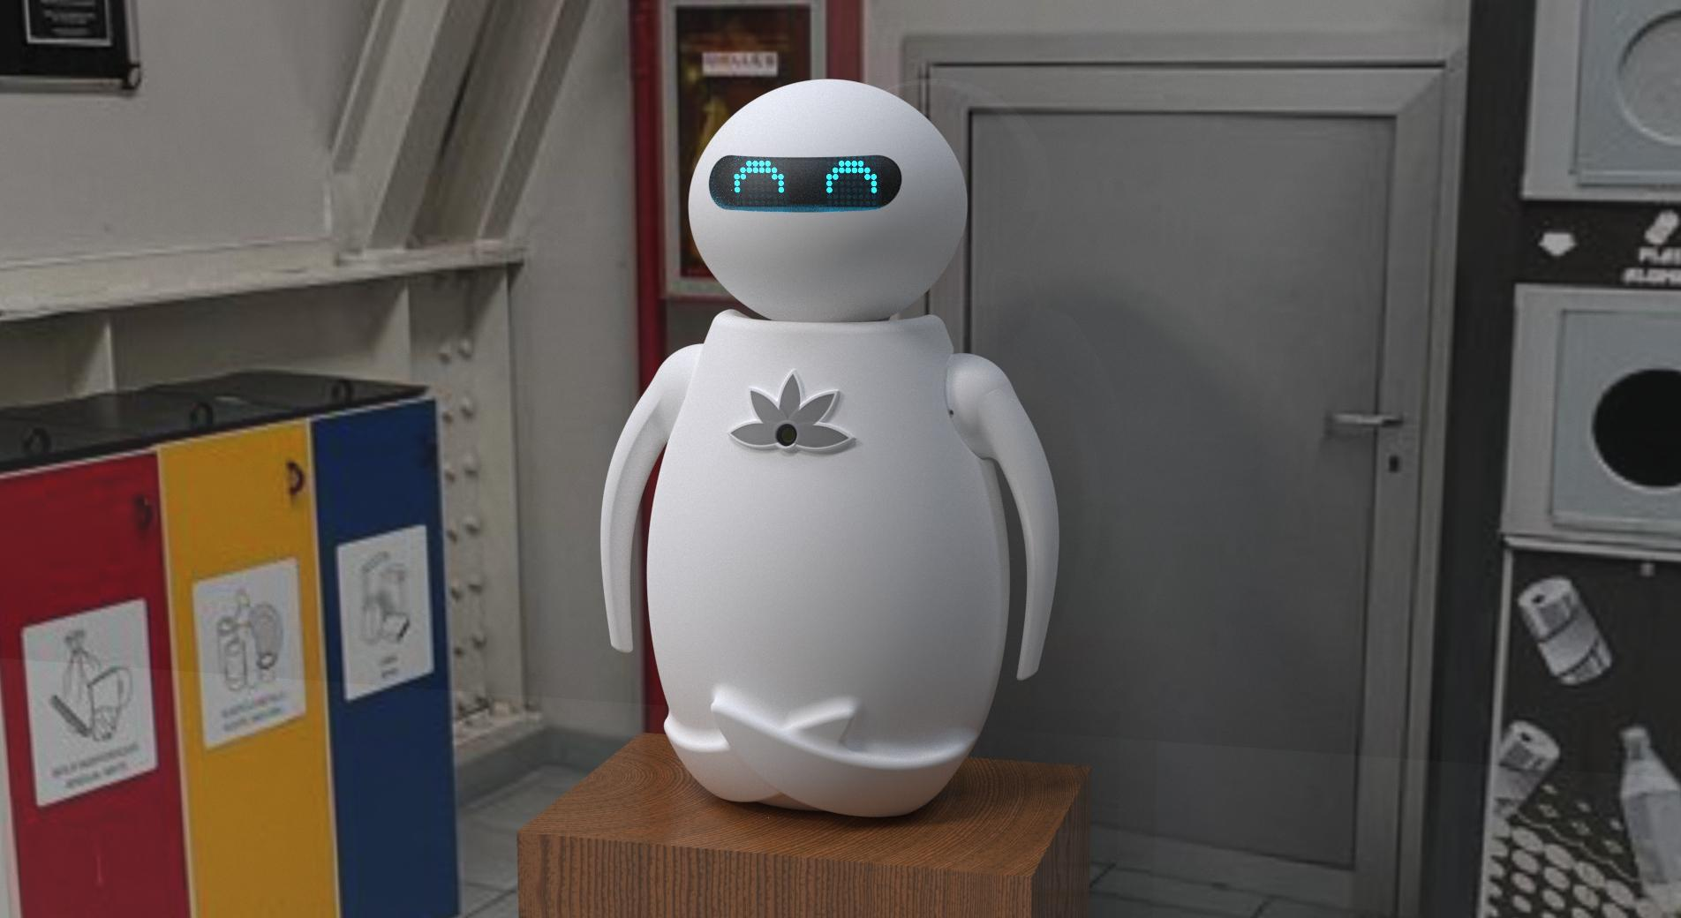

## Movements

### Detection

The Pi camera equipped with object detection and pose recognition AI evaluates the correctness of movement mirroring.

### Attraction

Once switched on, move its neck and arms, for 5/10 seconds, following these specific movements: class A, class H and class M. Simultaneously, sounds of gratitude and happiness will be emitted.

### Interaction

The robot performs a series of distinct movements, divided into three main phases, to complete the user-robot interaction successfully.

The first phase, called stretching, sees the robot perform eleven movements in random order. For practical purposewe have classified each movement into classes:

* Class A (the first of each action): horizontal lateral arm positioning.
* Class B: vertical right arm and horizontal left arm.
* Class C: horizontal right arm and vertical left arm.
* Class D: right arm vertical and left arm lowered.
* Class E: right arm lowered and left arm vertical.
* Class F: bending of the head to the left.
* Class G: bending of the head to the right.
* Class H: right and left arms vertical.
* Class I: right arm horizontally sideways and left arm horizontally forward.
* Class L: right arm horizontal forward and left arm horizontal sideways.
* Class M: general stance.

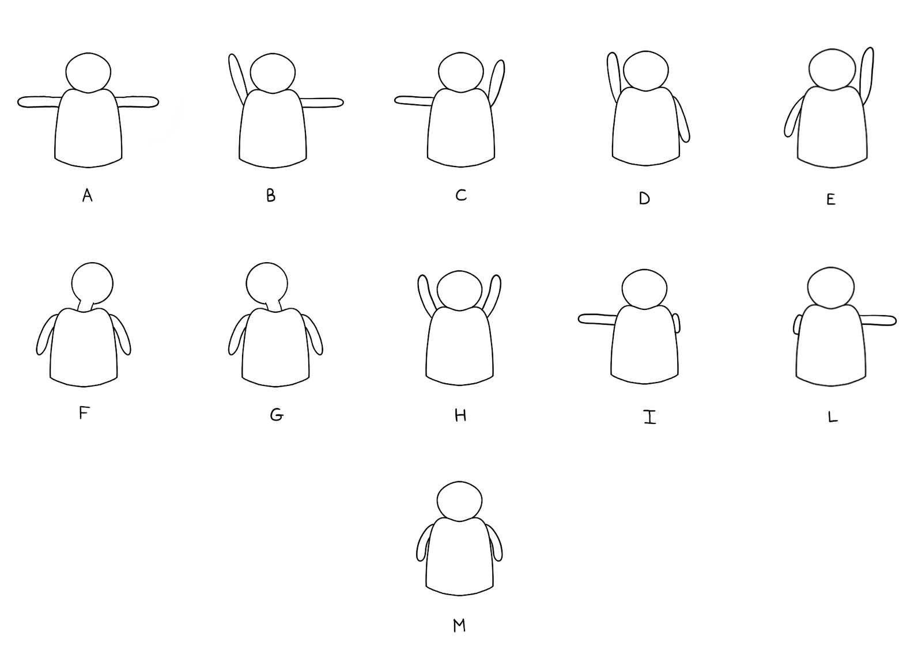

In the second phase, called active, the robot proceeds with 4 random sets of exercises, each of which is characterised by a sequence of movements:

* Exercise 1: class H + class A
* Exercise 2: class D + class E
* Exercise 3: class C + class B
* Exercise 4: class I + class L

Finally, we defined a farewell animation function, which we called ByeBye(), to salute our user and thus signal the end of the interaction. We decided to define a few alternative endings, with a different probability of occurrence, to make the farewell a sort of reward in itself. The most likely outcomes were the simpler ones, one being a salute performed with the right arm, and the other being what we imagined as a Japanese salute performed with a nod of the head. We allowed ourselves to come up with stranger, funnier and much rarer endings to serve as more desirable and attention-grabbing rewards for user engagement in the interaction.

## 

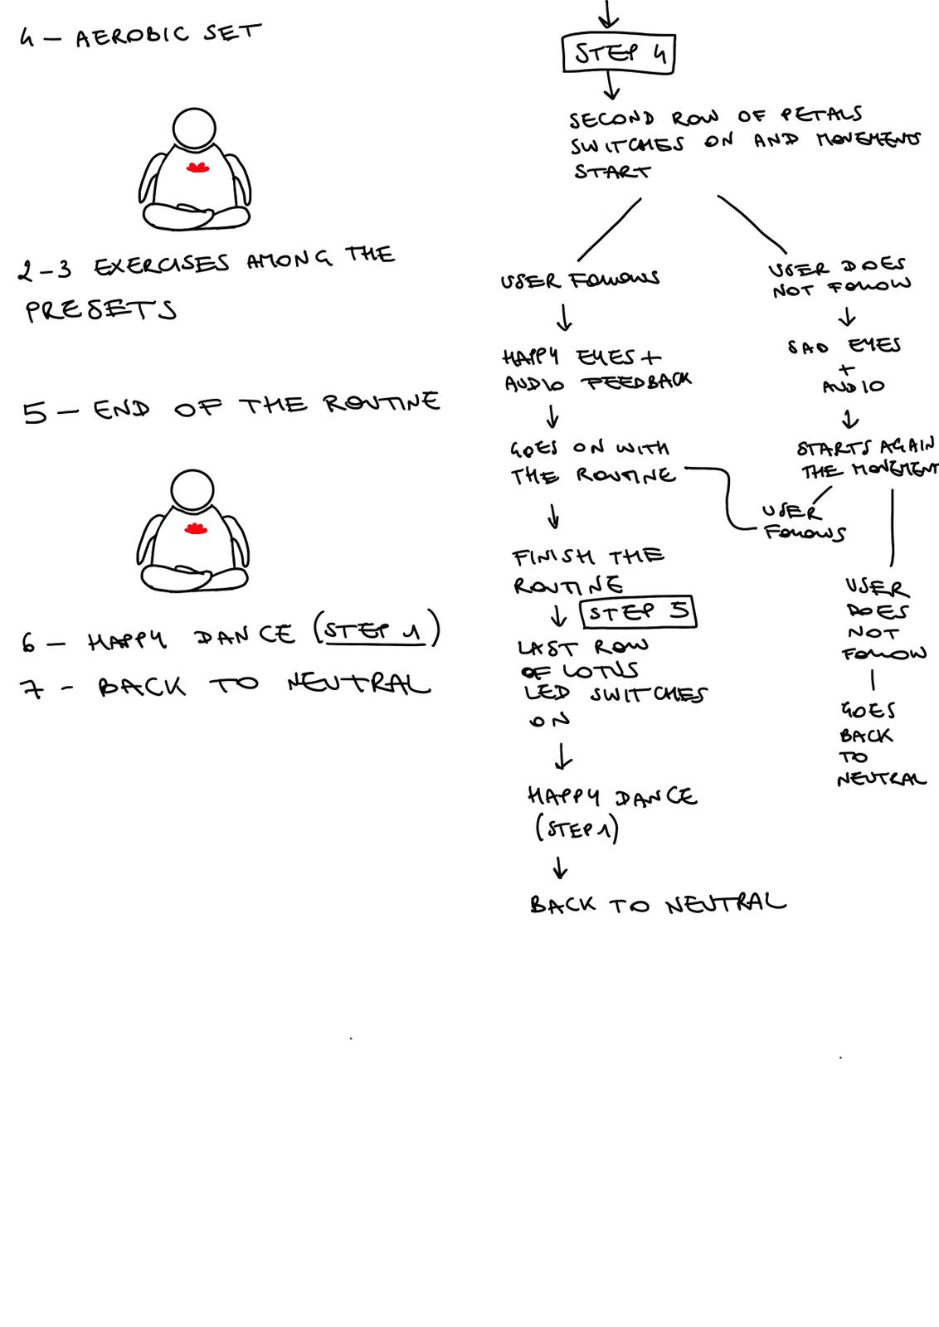

## Expressions

We decided that the robot would interact with the user via emotional expression, as the robot is interacting only via non-verbal interactions, we decided to equip it only with a set of visible eyes and audio feedback, as there was no need for the presence of a mouth. We therefore decided to relate the motion feedback to the emotions of the robot, to do that we chose to use LED dot matrices to show the eyes in a simplified way. We designed four simple eyes to convey a quiet state to show when the user is not interacting with anyone, a happy state to convey positive feedback, a sad one to convey negative feedback, and lastly, a hangry expression to convey the reiteration of negative feedback.

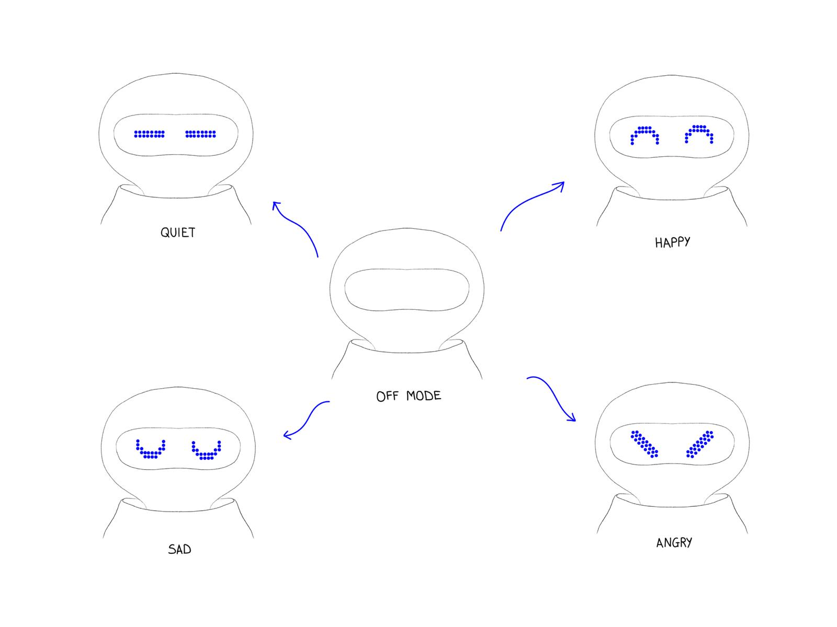

## Concept

The result of the two initial defining phases was the following:

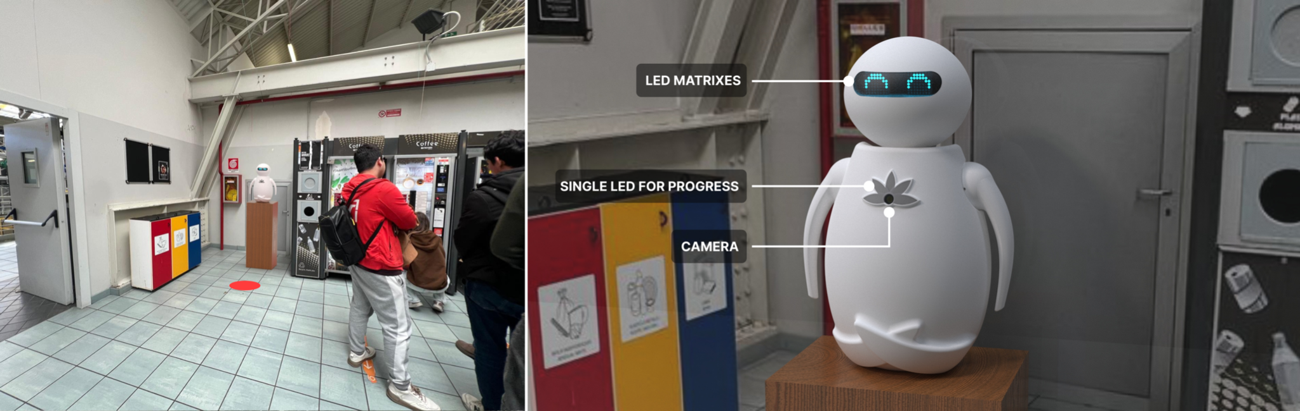

A robot with LED matrices as eyes, a camera to detect and evaluate user movements and a lotus flower to show the exercise progress. Thanks to the arm joint design, the robot is able to perform all movement classes.

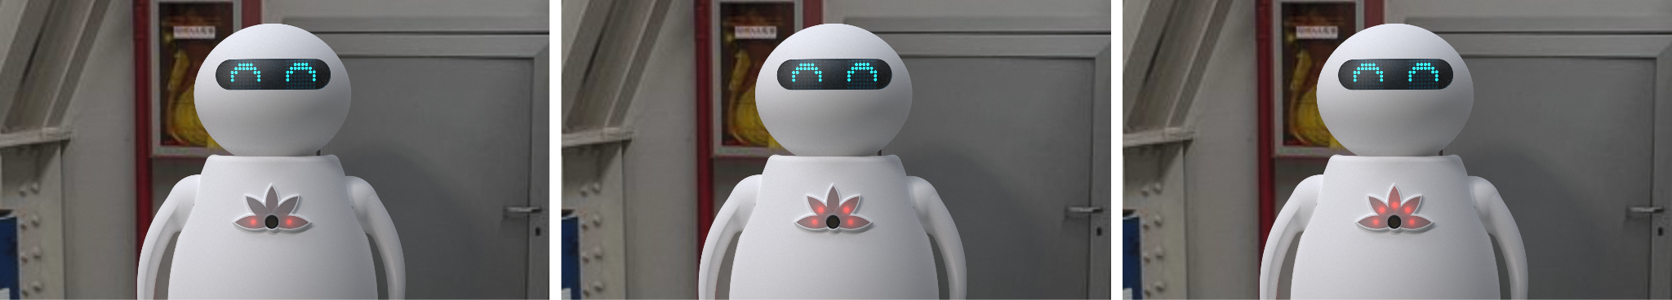

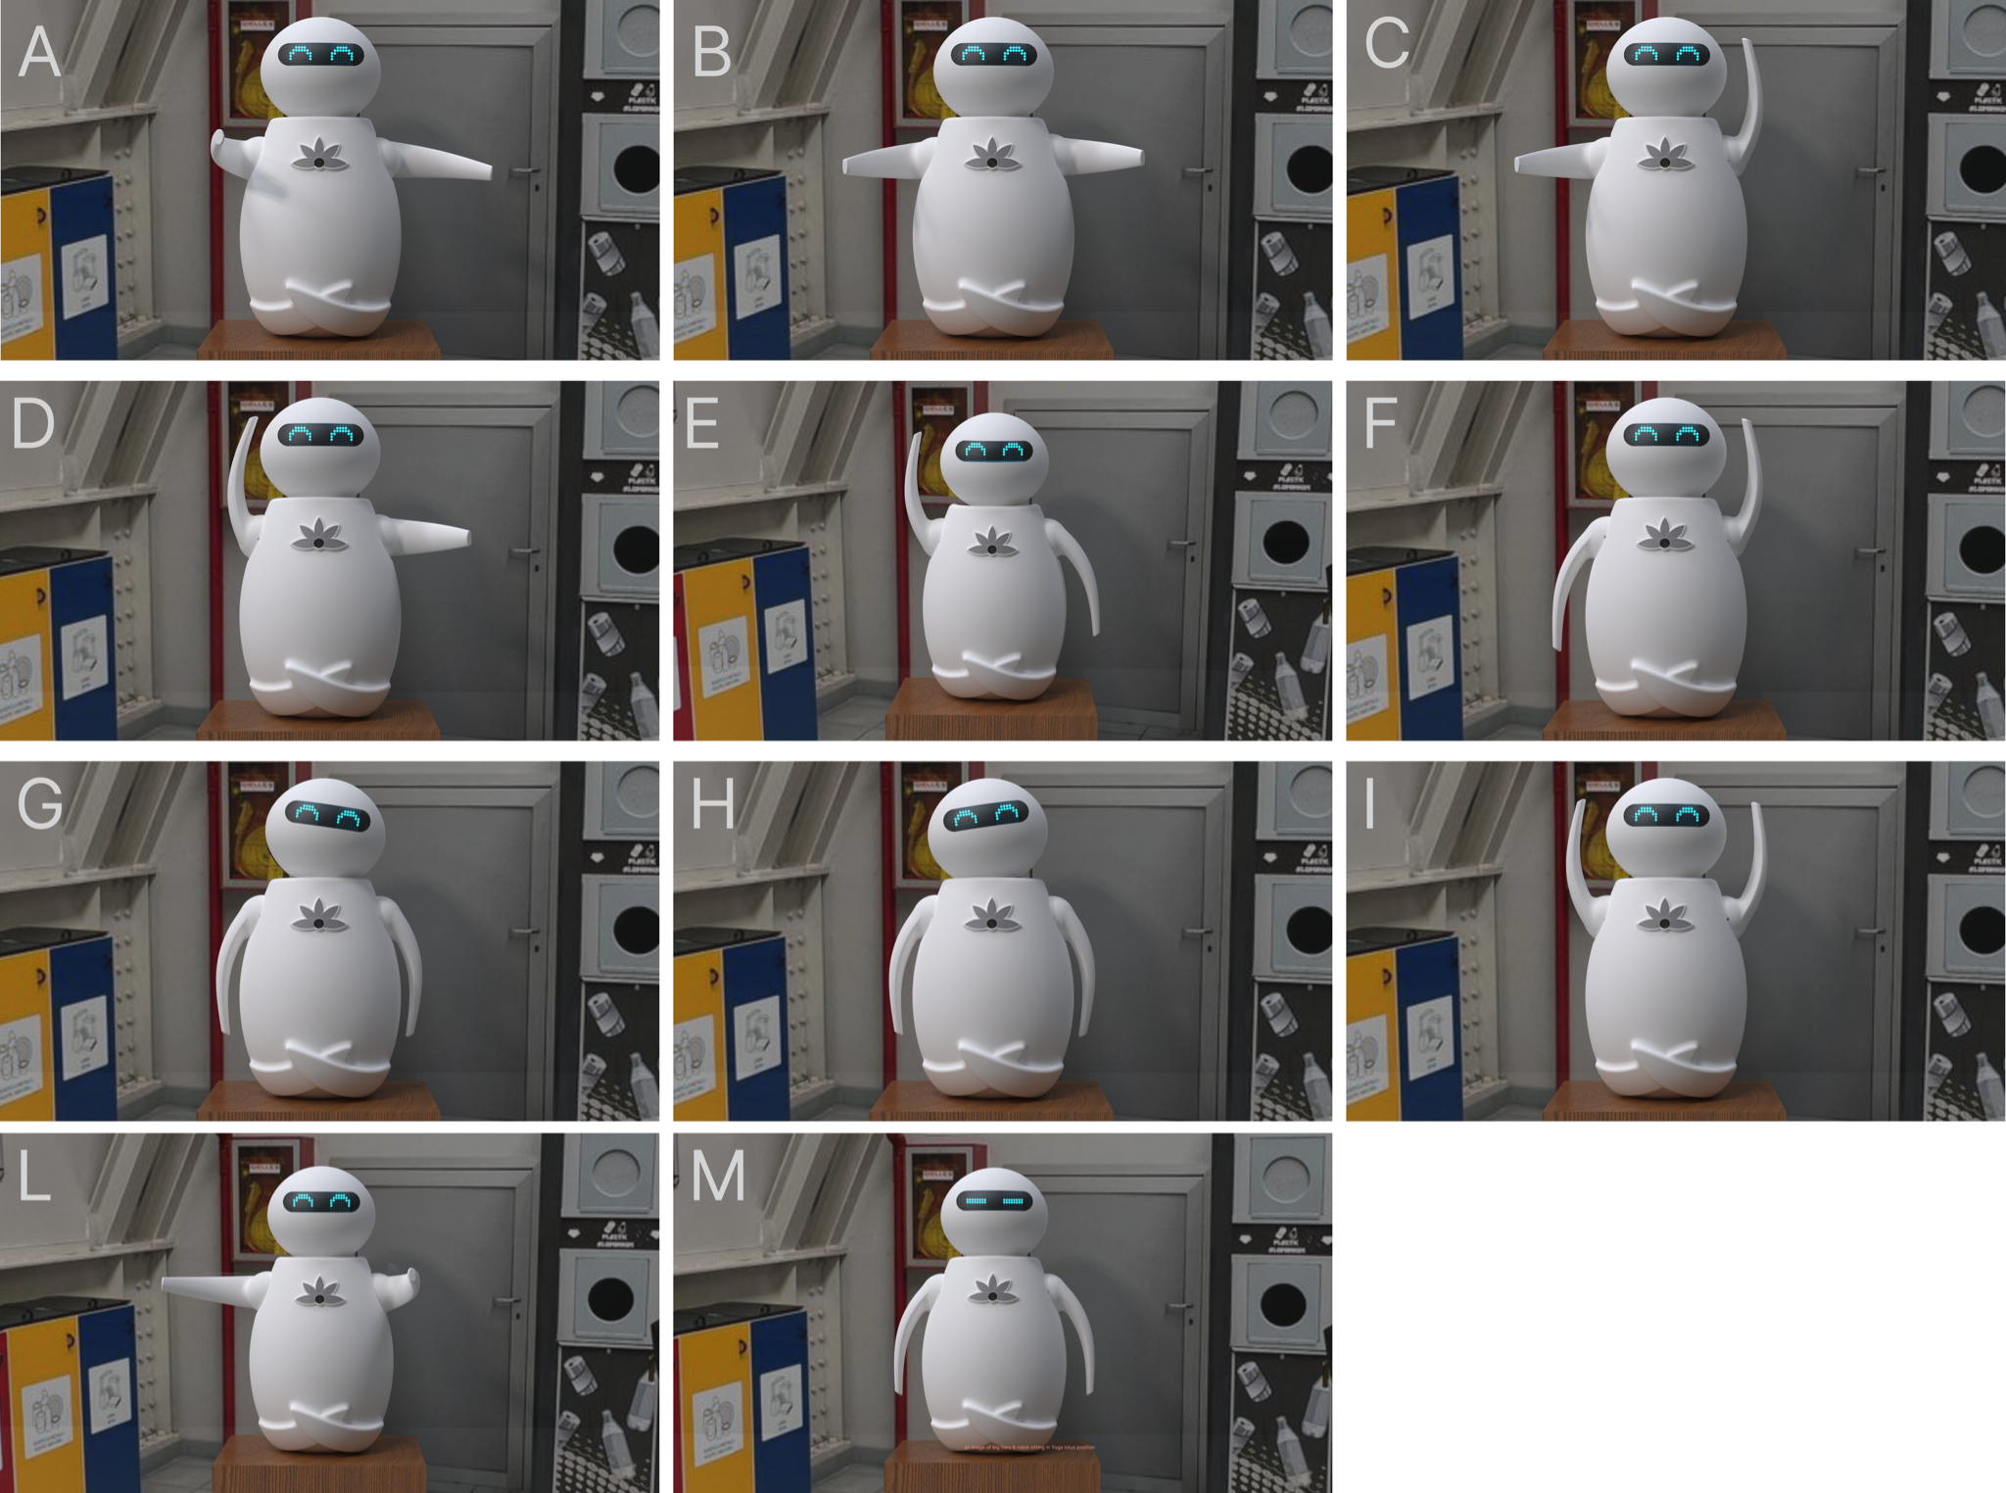

The design presented to the professors was not well-refined, as we focused a lot on the technical aspects of it, trying to push on the development; for that reason, the overall aesthetic of the product was not fully coherent with our starting idea and the mood we wanted to convey, since we still had time and we wanted to focus more on the overall design of the product (as the technical development was overall proceeding smoothly) we decided to take a step back and make another design iteration, opening again the define phase and drawing from new references with a renewed eye for the project.

### Third Defining Step

The redesign focused at first on the general aesthetic of the casing, focusing especially on making softer shapes and making the overall look more relaxing, resulting in an analysis of different kinds of head shapes, eye cover shapes, arm shapes and legs shapes.

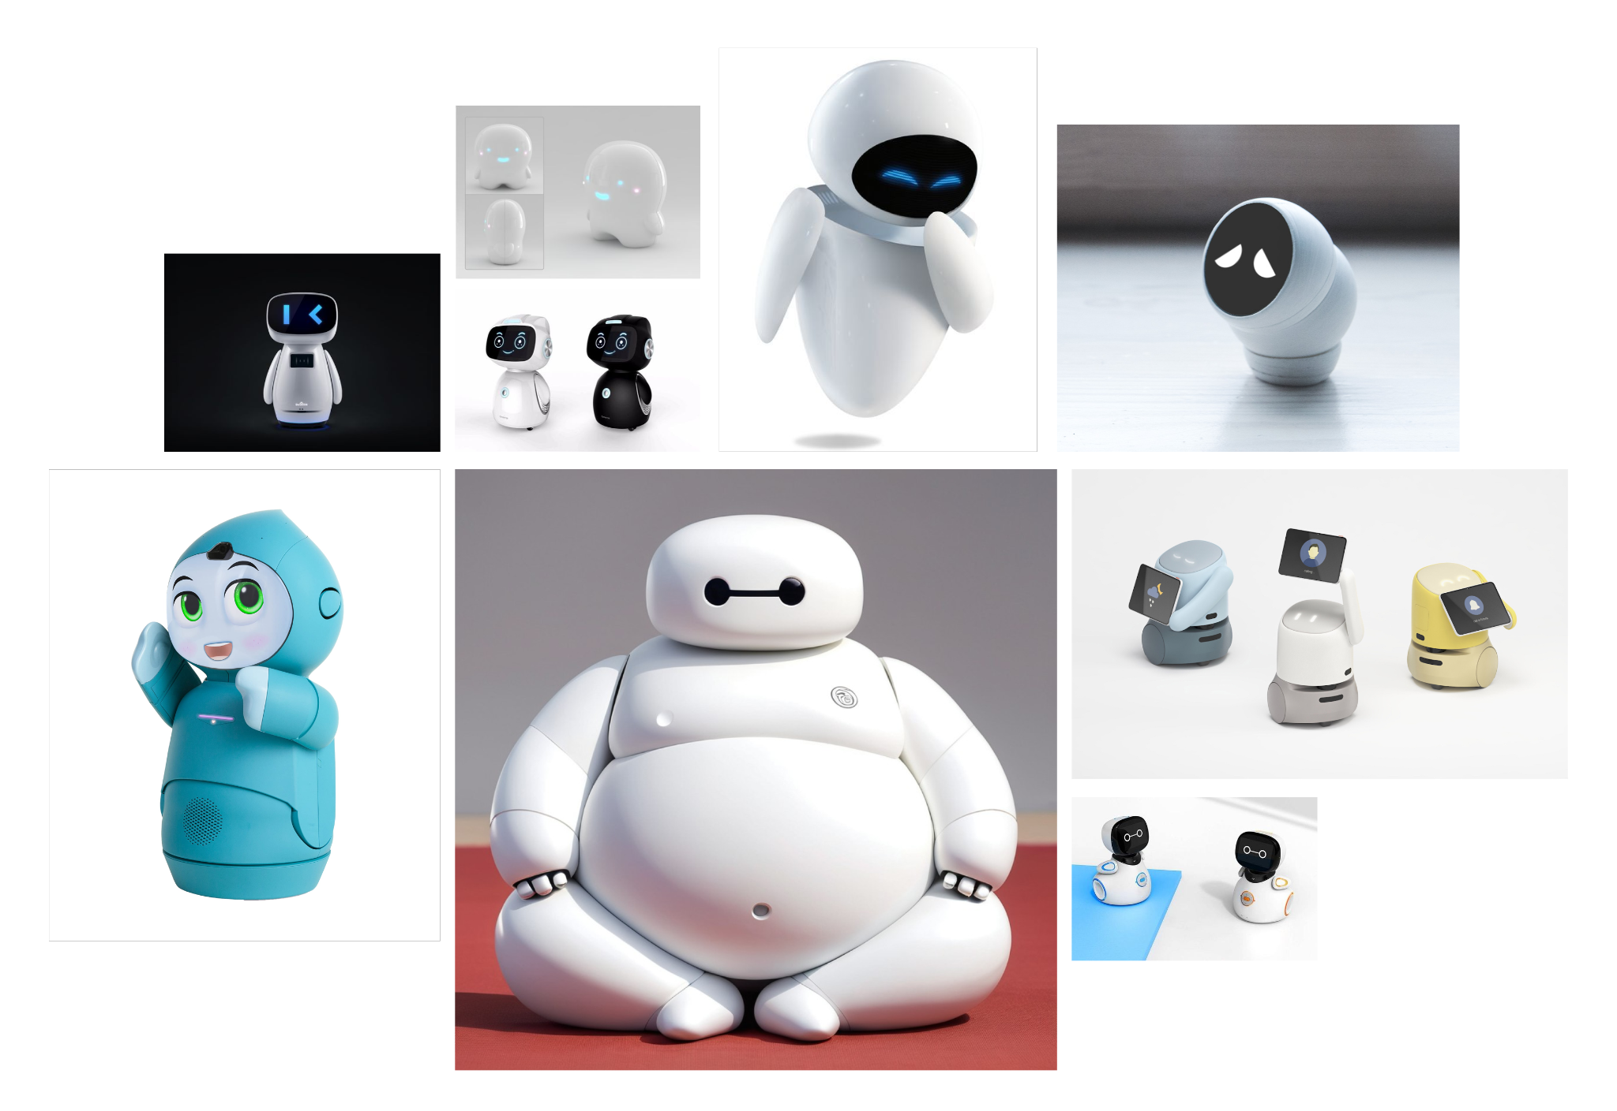

Based on the references, we opted for wider legs that would have better conveyed the idea of the lotus position, a different arm shape, with a smaller ball joint and a less pointy development, a slightly more rounded body shape and a more elliptical head, aiming for a more friendly looking robot. One important feature connected to how the robot should be perceived is the body shape, because of its aim of promoting movement, the robot should indeed not be perceived as fat, on the other hand though, as the robot is sitting in a lotus position and is almost looking like a Buddha in the chosen location, we wanted to find a trade-off between softness and fatness. During this iteration, we also decided to add an extra layer of interaction with users, a soft belly to show the breathing movement during the exercises.

Following is the final product of the third design iteration:

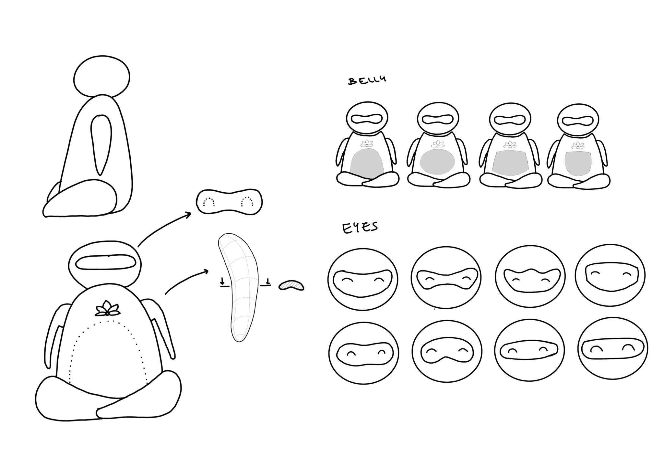

## Electronics

Starting from our interaction needs in terms of degrees of freedom, expressivity, and sensor information, we defined the components and interconnections of our system.

To move the arms around two axes, the head around three, and the breathing belly of our design, we needed eight servo motors. We decided to use six 13kg/cm servos and two smaller ones (around 2kg/cm), with the smaller ones placed in the shoulder joints of the arms. The smaller motor is as follows:

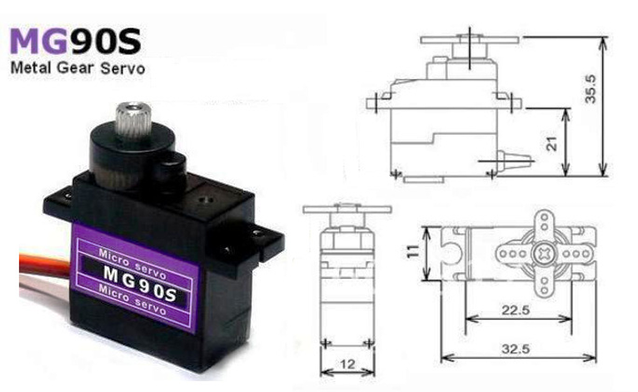

The other motor is as follows:

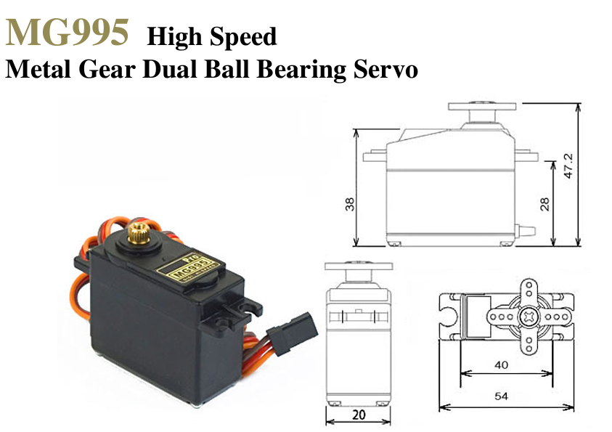

We then needed a way to provide power and control signals to them. Based on previous experiences with the difficulty of providing balanced power to multiple servos moving simultaneously, we used a PCA9685 Servo shield, which would provide the characteristics we needed, and communicate with our controller through I2C protocol.

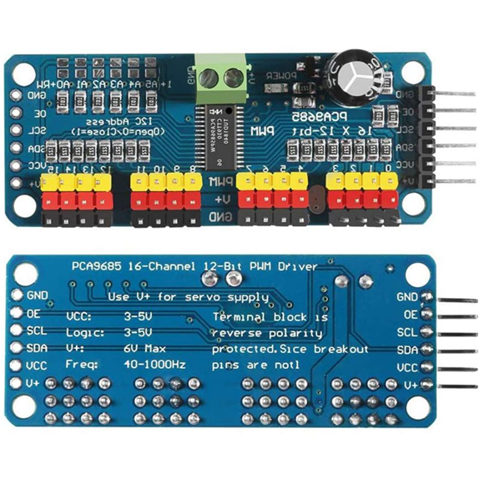

On the system control side, we decided to go for a Raspberry pi4 - Arduino Uno setup, with serial USB communication between them, where the Arduino Uno controls the hardware related to servos and LEDs, which included two LED matrixes for the robot’s eyes and several sections of LED strip (5 strips with 3 LEDs each) for the lotus flower, and the Raspberry managing the Artificial Intelligence software and the overall flow of the interaction, including sound and animations.

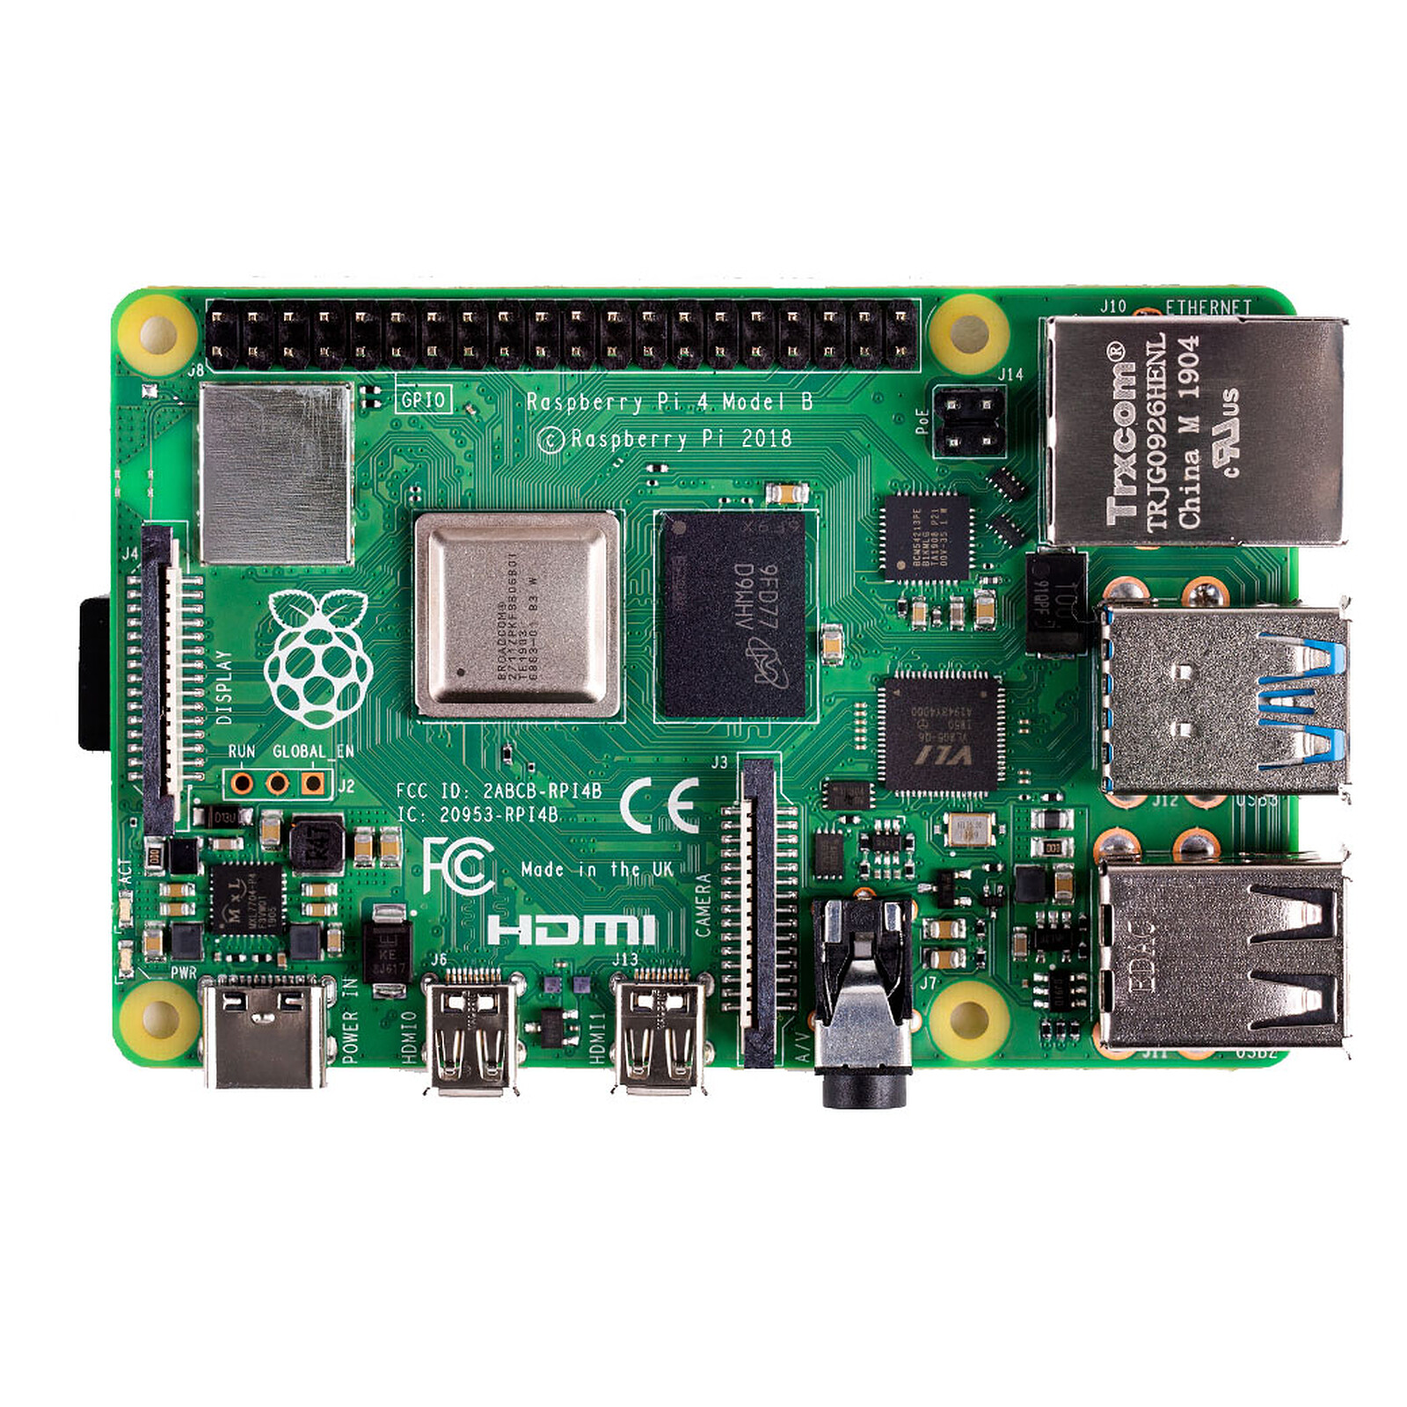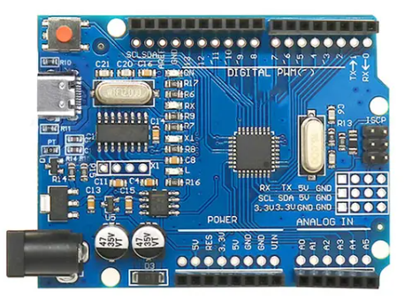

The LED matrix for this project is :

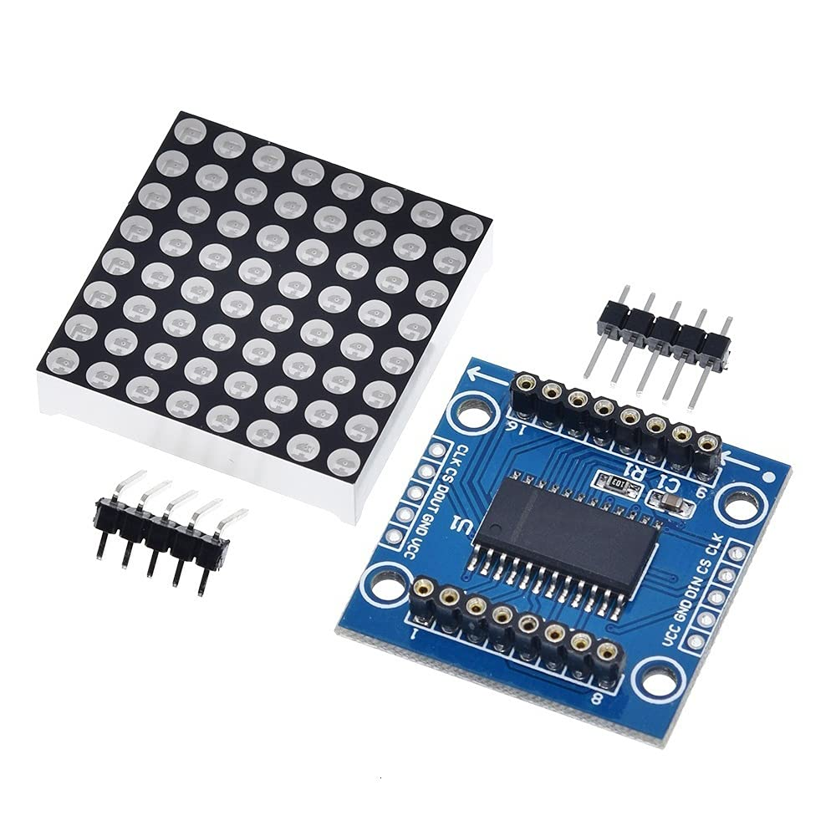

The lotus LEDs is composed of five splitted strips of three LEDs.

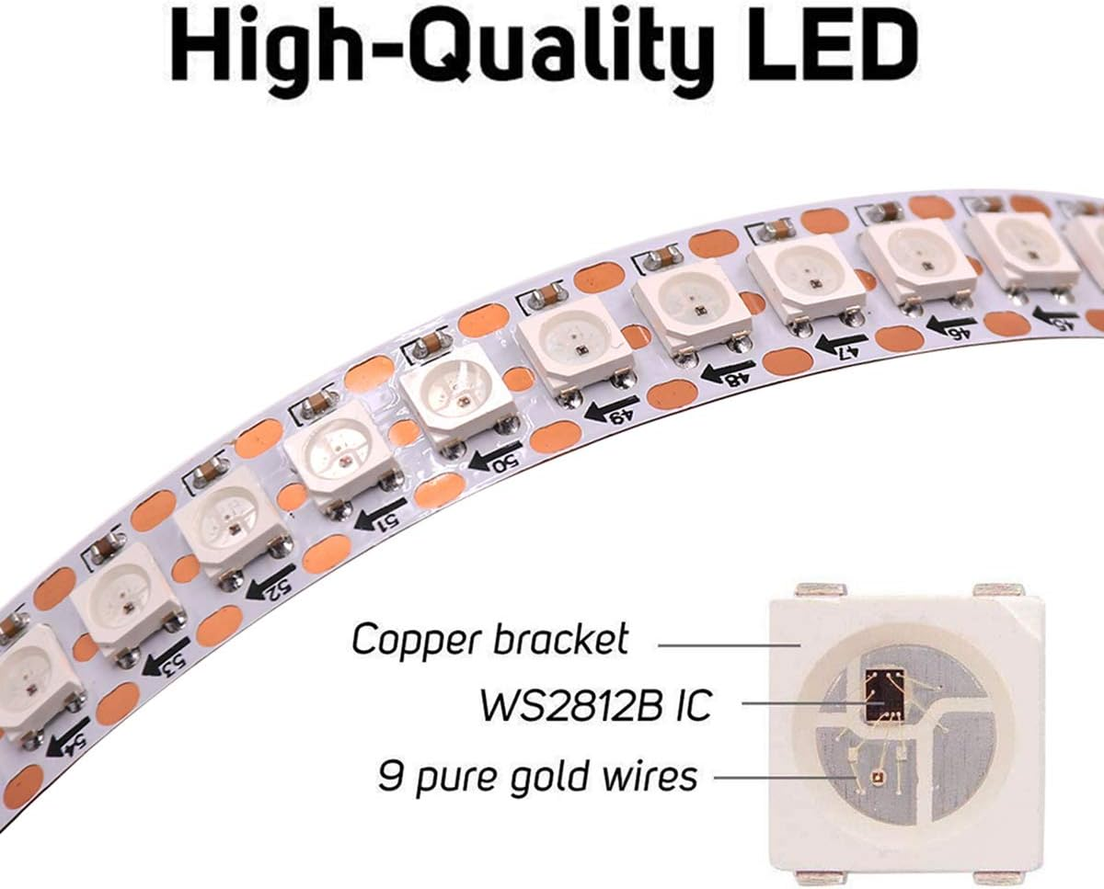

In our initial design, we thought of using two Arduinos to separate LED feedback and motor control so that they could work in parallel without one slowing or bothering the other.

To produce sound, we used a speaker that would be connected to the Raspberry Pi directly through a 3.5mm Jack. The setup for the audio are as follows:

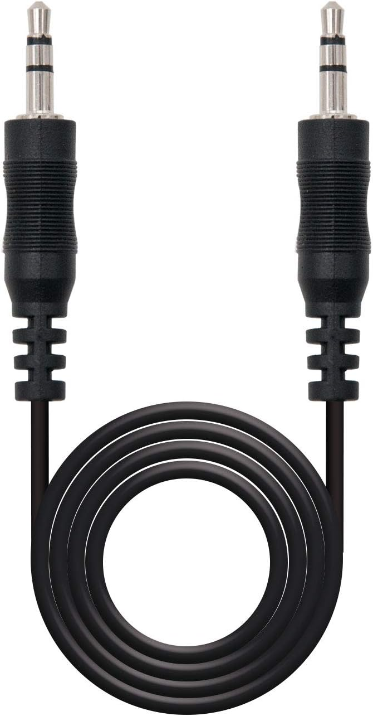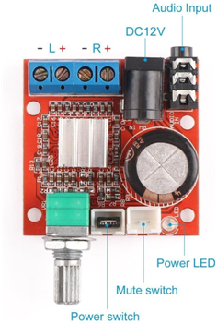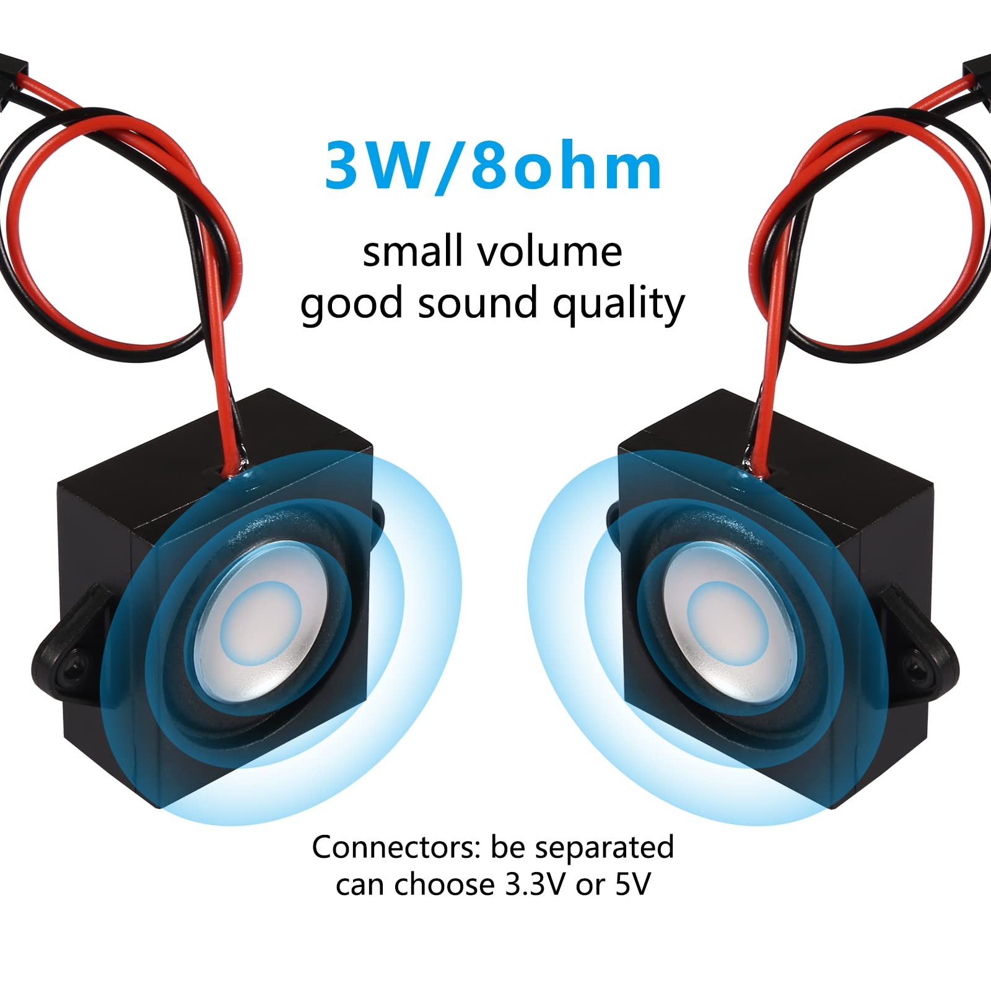

Our only sensor for this project was a camera compatible with Raspberry Pi, which was indeed connected to our Pi 4 through its ribbon cable.

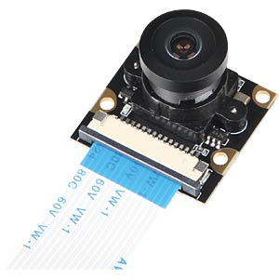

At this point, we estimated our overall power requirements and chose the power supply. Most of our hardware needed 5V, so that was settled quickly. On the other hand, the current requirements had to be estimated. Through our previous experience and online research, we found evidence that:

* Raspberry Pi4 would draw a maximum of 3 Ampere at full computational power,
* Each servo would draw up to 1/1.5 A at stall torque, which we knew, given the defined animations, we would never reach.
* Arduino and other devices, including LEDs, would amount to less than 2A

All things considered, we settled on a 5V, 10A power supply, that we could plug directly into the 220v AC. We judged this would give us enough margin in case our estimations were too optimistic. For the audio, there is a need for a 12V adapter for the amplifier. Instead of using a 12V adapter and a lot of step-down modules, we used another small power supply only for the amplifier.

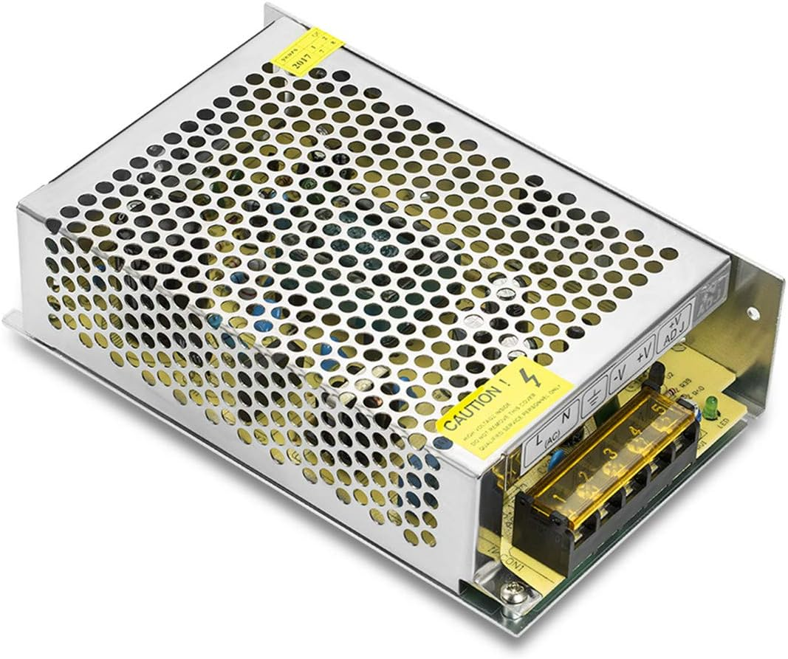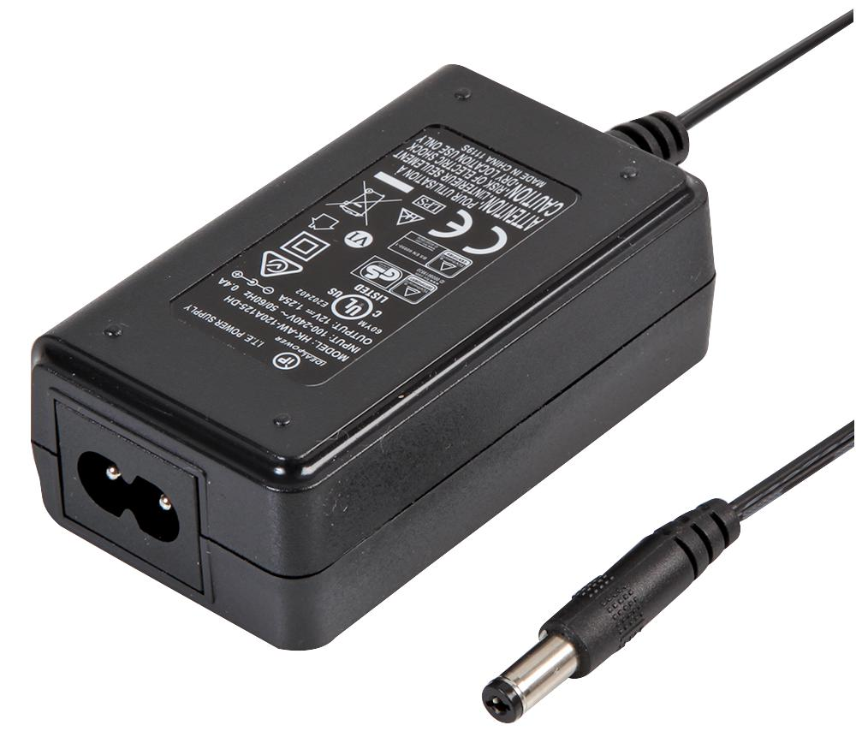

# Phase 3: Develop

## Strategy

Having defined the characteristics of the robot and its shape in the third definition iteration, we started developing the final version of the product, modelling the new body with a refined product architecture, and testing the whole system.

## Modelling

Even in this case, while modelling from the new sketch, we went through a lot of refinement sessions to achieve the final look we have right now, the trickiest part was the modelling process of the legs, indeed we tried three different modelling solutions, the first one being a normal extrusion of the legs shape from the body and then a series of fillets, the second one being an extrusion, an extrude cut to make the legs follow the shape of the body and lastly, and also the most effective technique, a loft created via a series of sections.

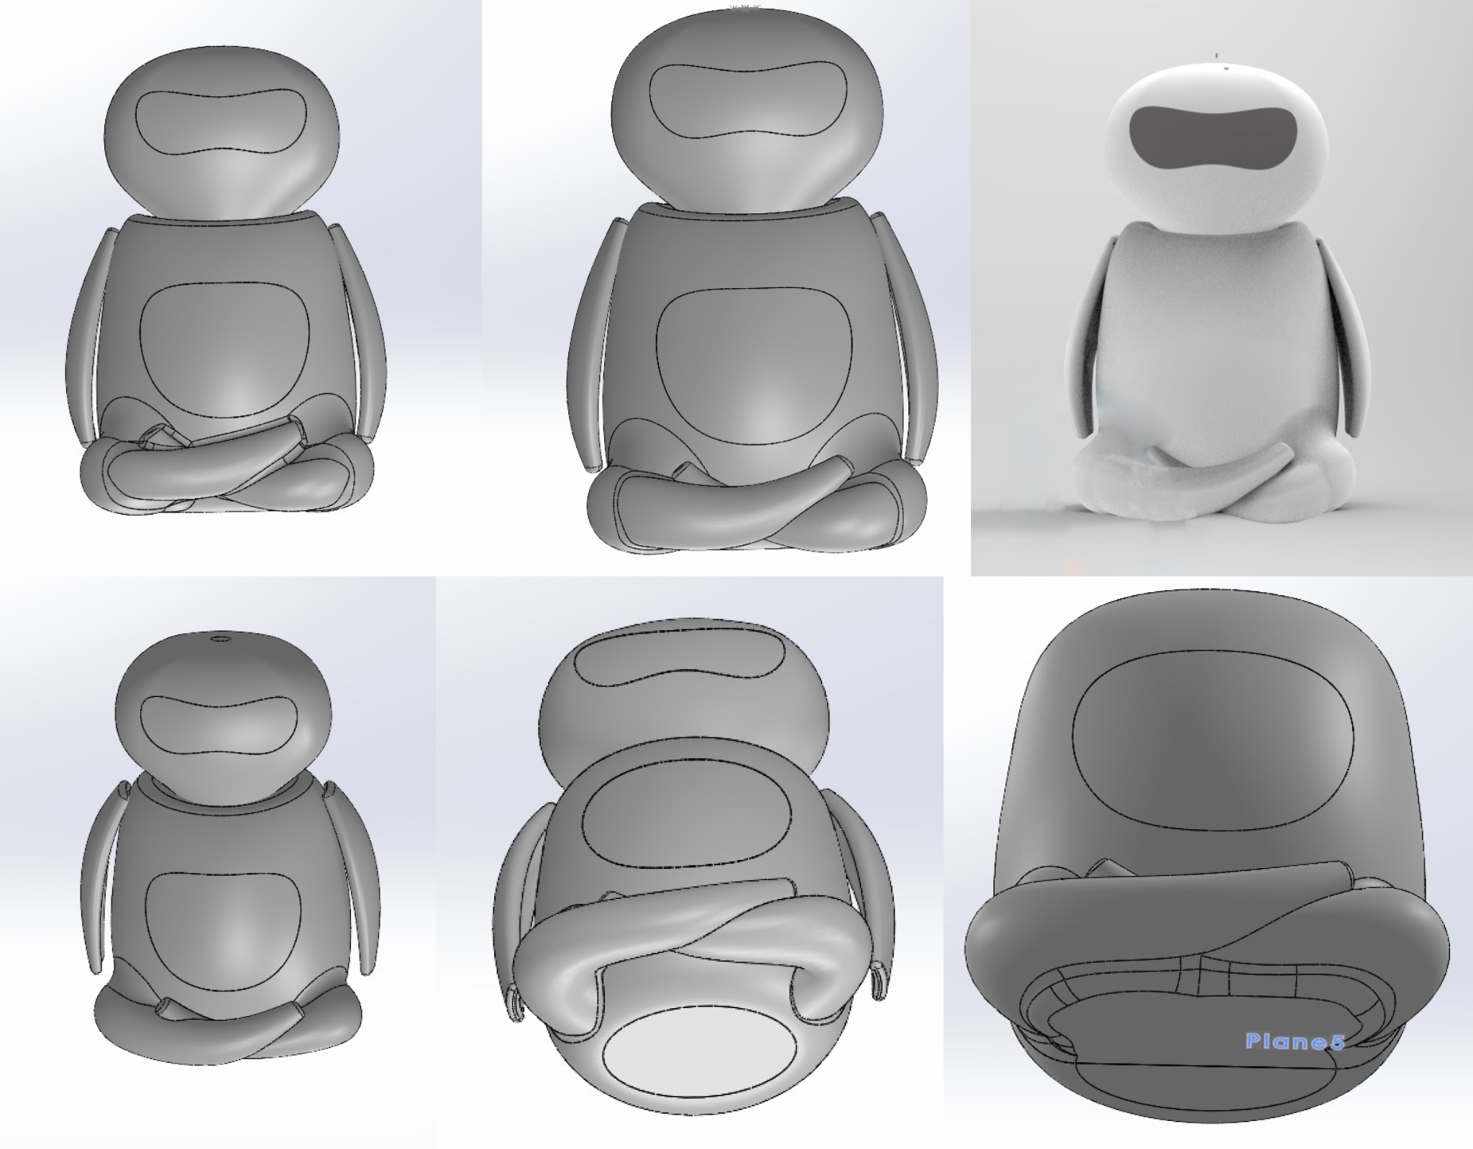

Initially, we thought about a different arms design, the new design used a smaller motor on the “shoulder” of the robot and avoided the ball-joint look. The new arm joint was surely way smaller than the old one, but the overall aesthetic of it was still not coherent with the rest of the body, starting from the fact that the user could see the shoulder motor during the interaction. We refined the arms model once again by implementing the ball joint with the smaller motor, adding some fillets and making the arm shape follow the body shape.

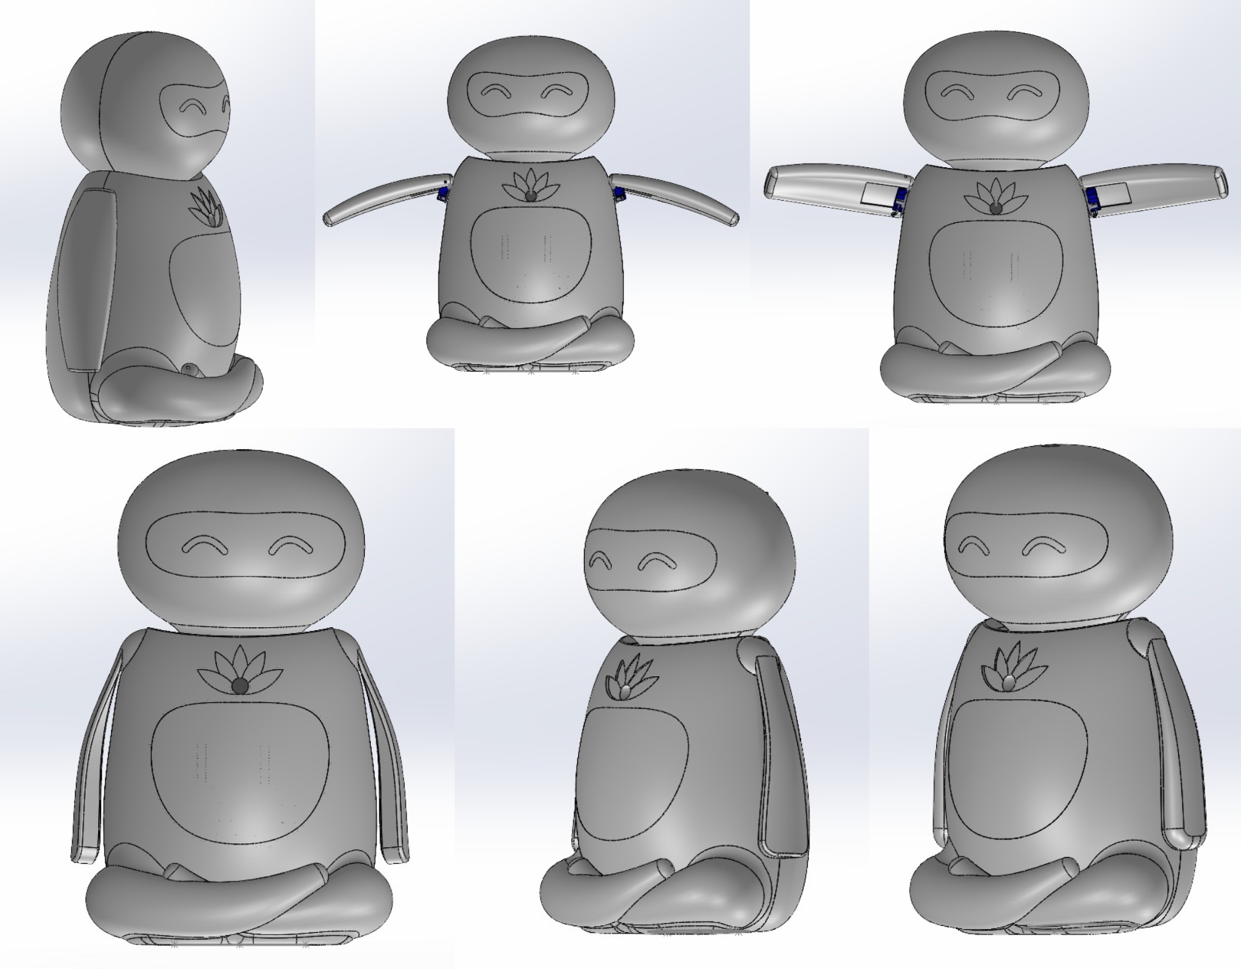

Now that the product shape was defined, it was time to develop the product architecture to fit everything in the new body. Past experiences taught us how important it is to be able to quickly access all the functional components of the machine, to maintain them easily and to promptly identify technical problems. Therefore we decided to build all the product around one primary support, housing all the boards and the motors, to be able to assemble and test the head and arms even without the rest of the body. The main casing, the body with the legs, was designed to be an aesthetic part to fit around the primary support and close the entire structure.

## Prototyping-Testing-Refining

We 3D-printed and assembled the first fully working prototype of the robot. As the prototype was meant for testing, we only printed parts of the head and arms, as we needed to check the efficiency of the mechanism and not the full aesthetic.

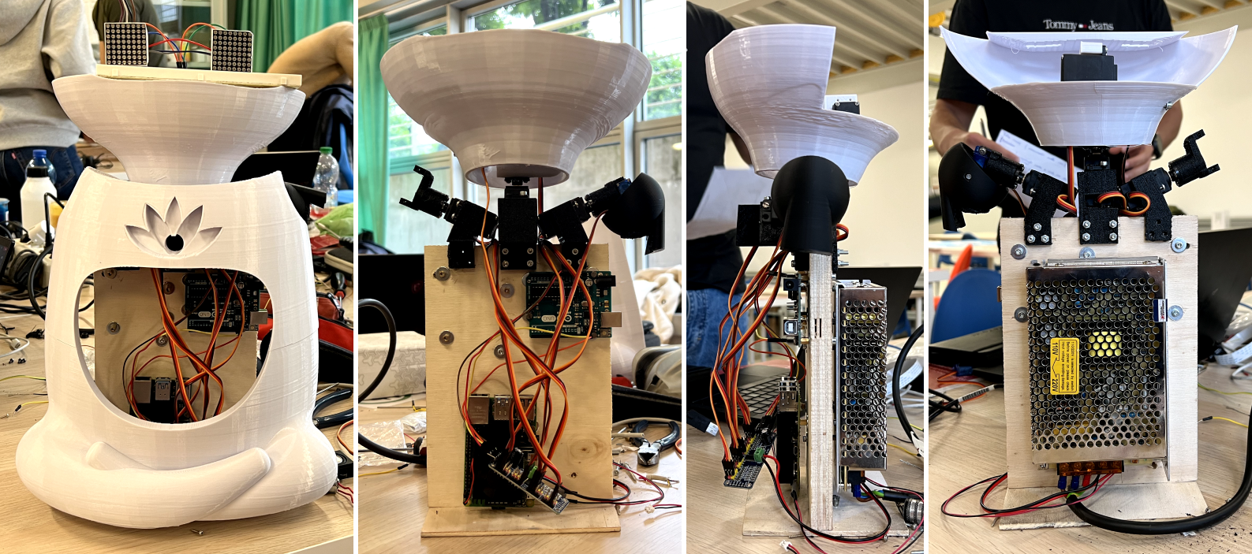

As shown in the pictures, a wood slab was used as the main support for all the functional components, then motor supports were mounted via screws and the arms and head sections were then connected to the mounted motors; the back was housing the power supply only and the front was connected to the two arduinos and the raspberry pin (after the review with the professors we got rid of one of the two arduinos, hence there is only one mounted in the pictures). The front case presented a lotus slot to put LED stripes and a hole in the middle to let the camera get pass through; in the middle of the body, we added a hole for the soft belly material, that we envisioned in foam covered in lycra.

It is worth noting that his new design had a completely new architecture, with newly modelled motor support and an enhanced head structure system: a set of three servo motors to control the movement on x,y,z axis has been stuck together to then connect to the head via one of the round horn, on top of that the support for the eyes matrices.

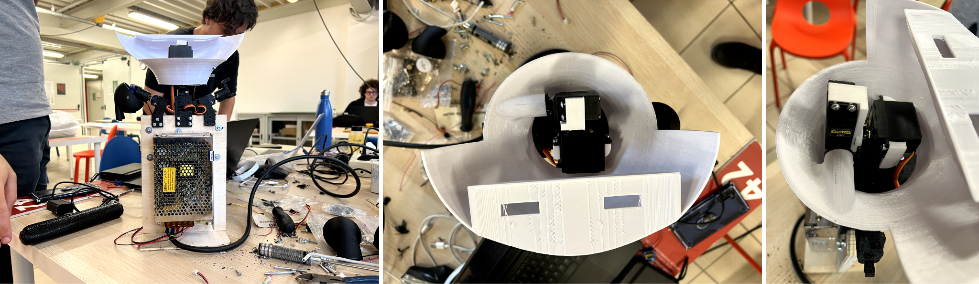

After the review with the design professor, we decided to continue developing the project. The main point of discussion was the way we split the case, with a logic merely related to the ease of printing, we split the main body into two large parts separated from a straight line in the middle. To make the cuts as a part of the final design, we worked on a different set of cuts, making the legs as a free standing base, to which we would screw the functional component support, with the head and the arms connected to the motors, and last but not least, the top portion of the body would be split into two sections attached with magnets. This way we can have a more stable and coherent body structure, with removable cases for maintenance. As we decided to have the top portion to be disassemblable, we noted that it would have been better for that part to not be connected to any wires, hence we decided to remove the lotus LED support from the front case and make it a different part to connect directly on the main internal support, leaving a lotus-shaped hole on the front case.

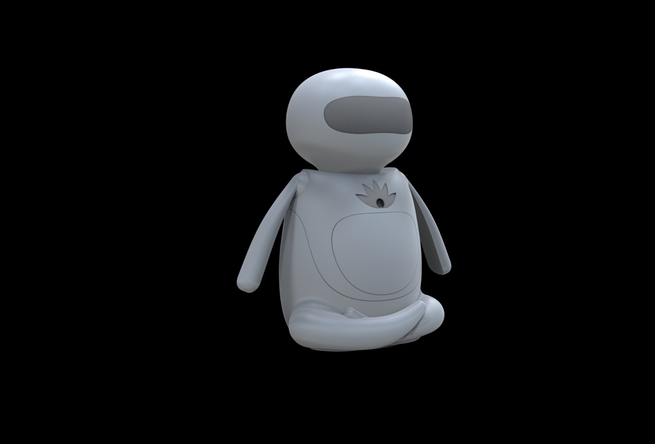

One last missing mechanism was the belly one. We decided right away to go for soft foam as the internal material, but we needed something to push it outwards and back to simulate the breathing movement of the diaphragm breathing. The general idea was to print a support to connect to a motor on the bottom side of the body and make it push, we thought about a large surface area pushing the foam piece. We used the old front casing to test the idea: we cut foam to shape and covered it with lycra, then glued everything to the belly part, we purposely glued only the lycra to the plastic, as we wanted to also test the best foam thickness to use.

Foam thickness started at 2 cm, regardless of a good aesthetic performance, its thickness required a lot of pressure for only a slightly perceivable belly movement, hence we reduced the thickness to 1 cm to solve this issue. The first support created to push the foam had a square shape and had three main touch points with the part, ideally ensuring a uniform movement on the foam piece. After some pressure tests, we decided that the first support was not satisfying our expectations, hence we decided to change it: when pushing the foam with our fist we were experiencing a better looking belly movement, therefore we decided to make a second version of it with a fist-like support. To not waste the material used and wait for another part to print, we decided to cut the olt support with a saw and glue a christmas ball to it, given that the christmas ball we found in the lab demonstrated better results in the belly movements.

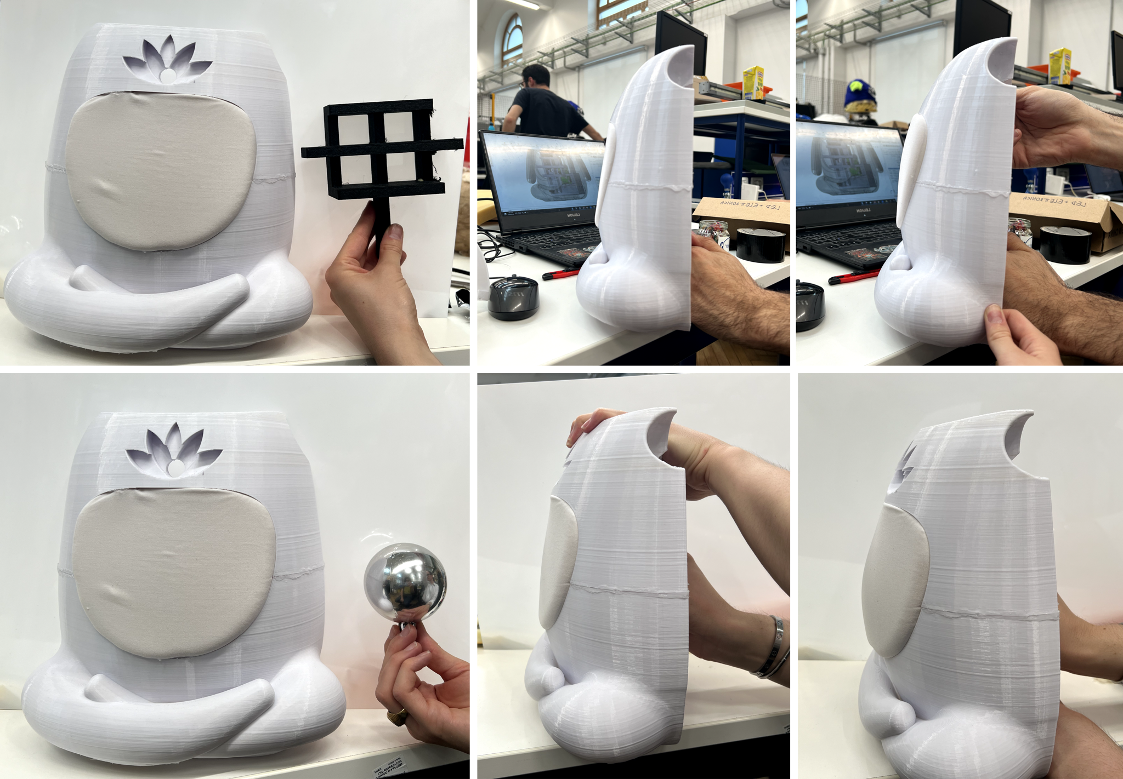

## Interaction Flowchart

A flowchart of the user-robot interaction was created, to define the robot reaction to user’s possible behaviours. Only minor changes were made to this flowchart in the final user testing.

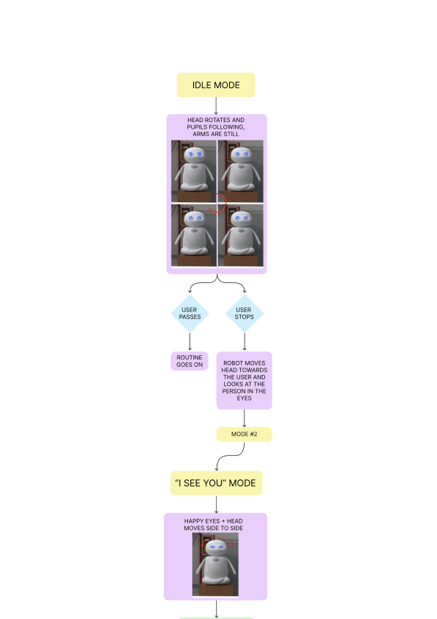

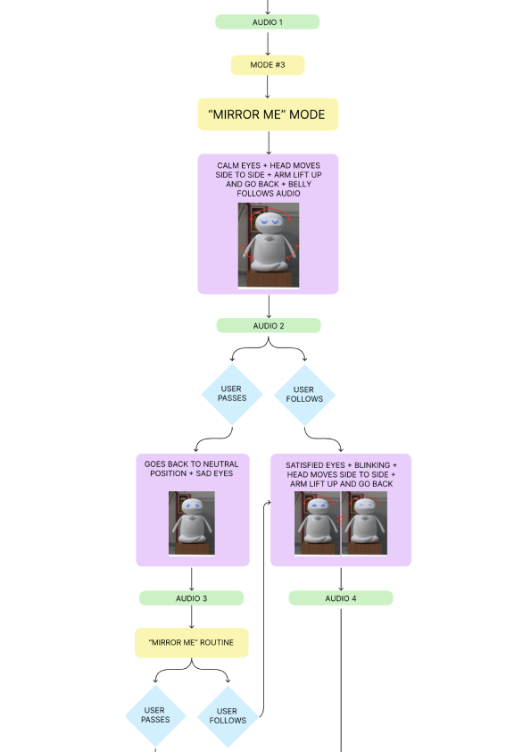

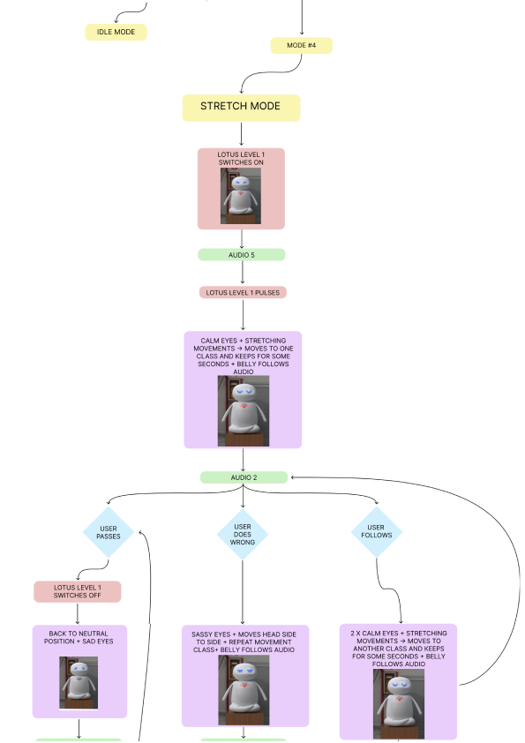

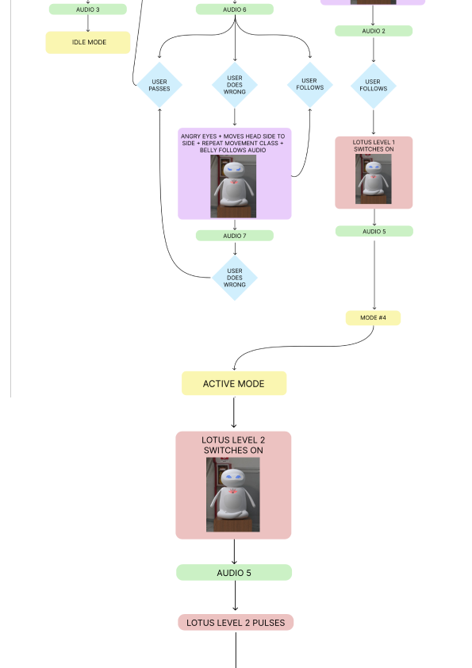

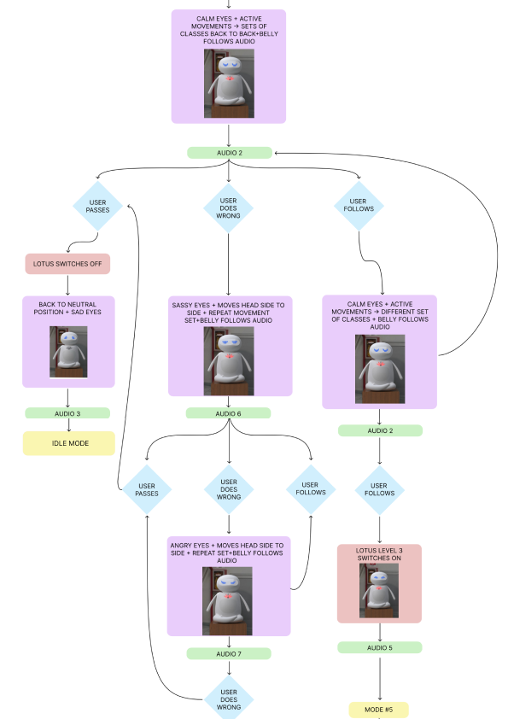

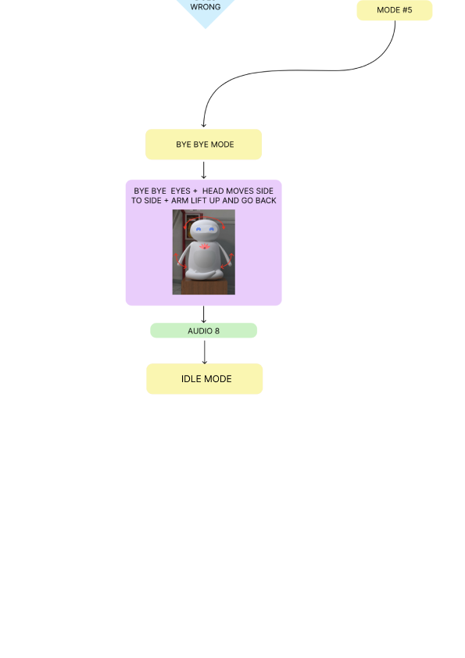

## Final Product Architecture

As we decided to change the cuts in the casing, we noticed a possible failure: the belly foam was now mounted to the removable top case, as we studied the magnetic connection to be on the top part of the body, close to the ball joint, there was a chance that the support for the belly movements would push too hard on the parts, overcoming the force of the magnets and making the front part fall down. To solve this problem we decided to add a mechanical locking system, creating a step on the front case to interlock with the base case and have a support to share the load with.

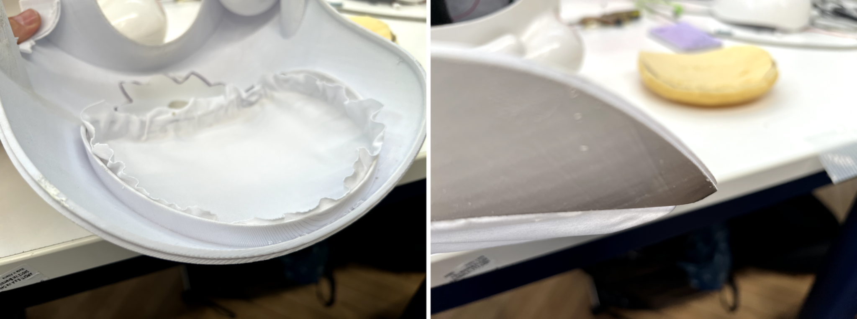

Using different kinds of LEDs for the eyes and for the lotus left us with the need of diffusing the emitted light to create a better looking effect. At first we tested two diffusive materials suitable for thermoforming, a fully transparent one and a white diffusive one, both with a 0.4 mm thickness. The transparent plastic was fully sanded to obtain a satin finish, as the head was split into two parts for printing purposes, we tested one single LED matrix with the diffusive materials. Aesthetically speaking we thought the white material was best suited for the application, as it was of the same color of the robot when switched off, apart from that, the two materials showed very similar diffusivity results. Following our big focus on disassembly, we decided to 3d print a mask frame to act as a support where to glue the diffusive material: to make it easy to assemble and disassemble, we designed two snapfits on the side to fit into two rectangular holes inside the head, giving us the freedom to easily access the matrices by applying a small pressure on the sides of the mask to detach it.

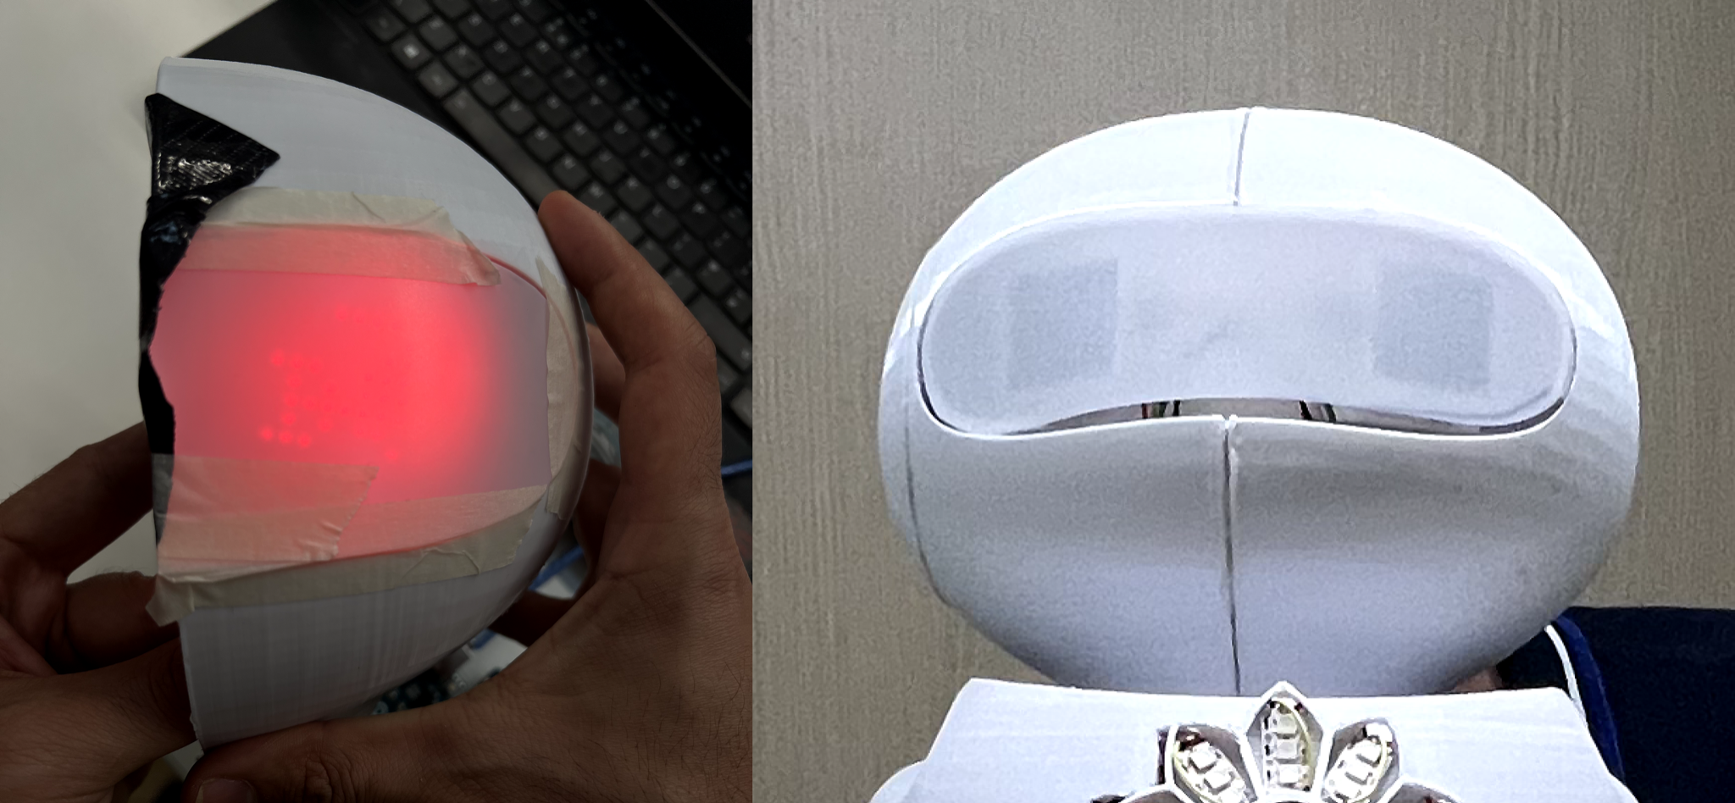

While testing the LED matrices we quickly understood that we could not leave any sort of distance between the matrix and the diffusive material, as the light was not intense enough and the result was not optimal. As the printed head was properly assembled, to save on printing time and material we decided to model and print an extra support for the matrices to be attached on, keeping them pushed towards the diffusive material.

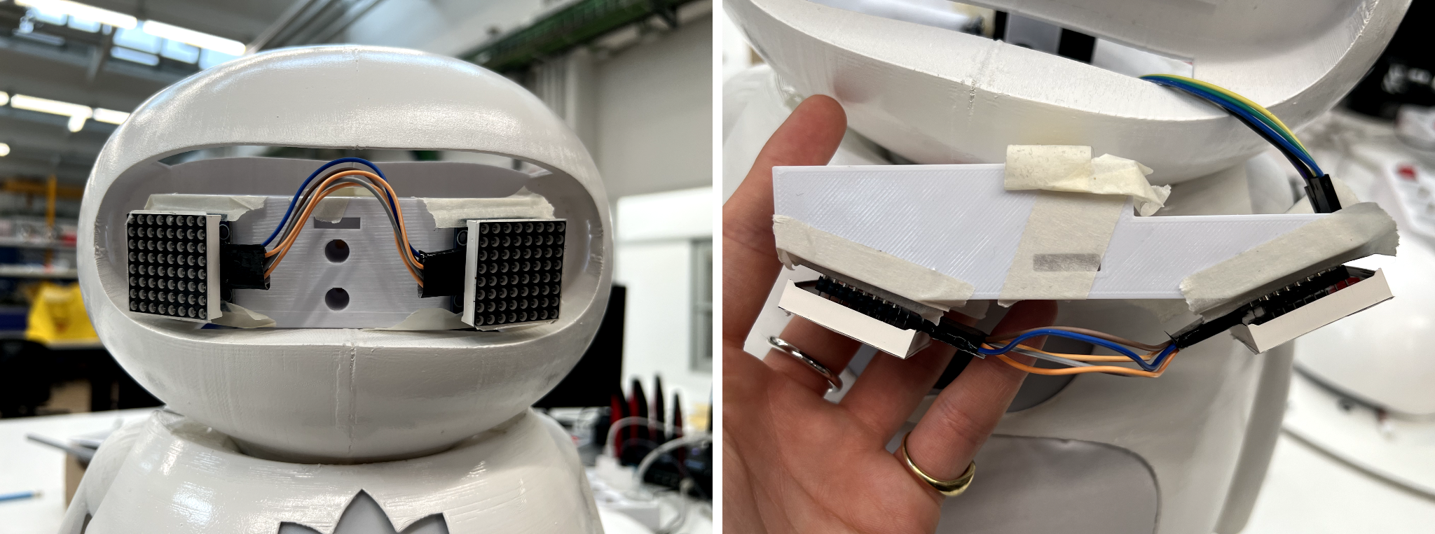

As we assembled and tested the solutions for the eye diffusers, we also realized that the white diffusive plastic sheet was slightly showing the dark outline of the matrix structure, hence ruining the seamless aesthetic we had in mind. We decided to make a fully printed mask with a 0.4 mm layer of plastic as a diffusive material, this solution turned out to be more durable and better looking than the first

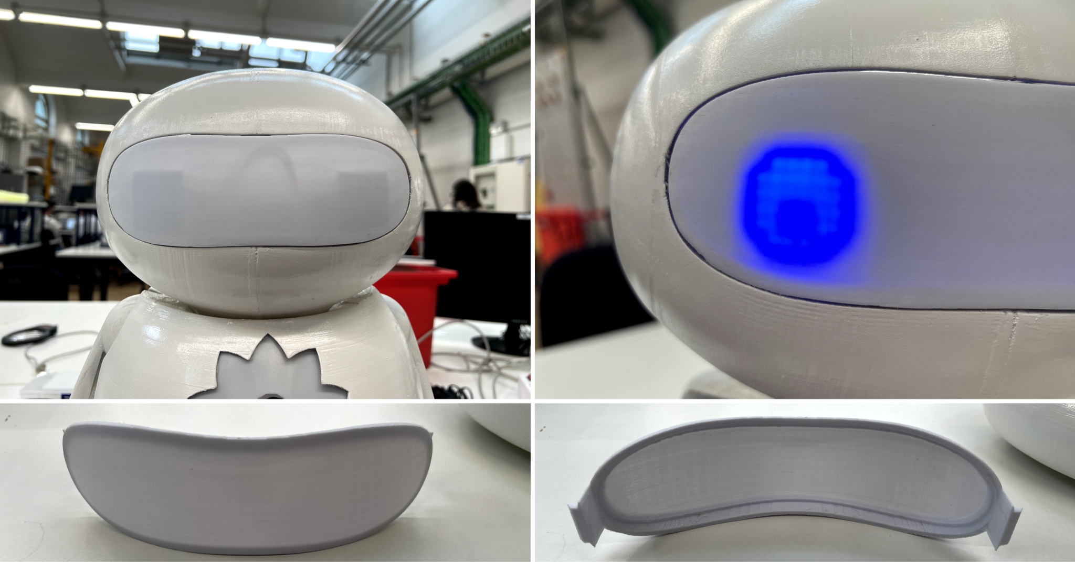

## Human-Robot Interaction

While developing the product and working on the prototypes we decided to start testing the human-robot interactions with some users, to assess their feelings and their first thoughts on the robot’s feedbacks, to do that we created a set of animated videos showing the robot movements, and the emotional feedbacks given via the eyes expressions and the paired audio feedbacks.

3 users were shown the animations:

* 2/ 3 users perceived the “quiet” state eyes as sleeping
* 3/3 users perceived the “sad” state as calm
* 3/3 users perceived the “angry” state as exaggerated, with an expression that would cause them to leave the interaction

After the user test we decided to make some changes to the eyes expression and to the overall interaction, with the goal of making it as rich as possible.

As the users were perceiving the quiet state as the robot sleeping rather than waiting for someone to get in front of it, we decided to animate that first mode (called “idle” mode), making the robot actively look around for people to interact with. As a human would do, we decided for the robot to move its head around, from side to side and occasionally moving the head a bit upwards or downwards. Again, as humans would do, we decided to give the robot proper eyes, with a moving pupil during the roaming phase.

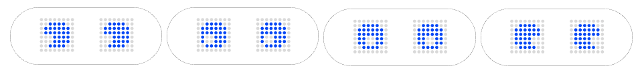

With this improved eye look, we needed to use a different kind of eye style: the first idea we had was playing on a wireframe aesthetic, but that look was not coherent with the new eye design chosen.

As the robot interaction started with the idol mode, where the robots “scans” the room to detect possible people to interact with, we needed a proper active reaction to the presence of a user ready to interact, hence we added the “i see you” look, a happily surprised reaction to give to the user. To match the new look of the eyes we went for a more full look, creating a whole shape rather than only its outline.

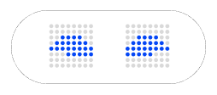

Once the robot gets users’ attention, it can start the “mirror me” stage, where it tries to get the user to follow the movements. Based on the idea of a yoga class, we decided to add a breathing sound, conveying the idea of relaxation and the idea of the robot as a yoga instructor. As users previously reacted to the sad eyes as calm eyes, we decided to use that expression in this stage, showing the eyes as closed and relaxed. To give the user extra visual feedback, the first row of petals of the lotus starts blinking following the breathing rhythm, and switches completely on when this part of the routine is completed.

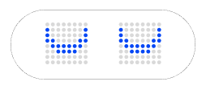

In the interaction we had to consider possible failure instances, indeed we considered a crying reaction in case the user doesn’t mirror the robot and decides to move away, and a satisfied reaction in case the user successfully follows the movements and finishes up the first phase of the interaction.

Even if the user follows the robot during the interaction routine, there is still the chance of improperly executing the exercise, therefore we added two negative feedbacks, one with a sassy expression, followed by the repetition of the movement, and an angry one to use in case of multiple wrong repetitions.

In all the different expressions we tried to recreate complete shapes to follow the new look of the eyes.

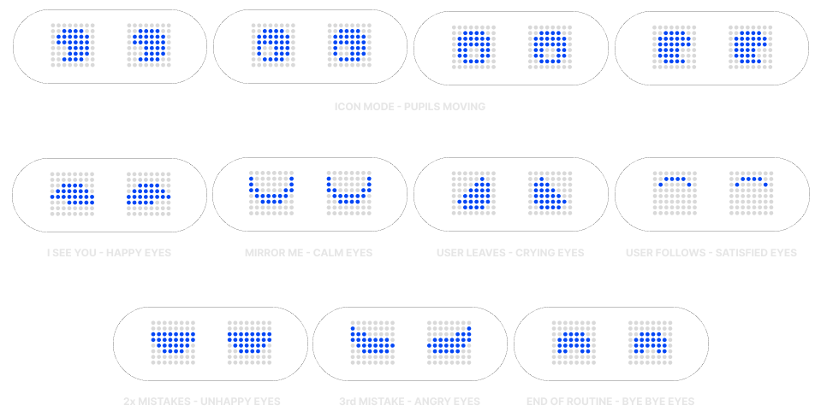

## Materials & Process of Production

The body parts have all been 3D printed and sanded down, all the boards and the components have been mounted via screws, mainly self-tapping ones, to avoid using heat inserts in the plastic, other connections were made with bolts and nuts.

## Electronics

During development, we had to correct our initial concept in two ways.

Firstly we found that we could use one Arduino instead of two, putting together the code responsible for LEDs control with the one for motor control without significant issues to the timings and functionality of both. This was both a code fix and a reassessment of our needs: in the end, it was not necessary to make everything work in parallel to obtain the kind of interaction and animations we envisioned.

Secondly, and most importantly, we found that the 3.5 Jack audio output from the Raspberry was not amplified enough to produce the sound volume we needed. Thus we looked for an amplifier that could be used in our design without having to change it significantly. After a bit of research, we settled on an amplifier that received 3.5 Jack input, was powered by an additional 12v power supply, and was compatible with our speaker. We had to use an additional power supply because ours was just 5V which was not enough to power on the amplifier. This integration was rather easy in the end because we could just hook the additional power supply to the same 220V AC input, and the interface was still through the Raspberry’s headphone jack, with no changes needed code-wise.

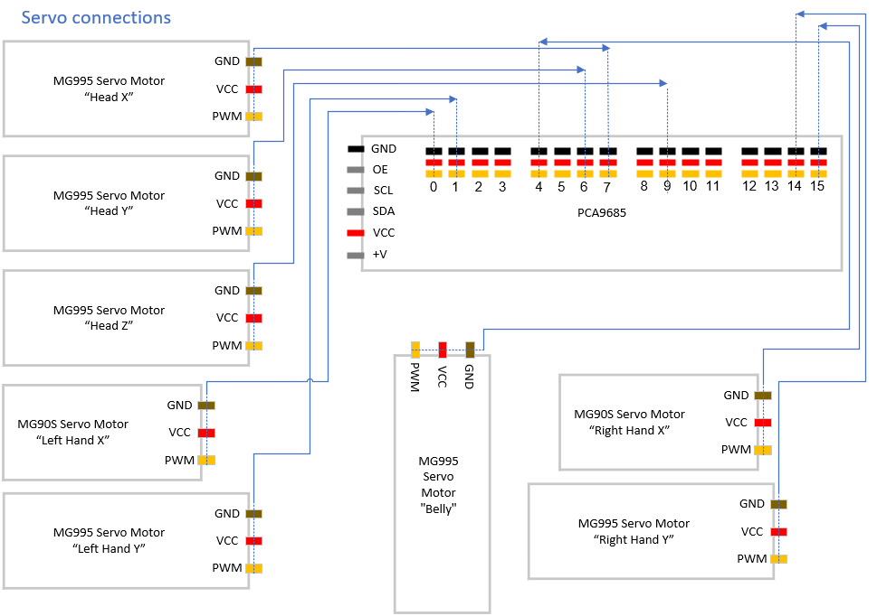

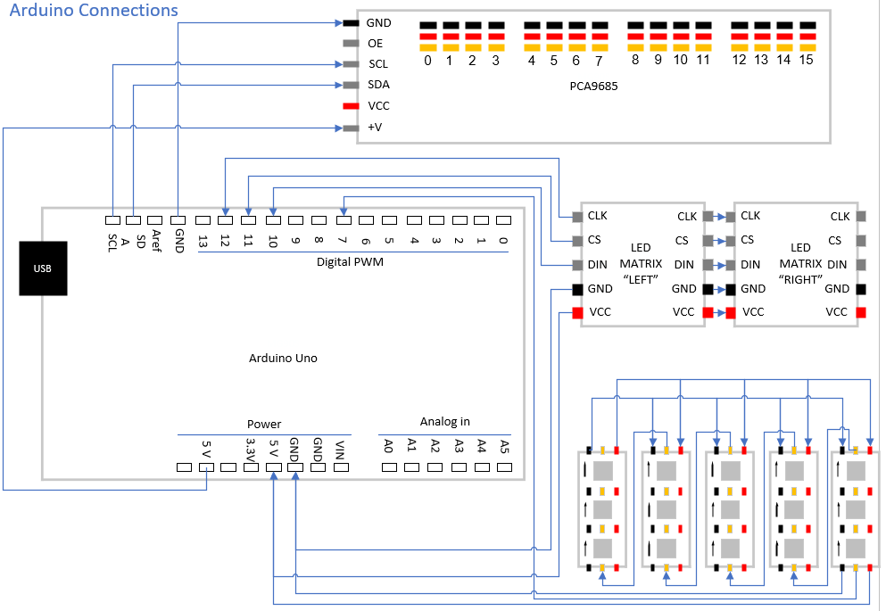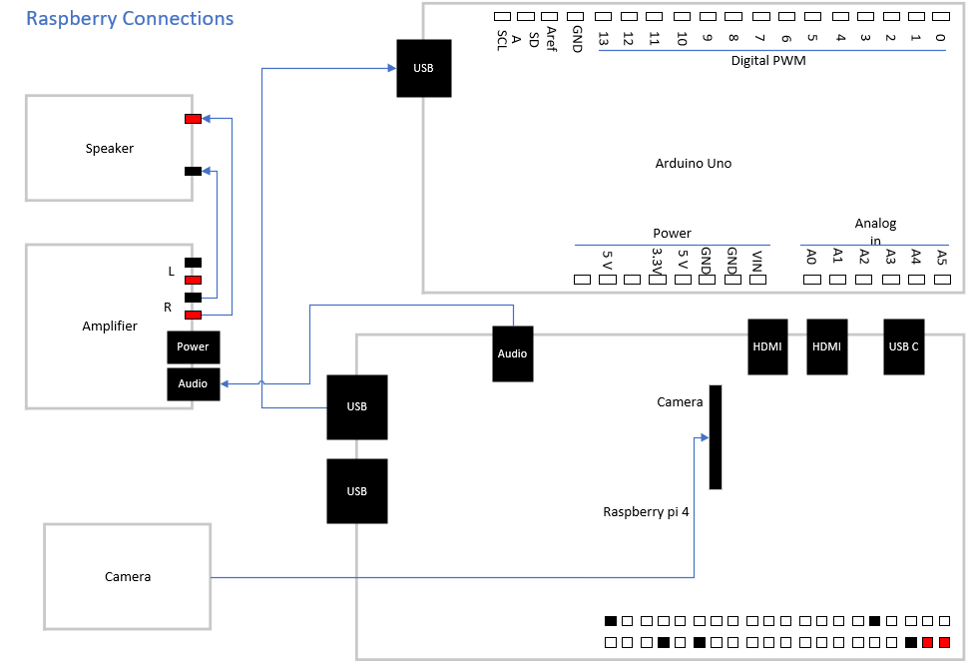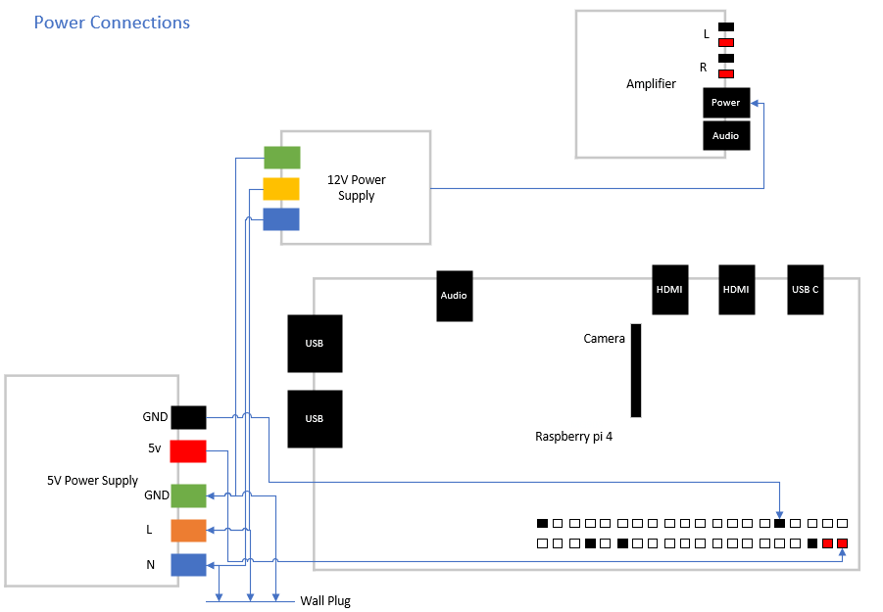

## Coding

* Arduino (C++):
  + Servo class: To control the speed of each servo while moving them simultaneously, and to keep information about each well organized, we created a Servo class having all the attributes and methods needed to operate each servo. We can thus initialize each servo as a separate instance of the Servo class, giving as parameters the instance of the PCA9685 Adafruit_PWMServoDriver library, its corresponding channel on it, and informations about the initial position, allowed range of movement and direction of movement. In order to move the servos, each one calls its Move method, inside a while loop, which goes on until all Move methods from all servos return 1. Inside the Move method, a delay is calculated depending on the requested speed and a delta of +/-1 is obtained through normalization to account for the right direction of movement. Then, if the servo has not reached the target position, the time passed since the last position update is larger than the calculated delay, and the target position is inside the allowed range of movement, we update the position of the servo by delta. This mechanism required a bit of trial and error, especially in the definition of the while loop condition. In fact, using the “||” or would move the servos sequentially in the order that they appeared in the condition statement. Using “|” bitwise or instead, solved this problem and allowed simultaneous movement. This while loop was placed inside the function FreeMov, making it easier to call it. This also allows the presence of blinking logic for the lotus flower, which depending on the situation might have to blink during movement, inside the while loop body. Relating to this class was one of the major problems we encountered and were able to solve. This problem manifested itself as a freeze of the robot movements, which would only unfreeze after a random time. After a thorough investigation, we found that at some point the time passed from the previous position update in some servos would become negative. We then understood that the function millis() in Arduino encodes time as a long int instead of int type, which we used for the variables that were interacting with millis(). This meant that the negative values in time-passed variables were a consequence of the long int overflowing in the shorter int type after a certain time of operation was surpassed. Fixing this type of mismatch fixed the behaviour of the robot.
  + LED Matrix library:

The LED Matrix are controlled using the LedControl Library. The main objective of this part is to create graphic visualizations to represent different states and emotions.

The program is structured as follows:

* Pin configuration and constants: it defines the pins for SPI communication with the LED matrices (CLK = pin 12, CS = pin 11 and DIN = pin 10).
* Library initialization: it configures the LedControl library.
* Image array: it contains images encoded in uint64_t format to be displayed on the LED matrices. It was necessary to define in the image array each expression that the eyes could assume. We used a website to make the conversion between images and uint64_t format [see Bibliography].
* Setup: it configures the initial settings for the LED matrices (intensity of the LED matrices).
* Display functions: specific functions to display images on the LED matrices.
* Eyes expression functions: using the “displayImages” function, we created other functions that would send the following expressions to the matrices (specifying it for both eyes). A particular use case of this method is the SATISFIED state, for which we desired a blinking effect between the two expressions. However, since we couldn't use a “for” loop in the corresponding function without blocking the movements of the servo motors, we decided to create two different functions: 'fSatisfied1' and 'fSatisfied2' to be called via messages with a higher frequency. In this phase, it was important to define which image would go to matrix 0 or matrix 1 to distinguish the right eye from the left eye. Additionally, we initially decided on a different set of expressions, so we had to redefine both the image matrix and the corresponding functions.
  + NeoPixels library:

The Lotus flower LEDs are controlled using the Adafruit_NeoPixel Library. The NeoPixel LEDs create additional visual effects, enhancing the overall visual interaction.

The structure is similar to the previous one:

* Pin configuration: the pins for the NeoPixel strip (DIN = pin 7).
* Library initialisation: it configures Adafruit_NeoPixel libraries.
* Setup: it configures the initial settings for the NeoPixel strip.
* NeoPixel LED management functions: functions that set the colors of the NeoPixel LEDs to create various light effects.

We decided to create four functions to manage the lotus flower petals. 'lotusL1' was used to control the two petals at the base of the flower. Through a state given as input to the function, we had five possibilities: all three LEDs on (state 0), only the two LEDs closest to the centre on (state 1), only the two central LEDs on (state 2), only the two outermost LEDs on (state 3) or all state off (state 4). This structure allowed us to control the blinking by sending a specific message from the Raspberry Pi. It was also very important to include the “pixels.show()” and “pixels.clear()” functions to send the command for the LEDs to turn on and subsequently turn off to transition to the next state. In theory, the “pixels. clear()” function was supposed to clear the LEDs by giving only that command in state 4 (all LEDs off); they remained on. So, we decided to manually set the LEDs to off using the RGB encoding rgb(0, 0, 0)

The other functions, 'lotusL2' and 'lotusL3' have the same structure with the addition of always keeping the previous level on. These functions were created using the “pixels.setPixelColor” function from the Adafruit library to define the color of each individual LED using RGB encoding. We decided to use the following three colors for the three levels: L1 =rgb(148, 30, 79), L2 = rgb (161, 33, 159) and L3 = rgb(99, 30, 148). using progressively lighter shades starting from the center and moving towards the outer part of the petal. The 'lotusL4' function instead sets all LEDs to green for one of the possible 'ByeBye' states."

* + Communication with Raspberry: the reception of commands from the Raspberry to the Arduino is made possible by using serial communication, which on the Arduino side is managed with its Serial library. The main loop in the Arduino will thus listen for messages, using the Serial.available() function to check how many bytes of data are ready to be read from the buffer. If there is data to be read we use the Serial.readStringUntil(‘\n’) to be sure to read the whole message, up until its end, determined by ‘\n’ character. To be completely sure, we increased the Serial timeout with setTimeout() to 5 seconds. Then we check if the received message is a motor (M: ) or a LED (L: ) command and proceed to extract the data:
* For motor control, we use an “sscanf” with a fixed format to extract the integer values for the target angle and speed of each servo. At first, we had a verbose explanation for each number to make it more readable. Still, in the end, we opted for shorter messages using a positional pattern to encode which servo each pair of numbers related to. We also made arrangements in the servo class so that if a servo did not need to be moved from its current position, we would just need to put 300 as the target position and one as speed in its corresponding spot in the message to convey this purpose.
* For the LED commands instead, we used a lighter char encoding, where ‘f’ or ‘l’ would discriminate between “face” (led matrix expression) and “lotus”, and subsequent chars would give more specific commands for each.
* Raspberry (Python):
  + AI mode ‘posenet’: The main functionality of our robot, the ability to be imitated by the users, relies heavily on the fact that we can detect their pose. At the early stages of our concept, we thought of using moving Time Of Flight sensors to recognize the placement of the arms. This was a feasible but difficult and extremely restricting idea, in terms of the variety of movements we could detect. We thus moved away from it in favour of using some kind of machine learning algorithm to accomplish this task.

Even here though we went through some iterations and quite substantial changes of approach. At first, we designed a classification Convolutional Neural Network, helping ourselves with transfer learning from a premade EfficientNetB2V2, and training on a dataset of around 5000 images of ourselves. This approach yielded some results in training (96% accuracy on the Validation Set). Still, when tested on new real-time images, and crucially after quantising the network to uint8 to make it work on TF-Lite, its precision dropped significantly, making it too unreliable for use in our design.

This is where we finally settled on our final approach. We looked online for a premade PoseNet, a neural network performing regression on the position of the joints of a person or animal present in an image, and found one on the website of Coral Accelerators, which we were planning on using at first. The model we found was made to work on TF-Lite and estimated 17 joints with y-position, x-position, and confidence of prediction for each of them.

Having tested its performance and reverse-engineered some parts of the output interpretation that were unclear from our research, we proceeded to mesh this model into our design.

The AI part of our code is one class, having two dynamically settable modes of inference and running on a separate thread from the main one but having its attributes accessible from it. We considered using Locking mechanisms to manage the parallel access to the same resource by the two threads. Still, we determined that very little trouble could come from it because these resources were always used in reading mode by one thread and only written by the other. This meant that the worst that could happen was not any loss of information or overwriting, but just a delay in reading the correct, updated information.

For the “posenet” mode, we just feed an image taken by the camera into the TF-Lite interpreter encapsulating the posenet model and then pass its outputs to a PoseToClass() method inside the AI class to translate the joint's position into one of our predefined classes of movement. This translation was quite straightforward, with the only problem being some confusion between class A and class I, which, to our translation logic, looked quite similar.

As a final note, we have to discuss one of the potential problems that had given us doubts since the design phase: performance. Our model runs on the Raspberry pi4, which has a reasonably capable quad-core processor on it. In the definition of our concept, we were not sure that it alone could provide the performance we needed for a smooth interaction. That is why we planned on using a Coral USB Accelerator. Unfortunately, we were not able to make it work, since it needs specifically converted models, and that after a fair share of trying, we could not manage to make this conversion with the tools that were supposed to do it. Thus our initial performance, PoseToClass conversion included, was 1 Frame Per Second. This was certainly too low for a smooth interaction, so we got to work on improving performance and in the end got some significant increases. Firstly, we found that TF-Lite interpreter let us use multiple threads for the same model. Having a quad-core processor, it was reasonable to use three threads on the AI and 1 for the main so that each could run on a complete core of the processor. This brought down AI-latency from 1 second to 0.68 seconds. Then we found that we were running on the camera port of the PiCamera library, which meant having more quality of the pictures, trading time for it. Setting “use_video_port” to True, was enough to reduce latency to 0.33 seconds which translates to 3 FPS, so a 3 times our initial performance. The AI was now ready to be smoothly integrated in the overall behaviour of the robot.

* + AI mode ‘detect’: Detection of a user, interested in or just standing by our robot, was a crucial part of our approach. At this point in the development, the ‘posenet’ part of our AI was looking quite promising, so we decided to use again a premade model to process the camera input and detect a potential user. We looked on the same set of webpages we had found the posenet model, and found an object detection models, trained on a dataset of 90 objects, including “person”. However, we were presented with a set of problems that made it hard to even interpret the output of the model. This combined with the fact that other than detecting, we needed a reliable way to also evaluate if the detected user was in fact in the right position to interact with our robot, made us reconsider our approach. After some thinking, we decided to stick to a solution that included the posenet model (which we already knew it worked and how to use it), and just adapt it to this new task.

This way was made possible by the confidence value provided by the model regarding its joint placement predictions. If the average confidence of the joints subset we were interested in, was above 60%, then there was indeed a person in the camera view, otherwise not. Over this new approach we were able to construct some very interesting features of our robot. In the “I See You” part of the interaction (triggered by detection of a person), we can point the head of the robot to look directly at the eyes of the detected person. Even more, we can estimate with a measured precision of about 10/20 cm the distance of the user from our robot. This is made possible by trigonometric calculations that take the proportion of the distance between left shoulder and left hip, and the size of the image plane. Assuming the shoulder-hip distance to be 50 cm, and knowing the Field Of View angles of our camera we estimate distance using Carnot and Sine (Euler) trigonometric theorems, and some more basic trigonometry to compute the pointing angles to the nose of the person from our robot’s head joint, knowing the ones from our camera.

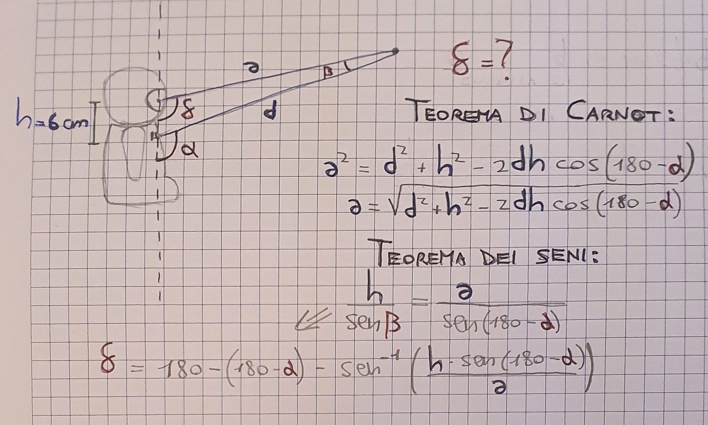

* + Sound: to reproduce sound, we looked online for suitable mp3 recordings to be used in each phase of the interaction. These were transferred in the raspberry pi memory, and then accessed and played through the “pigame.mixer” class. This was actually a very simple part of the program, and we encountered no significant problems relating directly to code.
  + Communication with Arduino: Given the Arduino code explained before, communication implementation in raspberry was defined easily using the “pyserial” library. Commands are encoded as string messages compatible with the receiving code and sent through the right usb port. To ensure synchronisation, which was a problem in the first implementations of our protocol, we made it so that each command is managed by a SendCommand() function that waits to receive a “Done” message from the Arduino, before completing and thus allowing new messages to be sent.
  + Animation: Given all that was explained above, implementing animations was just a matter of creating functions with a sequence of commands, and fine tuning the timing between each, through the use of delays. In some of the animations, access to the AI attributes were needed to make decisions on the subsequent behaviour. The concatenation of these animations created the overall decision tree of our interaction. We did have to solve some problems, mainly relating to the control conditions, but in the end it was fairly easy to translate our well defined flow-chart into code.

## Logo

For the logo creation process, we used online platforms managed by artificial intelligence, which can generate images by typing in complete and descriptive sentences.

The website used is Recraft which gives you the option of generating two types of images: raster or vector. Having selected the vector type, we set vector art as the logo style and then typed the phrase ‘Create a logo combining the word Yudu and a lotus flower’. The first attempt generated a rather good but still unsatisfactory image.



So we modified the settings further, choosing a white background and inserting a colour palette consistent with that used for the lotus flower animation.

  

These generated images reflect the concept of the project, which is why we inserted a new colour palette and only modified the second logo with a 50% similarity to the reference image. In doing so, we obtained our final image.



# Phase 4: Deliver

In this phase, we describe the final robot. You can repeat some paragraphs from the development process if needed.

## Final Robot Description

### Strategy

The very last steps for the robot design were to spray paint it and assemble the pieces for the final prototype.

The final prototype is all newly 3D printed, apart from some cases (e.g. the head) where we repurposed already printed parts. The head was split vertically into two halves to reduce support and printing time. The same thing was done by splitting horizontally the leg base, hence reducing the supports inside the legs. The other parts were made as whole pieces. We left tiny cylindrical holes in the parts, to guide the self-tapping screws inside the hole and avoid the use of heat inserts.

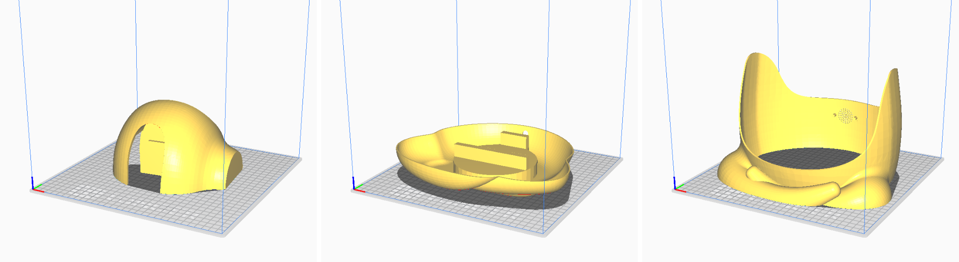

### Shape

The new and improved robot version is entirely made of printed PLA with an ivory white color. We decided to use a shiny paint for it, to enhance its look when moving in an area with many artificial lights and also to make the 3D printing lines invisible to a user seeing it from afar. We decided to useivory-whiteolor to make the body perceived as a whole, with the only exceptions being the eye mask and the lycra, of an off-white colour. The overall look of the robot is very friendly and with its new interaction, it is gonna provide a smooth experience to the user.

Here is the link to the 3D file:

3D [Model](https://drive.google.com/file/d/1cpVUW4RAMXzU9oNGo3faXh7MtdU6qHPC/view?usp=drive_link)

### Mechanics

Here is the exploded view of the final robot:

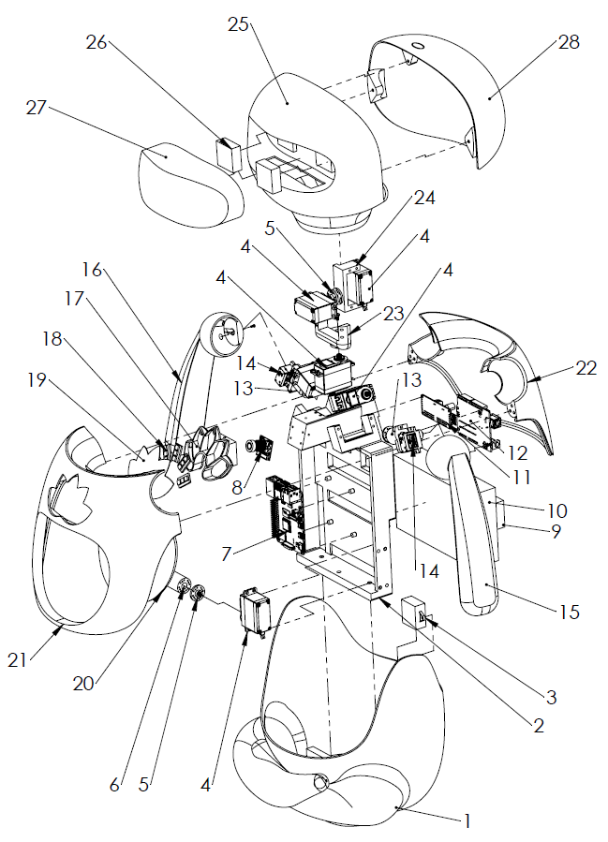

And here is the list of the parts respectively:

| **Number** | **Name** |
| --- | --- |
| 1 | Body - Lower shell |
| 2 | Main Frame |
| 3 | Speaker(&amplifier) |
| 4 | Servo Motor (MG995 ) |
| 5 | Circular horn |
| 6 | Belly Actuator |
| 7 | Raspberry pi4 |
| 8 | Rapberry cam |
| 9 | 12V Power supply |
| 10 | 5V Power supply |
| 11 | Servo Shield(PCA9685 ) |
| 12 | Arduino uno |
| 13 | Motor Support 1 |
| 14 | Servo Motor(MG90S) |
| 15 | Left Hand |
| 16 | Right Hand |
| 17 | LED Support |
| 18 | LED strips |
| 19 | Lotus diffuser |
| 20 | Foam and Silk (for Belly) |
| 21 | Body - Front Shell |
| 22 | Body -Rear Shell |
| 23 | Motor Support 2 |
| 24 | Motor Support 3 |
| 25 | Head- Front Shell |
| 26 | LED Matrix |
| 27 | Eyes Mask |
| 28 | Head- Rear Shell |

Suggestions for further enhancements:

The structure in the prototype had some issues which originated from design and prototyping. To address those issues, here we list a few suggestions.

The mechanism for the hand:

The main problem of the robot was some unwanted frictions in arms due to misalignments. The reason behind the misalignment was big displacement in the main frame due to its weak elastic modules. The main reason behind this was fast prototyping of the main frame and using 8% as an infill to produce the main frame. As a result after assembling the main frame, the power supply, due to tight tolerances, did not let it be screwed straightly to the lower body. And the whole frame had an inclination toward the front direction. The tolerance for the arm was not tight, but this significant misalignment in the frame made a lot of friction in the arm movement. For the prototype we used zip tie and scotch to solve the problem, but for a proper prototype following suggestions can be considered:

1- reprinting the main frame with at least 20% infill to enhance the stiffness.

2- putting a looser tolerance for fitting the power supply in the main frame.

Another issue was the alignment of the head which originated from a printing problem. A reprinting head could solve this issue. But using some screws instead of magnets is highly recommended.

### Electronics

The schematic presented in the previous phase is still valid.

### Informatics

The final design in terms of code was a perfected version of the one we presented in the previous develop phase. However, after observing some users interact, we made small modifications, not to the functionality but to the length and timing of the interaction. We noticed, for example, that some users would not follow the MirrorMe phase to the end, and thus could not go further. This was probably due to the length of the phase, so we shortened it by removing some of its movements. Also we noticed some embarrassment in performing the moves to the full extent, which would result in misclassification and might become confusing after a while. To ease this aspect we relaxed the classification thresholds of some classes of movements and reduced the number of correct movements needed to pass the Stretch phase.

As a final modification, we ensured (by changing raspberry autostart files) that the program would start after turning on the robot without needing any external input, as up to that point we connected to the raspberry through RealVNC service and started the program manually.

Link to Code: [Code](https://drive.google.com/drive/folders/14hOvDSzaRLMLWtVcgzVTl8KZS7feTRXB?usp=drive_link)

# 

# User Interaction Discussion

Presentation day was our final test day, we had the chance to test the final working product only with other students from the course and so far the only unbiased test we took was using videos. We set up the robot next to the vending machine in B2 and were ready to go.

During the morning we took a look at the users from far away, the engineers were staying outside of the vending machine area, close enough to spot unwanted behaviours or software bugs, and the remaining designers stayed in the gallery on top of the vending machines on the “3rd” floor of B2 building.

As we expected, the presence of the robot in that area created a lot of interest from the users, people were approaching it to see it up close and to take pictures, the presence of the standing sign on the floor helped to let people understand at first where to position themselves. While we were setting everything up there was already a queue of people to try the experience.

* users immediately enjoyed the aesthetic of the robot, defining it “cute” out loud;
* the average user grasped the meaning of the robot during the “mirror me” mode, indeed the user perceived the robot as teaching a relaxing routine;
* while users were interacting there was a rather large audience of interested people, we noticed students were way more shy in doing the interaction on their own (e.g. in the moment when people were mostly in class and the area did not have much audience). As studies in the desk research showed,users were way more playful and open to the interaction when they were in a group;
* we noticed that a good number of users thought that the exercise was done when the first raw of petals switched on, at first we thought people were not understanding the correlation between the lotus and the levels of the exercise;
* to our surprise, we noticed a very interesting behaviour related to the lotus levels: groups of friends were sharing the same experience by quickly changing person in front of the robot while the lotus was lighting up a new row of petals, hence having a different person per each level and making the interaction as a sort of challenge among the group members, while cutting down on overall usage time;
* users interpreted the satisfied reaction from the robot as another movement to follow, hence following the clapping movement performed by Yudu;
* a minority of students initially thought that the robot was going to mirror their movements, and started moving in different positions, thus triggering the negative response of the robot;
* following the group logic, we counted two instances of recurring users during the morning. The recurring users not only tried the experience again, but took some friends with them to show them the robot and “guide” them through the movements.

In the end the user observation gave very positive feedbacks, users were really interested in the robot and demonstrated a good understanding of the interaction routine the complete absence of correlation with the , they did not specifically get the connection between the exercise and the muscle relaxation for study purposes (that was fairly expected), but they fully understood the idea of learning from the robot how to relax, hence keeping the assumptions that they could integrate the routine into their daily lives.

Probably we could have put the robot in a different position inside the room, as it was close to the door we noticed that a considerable amount of people passed by it and only gave a quick look, indeed the robot response was not fast enough to attract people’s attention while walking away. It showed the expected results in attracting people getting coffee, especially users waiting for the coffee to be fully brewed by the machine, in some cases users were so interested that they tried the experience with the coffee cup on their hand to not wait.

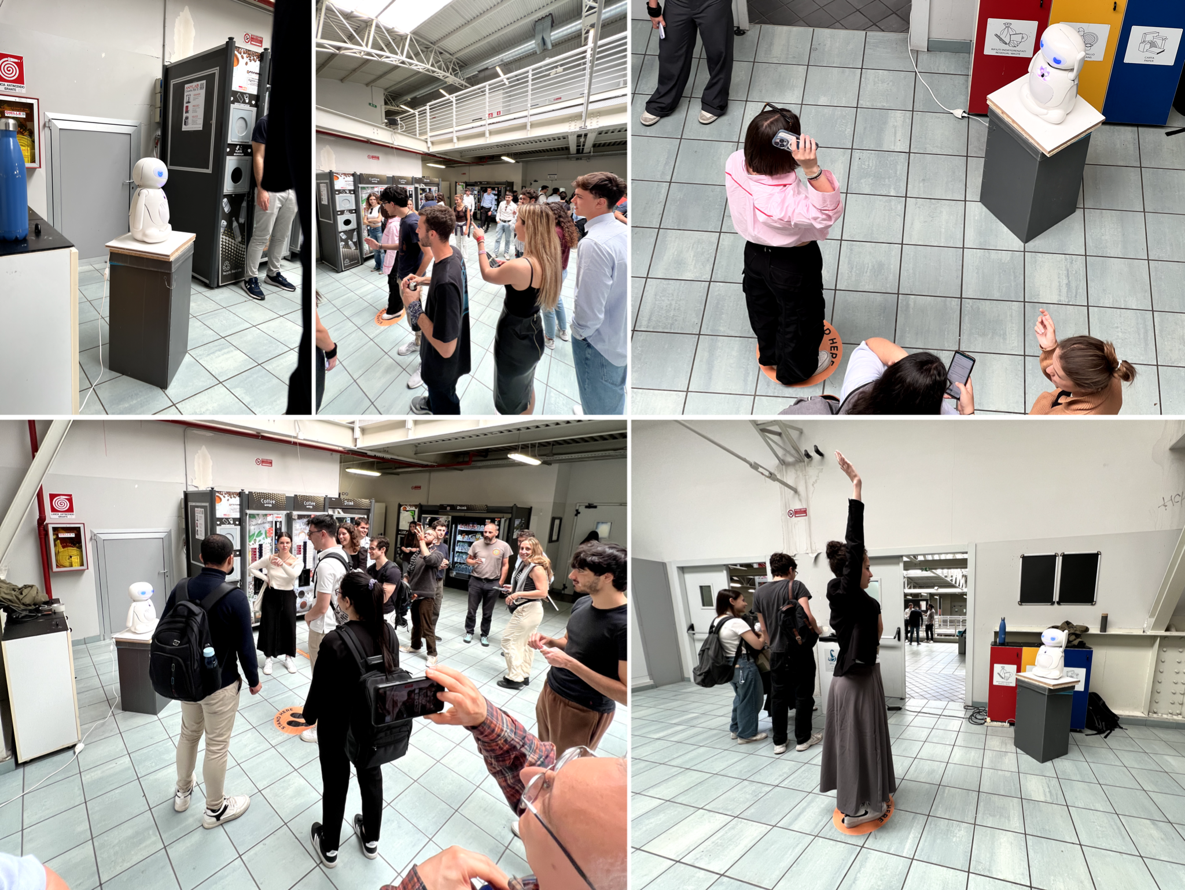

# Conclusion

When we started working together we could feel the difference in backgrounds we had, we had slightly different ways of conceiving ideas and discussing them, the most challenging part for us has been discussing the creative ideas in the first define stages, regardless, we always found a way to take every idea into account and create something all together. We worked surprisingly well in the teamwork organization; indeed this past semester, two of the designers were both working on their Internships and of them was abroad, given the premises, we managed the work quite well, separating into “sub-teams” (hardware and software) and discussing the individual problems and solutions into the sub team first and the bringing all together in the team meetings. Going back, we could have taken more time in the initial states to discover different shapes, we probably focused too much on putting together aesthetics and functionality too soon; that being said, working in parallel on both hardware and software gave us the freedom to make multiple small changes along the way, and with some refinements, the process gave a result much appreciated from the users. The joint effort worked well also for crisis management, indeed, regardless the fact that in the same week we had to change multiple hardware components and the 3d printer broke mid-printing, our different knowledge backgrounds helped in finding quick solutions to the problems and still managing to present the prototype for one of the reviews.

# 

# 

# 

# 

# 

# 

# APPENDIX

# User & Maintenence Manual

# 

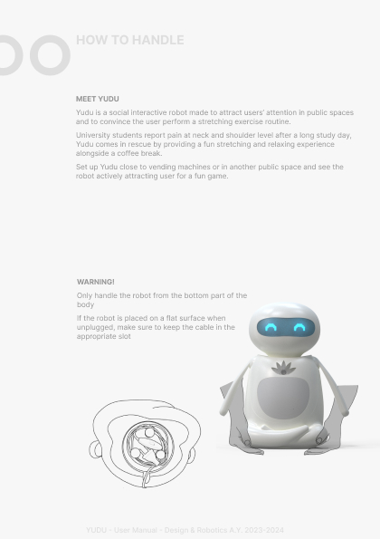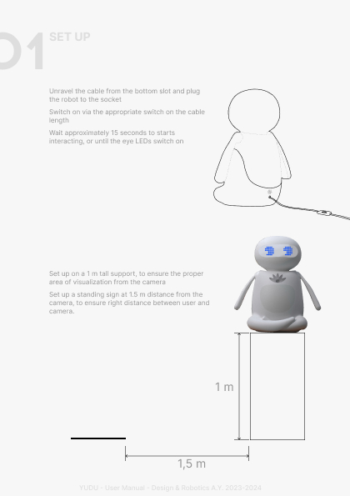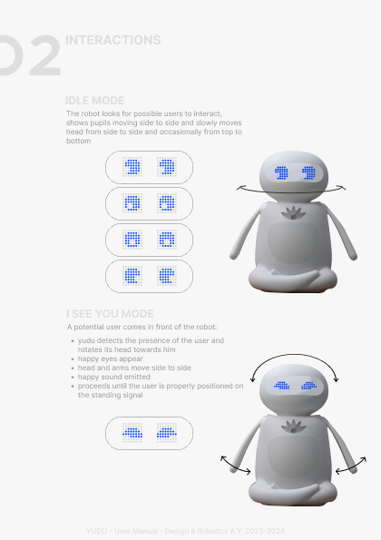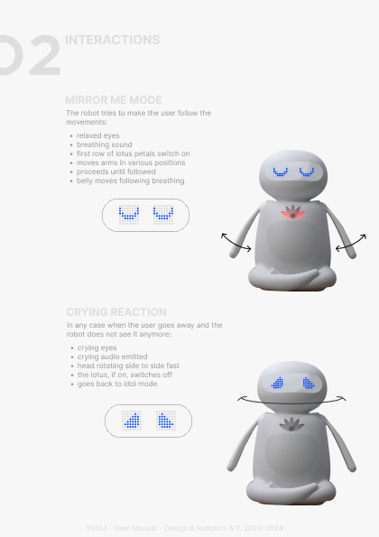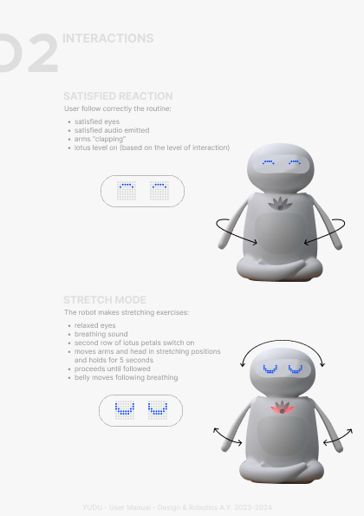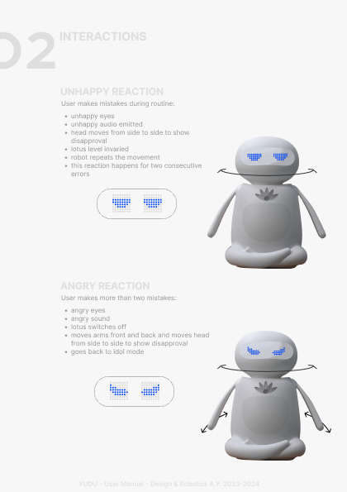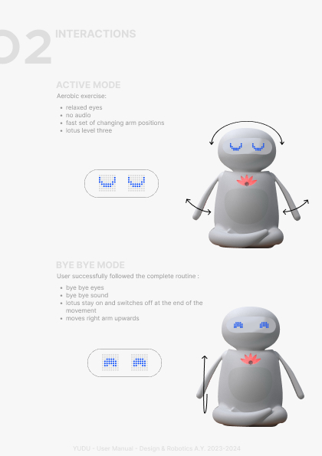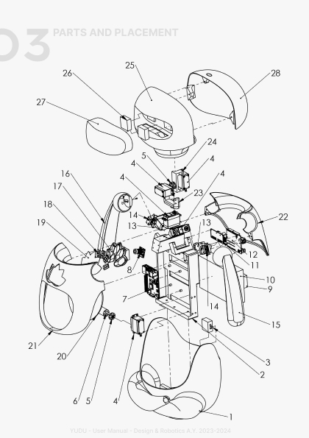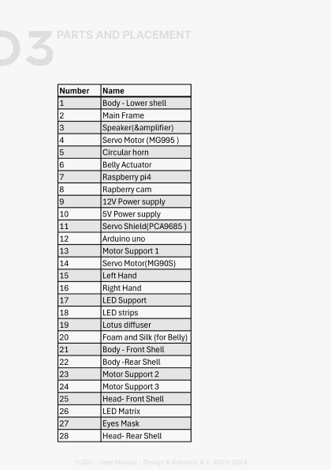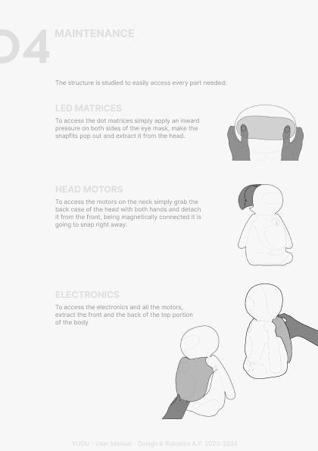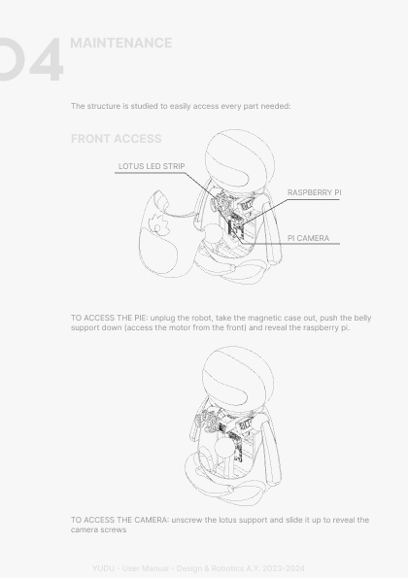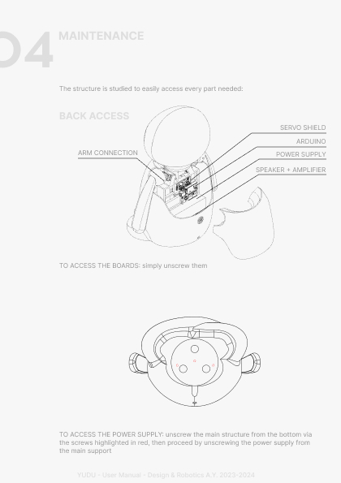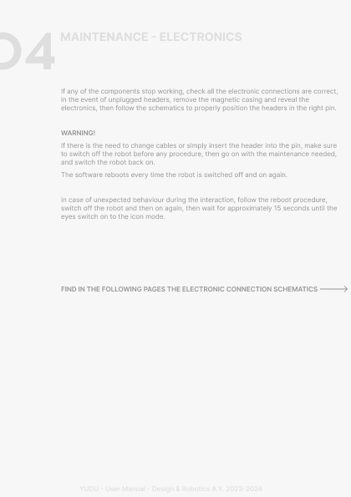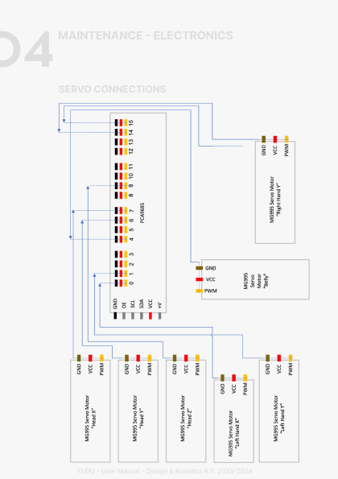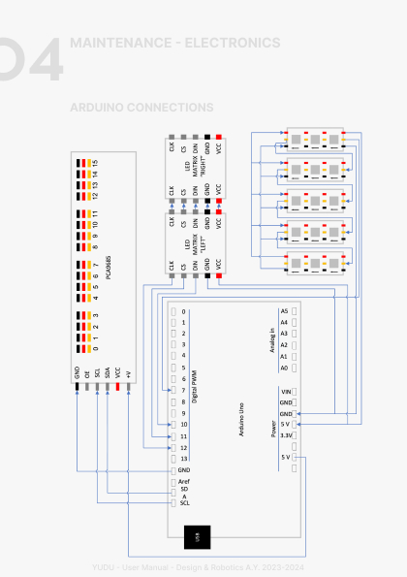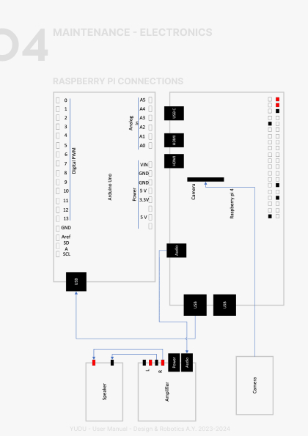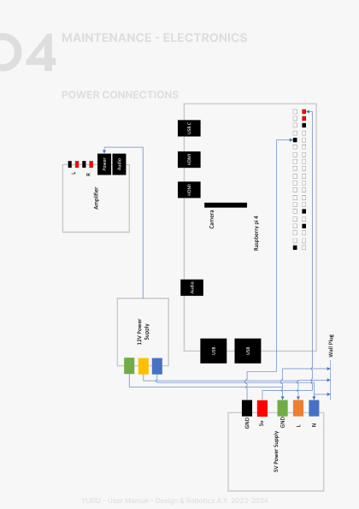

# Minutes of the Meetings

## Meeting 08/03/2024

Time: 2 hours

Venue: Politecnico of Milano

Attendees: Esfandiar, Grazi, Gregorio, Pedini, Verga, **Author**, Gregorio

* Assignment of roles
* Discussion about design and function

We decided on the generic functions, and we started thinking about the shape

## Meeting 15/03/2024

Time: 2 hours

Venue: Google Meet

Attendees: Esfandiar, Grazi, Gregorio, Pedini, Verga, **Author**, Gregorio

* Bill of materials
* Design of interactions

We decided which movements the arms and head must make.

## Meeting 16/03/2024

Time: 3:30 hours

Venue: Google Meet

Attendees: Esfandiar, Grazi, Gregorio, Pedini, Verga, Author, Gregorio

* Shape
* Interaction

During the meeting each member proposed a sketch of the robot in order to achieve a specific shape. Related to this specific design we have clarified which movements the robot will make. Also we developed a proof of concept for the lidar-like sensor system to test its feasibility

## Meeting 20/03/2024

Time: 2 hours

Venue: Google Meet

Attendees: Esfandiar, Grazi, Gregorio, Pedini, Verga, Author: Gregorio

* Design and interactions

We worked on the second task assigned, which involved the 3D-printed basic structure that supports an arm and the electronics. To conclude, we discussed the first 3D model to understand what to modify and improve.

## Meeting 22/03/2024

Time: 3:30 hours

Venue: Politecnico of Milano, Campus Candiani

Attendees: Esfandiar, Grazi, Gregorio, Pedini, Verga, Author: Gregorio

* Prototyping
* Testing

We built the prototype, verified the electronics and wrote the code for servo control and dataset gathering.

## Meeting 06/04/2024

Time: 3:30 hours

Venue: Politecnico of Milano, Campus Candiani

Attendees: Esfandiar, Grazi, Gregorio, Pedini, Verga, Author: Gregorio

* Dataset

## Meeting 11/04/2024

Time: 3:30 hours

Venue: Politecnico of Milano, Campus Candiani

Attendees: Esfandiar, Grazi, Gregorio, Pedini, Verga, Author: Gregorio

* Dataset
* 3D model fine-tuning

## Meeting 23/04/2024

Time: 1 hour

Venue: Google Meet

Attendees: Esfandiar, Grazi, Gregorio, Pedini, Verga, Author: Gregorio

* Modelling

## Meeting 25/04/2024

Time: 1:30 hours

Venue: Google Meet

Attendees: Esfandiar, Grazi, Gregorio, Pedini, Verga, Author: Gregorio

* Modelling
* Tested first concept of AI Model (failed)
* Wrote code for Serial communications, LEDs matrixes

## Meeting 26/04/2024

Time: 2:30 hours

Venue: Politecnico of Milano, Campus Candiani

Attendees: Esfandiar, Grazi, Gregorio, Pedini, Verga, Author: Gregorio

* Modelling
* Testing serial interface between Raspberry and Arduino

## Meeting 03/05/2024

Time: 2:30 hours

Venue: Politecnico of Milano, AirLab

Attendees: Esfandiar, Grazi, Gregorio, Pedini, Verga, Author: Gregorio

* AI model testing and 3d model revision for prototyping

## Meeting 07/05/2024

Time: 1 hour

Venue: Politecnico of Milano, Campus Candiani

Attendees: Esfandiar, Grazi, Gregorio, Pedini, Verga, Author: Gregorio

* Assembling

## Meeting 10/05/2024

Time: 2 hours

Venue: Online

Attendees: Esfandiar, Grazi, Gregorio, Pedini, Verga, Author: Gregorio

* Animation

## Meeting 13/05/2024

Time: 2 hours

Venue: Politecnico of Milano, Campus Candiani

Attendees: Esfandiar, Grazi, Gregorio, Pedini, Verga, Author: Gregorio

## Meeting 20/05/2024

Time: 2 hours

Venue: Politecnico of Milano, Campus Candiani

Attendees: Esfandiar, Grazi, Gregorio, Pedini, Verga, Author: Gregorio

* Prototyping
* Real life testing

## Meeting 24/05/2024

Time: 8 hours

Venue: Politecnico of Milano, Campus Candiani

Attendees: Esfandiar, Grazi, Gregorio, Pedini, Verga, Author: Gregorio

* Prototyping
* Real life testing

## Meeting 27/05/2024

Time: 12 hours

Venue: Politecnico of Milano, Campus Candiani

Attendees: Esfandiar, Grazi, Gregorio, Pedini, Verga, Author: Gregorio

* Sanding 3D printed parts

## Meeting 27/05/2024

Time: 12 hours

Venue: Politecnico of Milano, Campus Candiani

Attendees: Esfandiar, Grazi, Gregorio, Pedini, Verga, Author: Gregorio

* Real life testing
* Painting

# Bibliography

1 - Daniel Rozin. 2023. RGB Peg Mirror. In Proceedings of SIGGRAPH ’23 Art Gallery. ACM, New York, NY, USA, 1 page. https://doi.org/10.1145/3588428. 3593821

2- Tunwattanapong, P., Kongkasuwan, R., & Kuptniratsaikul, V. (2015). The effectiveness of a neck and shoulder stretching exercise program among office workers with neck pain: a randomized controlled trial. *Clinical Rehabilitation*, *30*(1), 64–72. <https://doi.org/10.1177/0269215515575747>

3- Vivi, P. (n.d.). *Esercizi di stretching da fare in ufficio*. <https://www.piuvivi.com/salute/distendere-muscoli-scrivania-computer-ufficio.html>

4- Lotfi, A., Langensiepen, C., & Yahaya, S. W. (2018). Socially assistive robotics: robot exercise trainer for older adults. *Technologies*, *6*(1), 32. <https://doi.org/10.3390/technologies6010032>

5- Fasola, J., & Matarić, M. J. (2013). Socially Assistive Robot Exercise Coach: Motivating older adults to engage in physical exercise. In *Springer tracts in advanced robotics* (pp. 463–479). <https://doi.org/10.1007/978-3-319-00065-7_32>

6- Antony, V. N., Cho, S. M., & Huang, C. (2023). Co-Designing with older adults, for older adults. *International Conference Oh Human-Robot Interaction (HRI ’23)*. <https://doi.org/10.1145/3568162.3576995>

7- Fitter, N. T., Mohan, M., Kuchenbecker, K. J., & Johnson, M. J. (2020). Exercising with Baxter: preliminary support for assistive social-physical human-robot interaction. *Journal of Neuroengineering and Rehabilitation*, *17*(1). <https://doi.org/10.1186/s12984-020-0642-5>

LED Matrix: <https://xantorohara.github.io/led-matrix-editor>

Colors lotus flower: <https://www.w3schools.com/colors/colors_rgb.asp>

PoseNet Model: <https://coral.ai/models/pose-estimation/>

PoseNet Output Interpretation: <https://www.tensorflow.org/lite/examples/pose_estimation/overview?hl=it>

# 

# Attachments

This part must be erased.

**To Deliver**

At the end of the course you need to deliver:

1. Working Robot
2. Printed report:
   1. Moodboard
   2. Interaction Flowchart (storyboard or state diagram if needed)
   3. Circuit
   4. Bill of materials with providers link and cost, eventually data sheets
   5. User instruction (1 page to explain how to:
      1. power supply
      2. switch ON
      3. provide Music
      4. Interact with.
   6. Maintenance Manual (change battery, solve problems, access to boards)
3. Files:
   1. Report (editable document)
   2. Firmwares and libraries
   3. 2D or 3D models (in DXF or STEP files)
   4. Short video
4. To fill
   1. Self evaluation form (same to the enrollment)
   2. Peer evaluation